Preschool Supply List

Please bring the following items for the first day of school.
We provide all learning materials (crayons, paper, markers, etc.)
We provide breakfast and lunch at no cost for all students who want to participate. Menus will be posted before school begins.

Please be sure to label EVERYTHING with your child’s first name and last initial

Two complete changes of clothes, including shoes
Crib sheet / small blanket for the cot at rest time*
A small lovey or toy that your child might want during rest time
Snack for morning and afternoon
Water bottle
Lunch (if not eating the FREE school lunch)
Backpack
A folder with pockets
One box of tissues and one package of baby wipes
*Pull-ups / wipes if needed (please label everything)

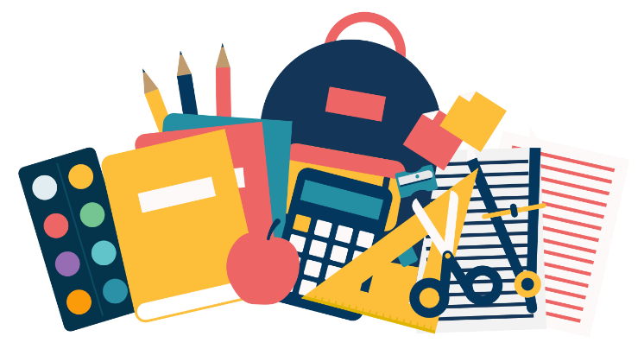
*Bedding will be sent home every Friday to be washed

