TRUMBULL FIRE DEPARTMENTS

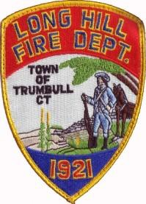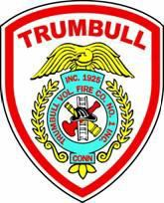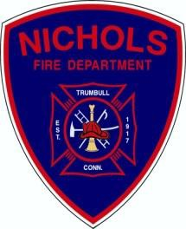

Long Hill Vol. Fire Co.
5400 Main Street
Trumbull Vol. Fire Co. 860 White Plains Road
Nichols Fire Department 100 Shelton Road

Chief Greg Sanfanandre Chief Richard Gregory Chief Jason Mumbach Liam Baker, Chairman Ed Riggs, Chairman Pat Freyer, Chairman

8/31 Proposed Agenda

- INSURANCE UPDATES
  - Did we get anywhere with the MOU?

- HIGHWAY CRASH TRUCK
  - Grant Success!

- DISPATCH SERVICES

- HOSE & LADDER TESTING ISSUES

- RECRUITMENT & RETENTION
- TOPICS OFF THE FLOOR

