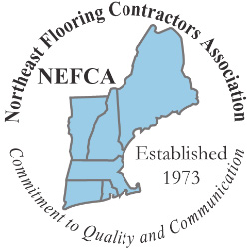
NEFCA
Associate Members Showcase
&
Education Exhibition

September 21, 2022 5:30 PM

Hilton Boston Woburn
2 Forbes Road, Woburn, MA

CONTRACTOR MEMBERS COMPANY INFORMATION
Company Name: |  | Primary Contact Name:
Mobile Phone: | Email:

Please enter all key members of your company attending
Name | Email | Mobile Phone

THERE IS NO CHARGE FOR THIS EVENT

Please Return by August 12, 2022

90 County Road Barrington, RI 02806 Phone (401) 258-2625
jimspiro@nefca.us www.nefca.us

Any no shows will be subject to a $100.00 charge

