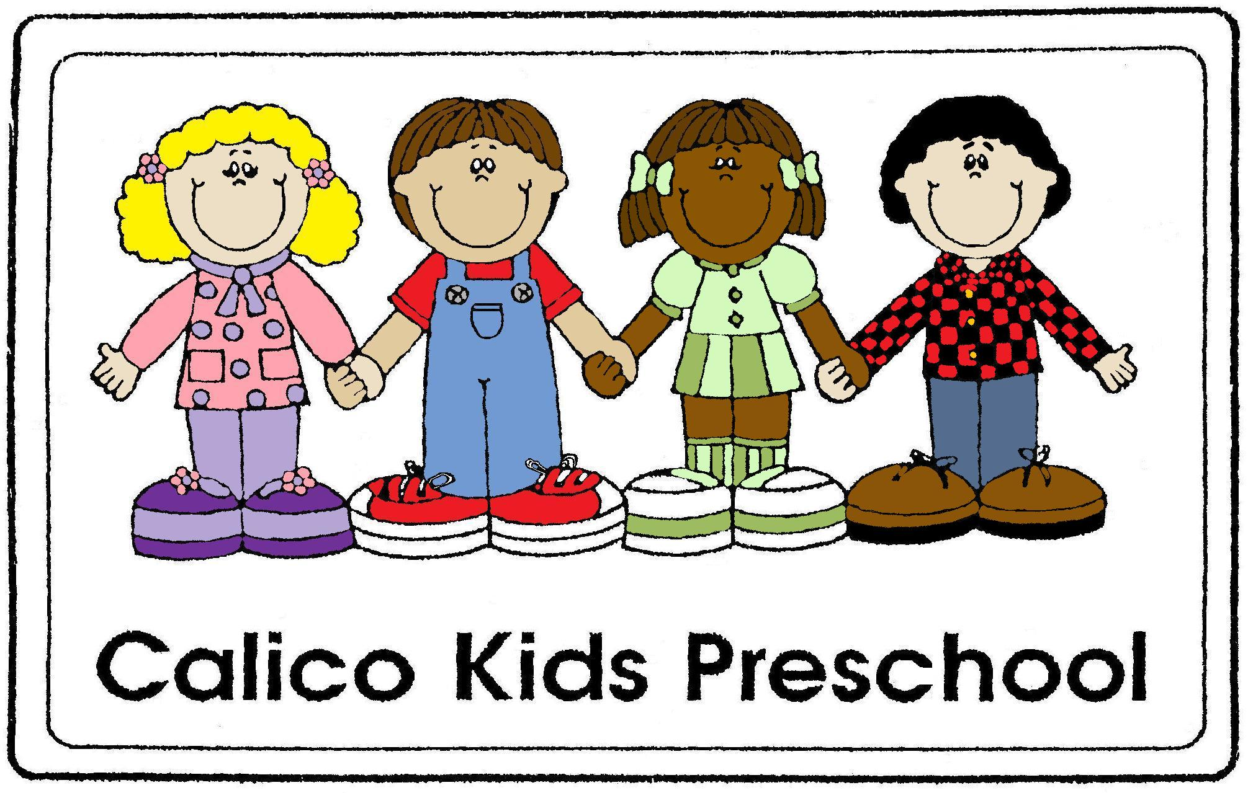

“Where learning is a great adventure”
1407 West 18th Street
Sioux City, IA 51103
712-255-7441
www.calicokidspreschool.com
calicokidspreschoool@hotmail.com

Parent Handbook

Updated 4-2-25
Table of Contents

History and Philosophy…….…………………………………. page 3
Mission Statement…………...…………………………………. page 4
Hours of Operation……………………………………………… page 4
Curriculum ………………………………………………………… page 5
Assessment………………………………….…………………….. page 6
Registration……………………………………………………….. page 7
Tuition………………………………………………….…………… page 8
Attendance………………………………………………………… page 8
Daily Routines………………………………………..………….. page 9
Daily Schedule.………..……………………….………………. page 10
Health and Safety…………………………….………………… page 11
Accidents & Emergencies……………….…………………... page 12
Child Guidance Practices……………….…………………… page 14
Parent Involvement…………………….…………………….. page 15
Licensing………………………..………………………………… page 17
Program Leadership and Management…………..…… page 17
Unauthorized Access…………………………….…………... page 17
Americans with Disabilities Act (ADA)……………….. page 18
Mandatory Reporter………………………………………… page 18
Parent Agreement………………………….……………….... page 19

Assistance is available to parents who need translation services.
Asistencia está disponible para los padres que necesitan servicios de traducción.
Hỗ trợ có sẵn cho các bậc cha mẹ cần dịch vụ.

HISTORY OF CALICO KIDS PRESCHOOL

Calico Kids Preschool has served as a preschool in Sioux City for more than thirty years. Calico Kids Preschool was established as an outreach of Mayflower Congregational United Church of Christ to provide a high-quality preschool on the west side of Sioux City. The program was set up as a typical preschool and was designed as a non-religious program. Calico Kids opened in the fall of 1983 with 13 four-year-old children.

An advisory board, made up of church members, the director, and parents of preschool children, guides the Calico Kids Preschool. In 2011, Calico Kids joined with the Sioux City School’s Preschool Initiative to provide a district preschool to four-year-old children in the afternoons. Calico Kids now offers Preschool Initiative to four-year-olds in the morning and afternoon classes. We also provide preschool to three-year-olds and five-year-olds not enrolled in kindergarten. Those children are supported by parent tuition or SHIP (Siouxland Human Investment Partnership) scholarships. Scholarships are based on family income. Application forms are available from the director.

Calico Kids Preschool is licensed by the Department of Human Services for no more than 20 children at any time.

PHILOSOPHY
All children, including those with special needs and second language learners, benefit from a developmentally appropriate preschool program.

Social/emotional readiness is critical to children’s success in school and in life, and is therefore, a focus of our program.

Children learn through play. Play is incorporated into the learning in all developmental areas.

Families are an integral part of the preschool program. Family beliefs and culture are important to young children.
MISSION STATEMENT
The mission of Calico Kids Preschool is to provide a safe, affordable, quality preschool for Sioux City and the surrounding communities. It offers programs for children ages 3 to 5 in an environment where they are encouraged to develop at their own pace. The staff is committed to the families served by providing support, information, and encouragement. The preschool is dedicated to providing a quality and diverse education that creates lifelong learners through a partnership with parents, teachers and the community. Our motto is “Calico Kids Preschool: where learning is a great adventure.”

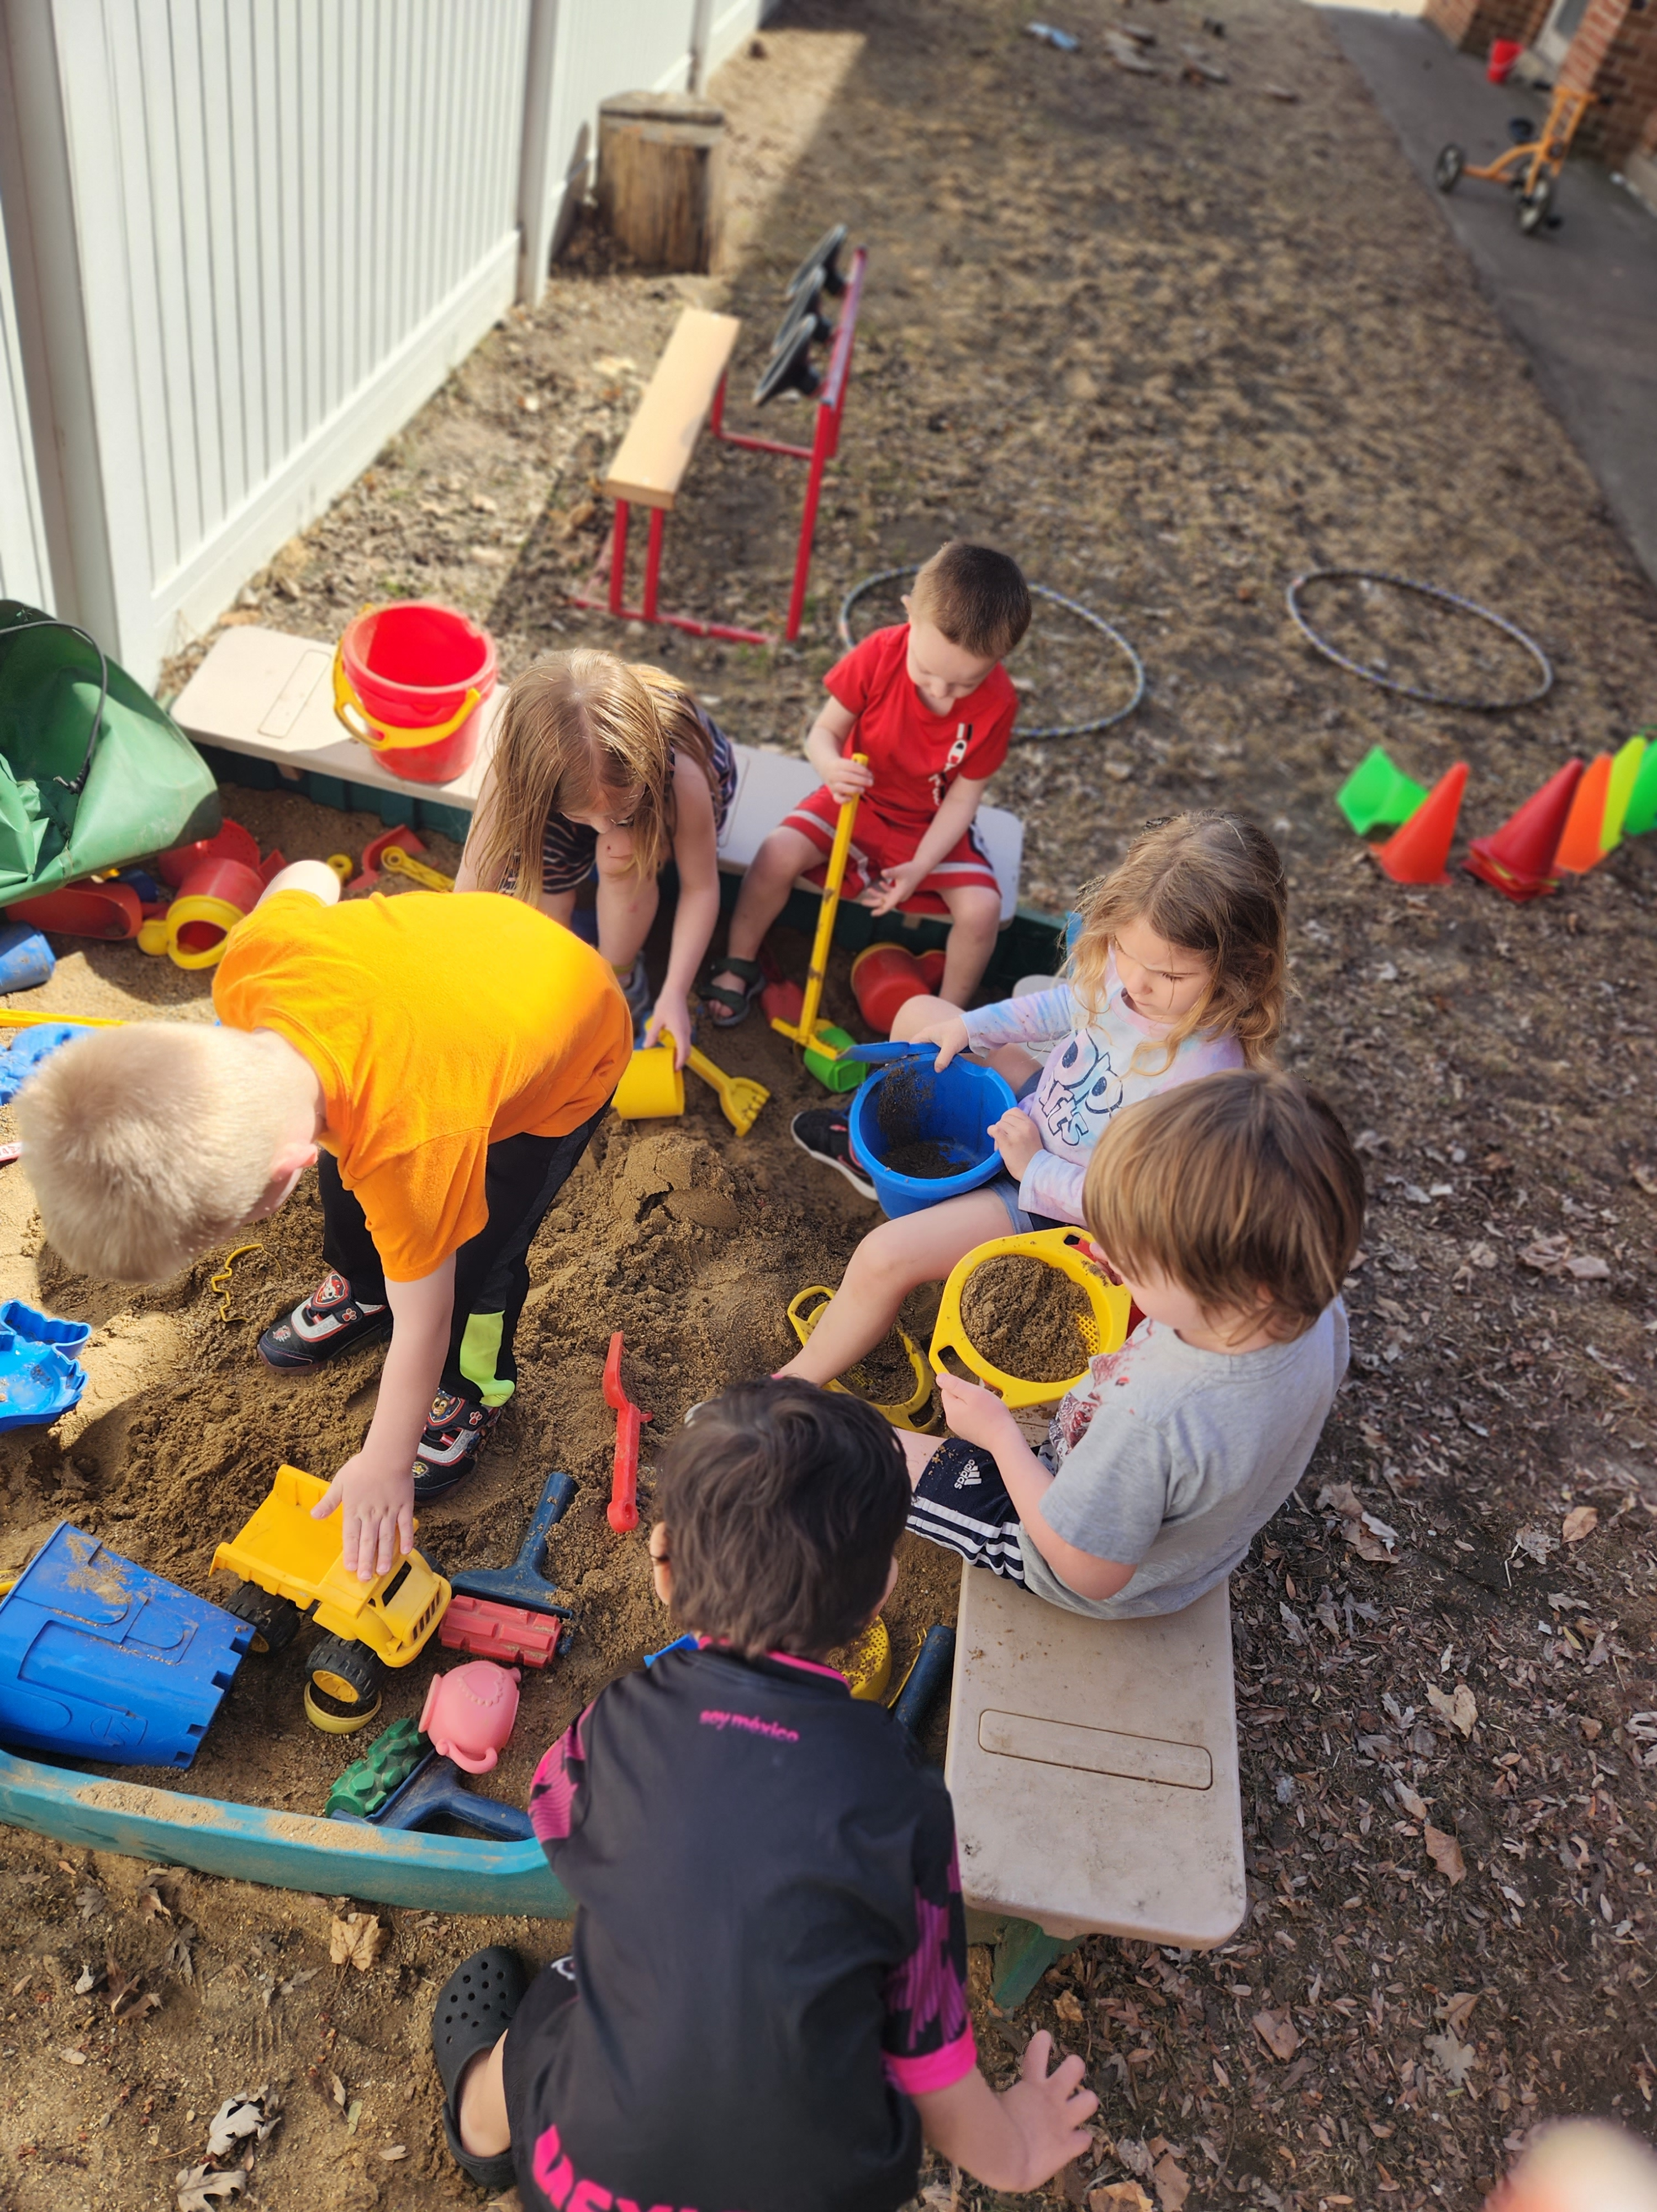
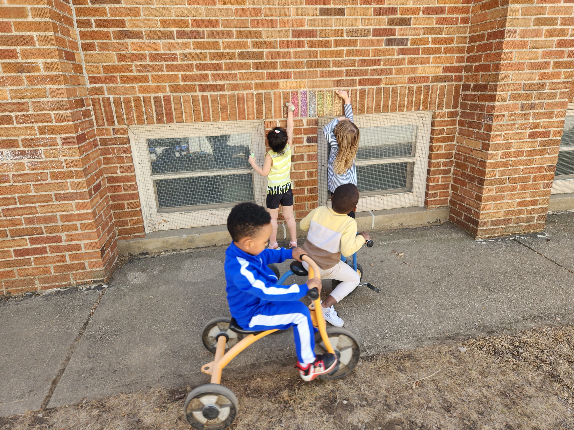

HOURS OF OPERATION

Morning Class:
Monday-Thursday 8:45-11:30

Afternoon Class:
Monday-Thursday 12:15-3:00

Three-year-olds may attend M/T, W/Th, or M-Th. Four-year-olds attend M-Th.

We will dismiss the children upstairs 5-10 minutes prior to the end of the day. If you are late picking up your child (after 11:30 or 3:00), we may issue a late fee of $5 for every 5 minutes that you are late. This fee must be paid the following school day.

WEATHER-RELATED SCHOOL CLOSING
If Sioux City Schools are closed due to weather conditions, Calico Kids is also closed. If there is a two-hour late start due to weather, there will be no morning preschool. If there is an early dismissal due to weather, preschool will also close at that time.

CURRICULUM

Calico Kids Preschool uses The Creative Curriculum for Preschool® as the foundation for its educational program. Creative Curriculum is a nationally recognized, research- based curriculum which is developmentally appropriate for all preschool children. Developmentally appropriate practice means teaching in ways that match the way children develop and learn to promote their optimal development and learning.

The Creative Curriculum for Preschool is based on five fundamental principles. These principles guide our classroom practices and help us understand the reasons for intentionally setting up and operating preschool programs in particular ways.
The principles include:
•Positive interactions and relationships with adults provide a critical foundation for successful learning.
•Social-emotional competence is a significant factor in school success.
•Constructive, purposeful play supports essential learning.
•The physical environment affects the type and quality of learning interactions.
•Teacher-family partnerships promote development and learning.

The Creative Curriculum guides our interactions with children and the planning of our daily activities for children.

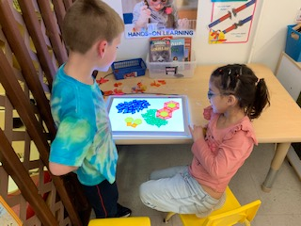

ASSESSMENT

Calico Kids Preschool uses Teaching Strategies GOLD® Assessment to assess children’s skills. GOLD is an authentic, observational assessment system that is designed to help identify what children know and can do, their strengths, needs, and interests.
The primary purposes of the GOLD assessment are to assist teachers in:
- observing and documenting of children’s development and learning over time,
- supporting and guiding classroom planning and instruction,
- identifying children who might need special help or further evaluation
- communicating with family members.

The GOLD assessment information is entered into an online system and scored three times a year. The areas of assessment include: social-emotional development, physical development, cognitive development, language development, literacy, and mathematics. Other areas observed but not scored include science and technology, the arts, and social studies. Specific objectives document progress in English language acquisition for children who are learning English. The staff enters notes daily to document and track each child’s progress. Information from the GOLD assessment is shared with families at conferences and upon request. The assessment data are analyzed and interpreted after each assessment period to determine what goals to work on. This information is then used to plan lessons based on what children need.

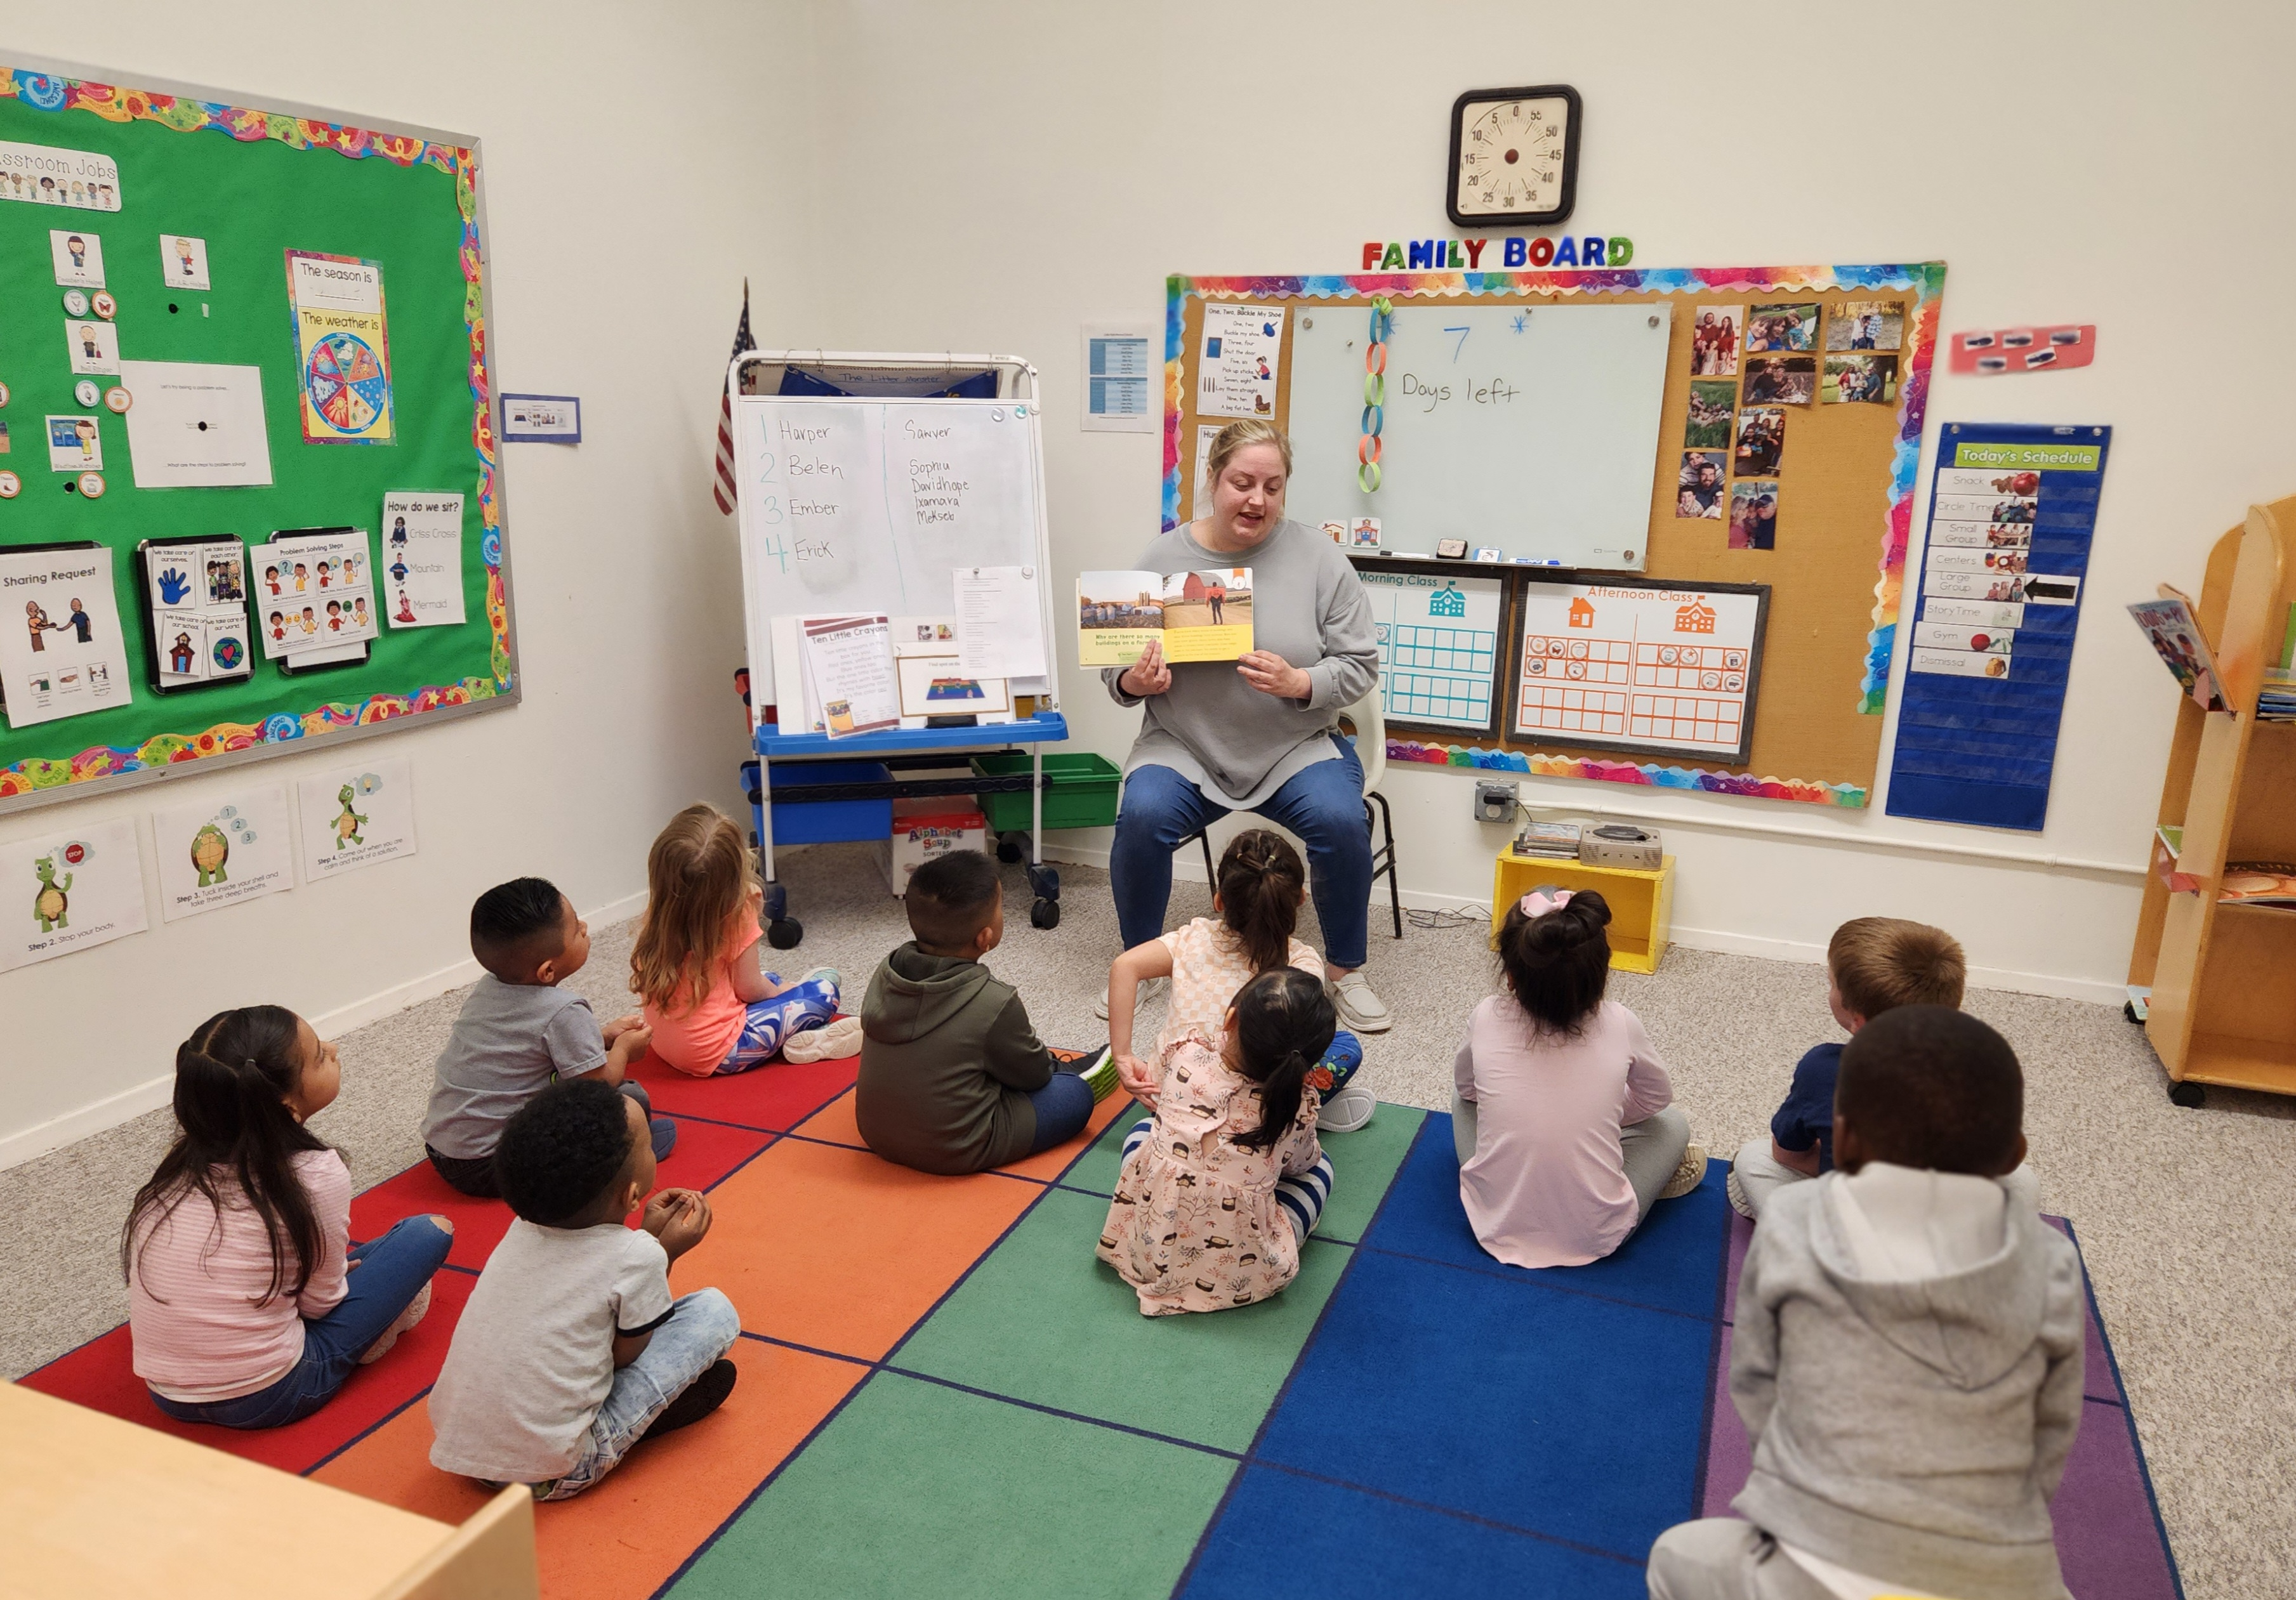

REGISTRATION

We accept registrations for children ages 3-5. The first month’s tuition (for three-year-olds) and required paperwork is due on the first day of class.

Required documentation includes:

- Completed registration packet. (The registration packet includes information on health insurance coverage required for treatment in an emergency, emergency contacts, list of people authorized by family to have access to child’s health information, information on any special health needs)
- Physical form filled out by a doctor
- Iowa Department of Public Health’s Immunization Record form, complete with doctor’s signature, unless a religious exemption form is turned in
- Blood lead test
- Dental screening
- For 4-year-old students: registration form, home language survey, copy of birth certificate

Physicals must be completed no more than 12 months before the first day of attendance. A parent may provide evidence that an appointment has been made for the physical or immunizations in order to start before the forms are turned in. It is the parent’s responsibility to update immunization and health information as changes occur. Physicals will need to be completed annually. Registration packets are reviewed and updated annually.

All child files are kept confidential and are in a locked file cabinet. Only authorized individuals such as teachers, administrators, and parents may access a child’s file.

EMERGENCY CONTACTS
Each parent must have on file a list of names and phone numbers of emergency contacts. The emergency contacts are persons in the area who are authorized by the parent(s) to pick up and/or care for the child in case of illness or emergency when the parent cannot be reached. Please be sure the persons whose names you give are aware that they have been listed for this purpose and that staff members will ask for identification of any person with whom they are not familiar.

In the case of legal issues, the registered parent must indicate who has legal custody and who may pick up the child on the enrollment form. We assume no liability if not properly advised.

If you will not be at the contact number you have listed during your child’s day at school, inform the teacher at drop off. Whenever there are changes to be made, it is your responsibility to update the emergency cards. Written authorization is required for changes in this respect. Children will only be released to persons whose names appear on the emergency cards.

TUITION POLICIES
Three-Year-Olds:
- Tuition prices:
- 3-year-old students: $80/month for two days per week, $160/month for four days per week.
- Tuition is billed monthly and is due on the 1st of the month. If the 1st lands on a weekend, it will be due the following week.
- A late fee of $5 will be charged if tuition is not paid by the 7th of the month.
- There will be a $25.00 fee for any returned check.
- Tuition payments may be submitted to the Director.
- A late fee of $5 per 5 minutes will be charged for late pick-up (after 5 minutes late), and will be due the following school day.
- If a special payment plan is requested due to unforeseen expenses, please contact the Director.
- Scholarships are available that are based on income guidelines. Please contact the Director for more information.

Four-Year-Olds:
- Tuition prices:
- 4-year-old Preschool Initiative Students: Free
- 4-year-old who lives out of state: pay tuition

Five-Year-Olds:
- Tuition prices:
- 5-year-old: pays tuition

ATTENDANCE

Calico Kids Preschool follows the Sioux City Community School District Calendar. There may be an occasional variance to meet Calico Kids Preschool needs. Families will be notified of any changes.

Please notify your teacher or the Director if your child will be absent on a scheduled day of attendance.

If circumstances cause you to withdraw your child, you must submit a written notice of your exit date to the Director two weeks prior to your child’s last day of care. If Calico Kids Preschool is not notified in written form, we will continue to bill your account.

Calico Kids Preschool will work with families as much as possible to ensure each child receives the best care and education possible. The Preschool Initiative Program’s goal is to maintain attendance at 90% or more. If you are struggling getting your child to school each day, we may schedule a meeting to create a plan for improved attendance.

A child cannot be suspended or dropped (expelled) from school due to behavior. If a child’s behavior is disruptive, the staff will incorporate strategies and interventions to attempt to reduce the behavior. If the behavior continues, consultants from Northwest Area Education Agency (AEA) may be asked to provide assistance, with parent permission, and other strategies will be implemented. We will do our best to help each child to adjust to preschool while maintaining a safe and happy learning environment for all children in our classroom.

DAILY ROUTINES

CLOTHING AND PERSONAL BELONGINGS
We ask that all clothing be appropriate for playing in. We do many fun and messy activities. Although children always have access to smocks and are asked to wear them for messy activities, there may be mishaps. We ask that you place a set of extra clothes in a gallon-sized Ziploc bag labeled with your child’s name and send it to school. We will keep the clothes at school to be used as needed. The clothes may include a shirt, pants, socks, and underwear. If your child uses their extra clothes, please send new ones so that we always have some on hand. We will send them home at the end of the year.
Please send your child to school with clothing appropriate for the weather since we will go outside if the weather permits. For the fall/spring this includes a jacket with a hood, tennis shoes and lightweight gloves or mittens. For the winter, this includes a heavy coat, waterproof mittens, hats, snow boots (please bring tennis shoes to wear indoors), and snow pants.
When in the sun, staff will apply sunscreen with at least SPF 15 to any exposed skin. Insect repellent with DEET may be used once per day when health authorities recommend the use of insect repellents due to a high risk of insect-borne diseases. The permission form for the use of sunscreen and insect repellent is located in the registration packet.

TRANSPORTATION
Parents will be notified in advance in the case of a field trip through newsletters and notes home. Transportation is the responsibility of the parents. Parents may not transport any children other than their own.

DAILY SCHEDULE
The following schedule is a suggested order and may be altered if needed.

ARRIVAL: Parents sign their child in and the children hang up their belongings on their coat hook. Parents and children say their goodbyes.

HANDWASHING/SNACK: Children line up to wash their hands. When they are done washing, they may prepare their own place at the table and serve themselves. Children practice their manners and engage in conversations with teachers and other children.

CIRCLE TIME: During circle time children learn about their jobs for the week, learn problem-solving strategies and social skills, and talk about the plan for the day.

SMALL GROUP: At small group time, children gather in small groups to play with interesting materials that incorporate a variety of learning objectives. The teachers support the children in learning new skills.

CHOICE TIME: Children choose to play at a variety of learning centers based on their interests. The available learning centers include: Blocks, Writing, Science, Music & Movement, Dramatic Play, Library, Toys & Games, Water Table, and Art. Teachers engage children in learning and document what children are doing with the GOLD assessment.

LARGE GROUP: Children gather on the carpet to engage in activities that are based on the topic of study. These activities also incorporate a variety of learning objectives.

OUTSIDE TIME: Weather permitting, children go outside and play on the playground, otherwise, they will go to the gym. During outside time, children practice their large motor skills: running, skipping, galloping, balancing, throwing, kicking, riding a bike, catching, and playing group games. They also have opportunities to have learning centers outdoors.

DISMISSAL: Children gather their belongings and papers and prepare to go home. Teachers bring the children upstairs to sit on the steps while the teachers say their goodbyes and dismiss the children to their parents.

HEALTH AND SAFETY

SICK CHILD POLICY
For the safety and health of all our children and teachers, sick children need to be at home. Please do not send your child to school if he/she has had any of the following described symptoms during the previous 24 hours. Also be advised, if your child exhibits any of the following symptoms while at school, he/she will be kept separate from the other children through the use of a screen and will rest on a mat and you will be contacted to come and pick up your child. When you have been contacted because of illness, please pick up your child within the hour. It is very important you have alternative care for your child when he/she is sick. We know it can be a very frustrating time when a child is sent home because of illness. No tuition adjustment will be made for absences due to illness.

Medical Conditions
- Fever of 100˚F or more or has chills
- Severe cough
- Shortness of breath or difficulty breathing
- Fatigue
- Muscle or body aches
- New loss of taste or smell
- Sore throat
- Congestion or runny nose
- Nausea or vomiting
- Diarrhea (2 or more loose stools)
- Skin rash-undiagnosed
- Continuous draining of eyes or scratchy and bloodshot eyes, pink eye
- Untreated head lice
- If the child is diagnosed with, or has any symptoms of, anything contagious such as chicken pox, impetigo, scabies, ring worm, etc.
- Asthma or severe upper respiratory infection unless parent provides a doctor’s note stating not contagious

We follow the recommendations from the Centers for Disease and Control and Prevention (CDC) in regards to COVID-19 (common signs and symptoms are bolded and underlined above). Please see their website for guidance in precautions and isolation procedures.

Should children become exposed to a communicable disease or illness, families will be notified via a communicable disease notification posting located next to the sign-in sheet. This notice includes signs and symptoms of the disease, mode of transmission, period of communicability, and control measures.

We work with the child care nurse consultant to receive guidance in health practices and we notify the consultant as well as the DHS licensor should an outbreak of a communicable disease occur.

HYGIENE
Children will be encouraged to learn good hygiene habits. Adults and children, guided by teachers, will wash hands with soap and water upon entering the classroom, before preparing, serving, or eating snack, after using the bathroom, after handling animals, before and after sand or water play, after handling bodily fluids (blowing or wiping nose, coughing on a hand, or touching mucus, blood, or vomit), and after playing outdoors. Adults also wash hands before and after feeding a child, administering medication, after assisting a child with toileting, and after handling garbage or cleaning.
Adults and children follow the proper handwashing procedures which include using liquid soap and running water and rubbing vigorously all areas of the hands and wrists for at least 20 seconds, drying with a paper towel, and using a paper towel to turn off the water. When soap and water are not available, hand sanitizer with 60-90% alcohol may be used.
For children who are unable to use the toilet consistently and wear diapers, staff will check diapers every two hours and change the diaper in the designated area when wet or soiled by following the diaper changing procedures that are posted. The diaper is disposed of in a hands-free garbage can that is inaccessible to children.
In order to prevent the spread of infectious disease during water play, staff will remind children not to drink the water, exclude children with sores on their hands, change the water for each group of children, and empty the water table at the end of play time.

CLEANING AND SANITIZING
The Cleaning and Sanitation Frequency table is used by staff to ensure the classroom is cleaned properly. Staff use ventilation and sanitation instead of sprays, air freshening chemicals, or deodorizers to control odors.
The staff are trained yearly in universal precautions to prevent disease transmission through bodily fluids.

MEDICATIONS
Since we are a half-day program, the preschool generally does not administer medication to a child if the medication is able to be given at home. However, we do understand that some circumstances may arise where your child may need medication during school hours. Parents and the child’s physician must fill out a medication form. All proper sections must be completed including instructions for administering the medication. The medication is to be handed directly to the teacher each day. Medications will be stored in a designated area inaccessible to children. Medications must be in their original container and labeled with the child’s first and last name, the date, the name of the medication, and the instructions and will be administered in accordance to instructions on the label. The teacher has taken training in medication administration and updates the training regularly.

ACCIDENTS & EMERGENCIES
It is the parent’s responsibility to ensure that their child’s dental and medical health care providers are listed in the registration packet and that the written consent for obtaining emergency care is signed. In the event of a mild accident, you will be called and an incident report will be filled out and given to you at pick up. In the event of an emergency, we will call 911 and then we will call you. Your child will be transported by ambulance to the medical facility listed in the registration packet. You will be responsible for the costs of all medical treatment necessary for your child's well-being. If the director is not on site during an emergency, the assistant director/assistant teacher will take over.

There is always at least one staff member present who is certified in first aid and CPR.

DRILLS OR EVACUATIONS
- Emergency plans for fire and tornado are posted by each exit door in the classroom and are practiced monthly, so that your child is familiar with the drill and not alarmed in case of a real emergency.
- In case of a need to evacuate the building, the children will be moved to a nearby school.
- An emergency and evacuation plan is available in the licensing binder.

NUTRITION
One snack is served during the preschool day at the scheduled time. All snacks must meet the Child and Adult Care Food Program (CACFP) guidelines. Staff ensure all food provided for the children are not expired or spoiled and expiration dates are regularly checked. Clean sanitary drinking water is available to the children throughout the day.

If a child has special feeding needs, staff will keep a record of the type and quantity of food that the child consumes and provide that information to the family.

IF YOUR CHILD HAS A SPECIAL HEALTH CARE NEED, A SPECIAL NUTRITIONAL NEED OR HAS A FOOD ALLERGY, IT IS IMPORTANT TO INFORM THE DIRECTOR SO THAT CHILD DOES NOT RECEIVE ANY FOODS HE/SHE IS ALLERGIC TO OR CAN’T HAVE. An individualized care plan will be provided to the program from the child’s doctor. With parent consent, any food allergy information will be posted in the food preparation areas and in other areas of the facility.

In order to prevent choking, the following foods will not be served to children younger than four years old: hot dogs, whole grapes, nuts, popcorn, raw peas, hard pretzels, spoonful of peanut butter, raw carrot chunks, or large chunks of meat.

SAFETY
Supervision of the children is of upmost importance. We maintain the ratio of 2:20 at all times. Staff position themselves to be able to see all children and move towards equipment that may pose a hazard.

Monthly playground inspections are done to prevent any preventable accidents or injuries.

Smoking, firearms, and other significant hazards that pose a risk to children and adults are prohibited.

CHILD GUIDANCE PRACTICES

POSITIVE BEHAVIOR SUPPORTS
At Calico Kids Preschool, we use positive guidance strategies, redirection, and planning to support children’s development of friendships and appropriate behaviors and to prevent problems. Positive guidance and discipline promote children’s self-control, teach children responsibility, and help children make thoughtful choices. Children and families can expect to be provided with:
- staff trained in the use of the Pyramid Model for Supporting Social Emotional Competence in Infants and Young Children.
- a predictable picture schedule.
- structure in rules and routines which teaches children which behaviors are appropriate and which behaviors are not appropriate in the classroom
- choices when appropriate
- engaging activities and materials that are appropriate for children’s developmental level
- instruction on feelings and emotions and involving children in problem-solving
At Calico Kids Preschool, corporal punishment and/or physical discipline is prohibited at all times.

Strategies used by the staff may include some or all the following:
- Positive, descriptive feedback: Encourages learning by telling the child what they have done and why we are acknowledging it
- Modeling: Effective teaching requires us to model the behaviors and language we want children to develop
- Active Calming: Taking deep breaths to calm down.
- Self-regulation learning center: Guide children through steps of self-regulation
- Positive Behavior Support: We use the Pyramid Model for Supporting Social Emotional Competence in Young Children which is a positive behavioral intervention and support framework that is used to promote young children’s social and emotional development and prevent and address challenging behavior.
- Redirection to another, more acceptable choice that provides children with acceptable alternatives to unacceptable behavior
- Whole class discussions about rules, friendships, and expected behaviors
If, after implementing the above strategies, the child continues to have behaviors, the staff may request a meeting with parents or family members to develop a plan for addressing the behaviors so that the child can be successful. Consultants may also be asked to offer support or suggestions.

PARENT INVOLVEMENT

Parents are welcome to visit the classroom at any time and are encouraged to participate whenever possible in the activities at the center. Parents may also attend field trips, class parties, and special activities during the year.

HOME VISITS/PARENT ORIENTATION
Home visits are conducted once a year: at the beginning of the year or at the time of registration, if starting mid-year. The teacher will contact parents to schedule a time to visit the child’s home. Home visits are important for several reasons: they allow the teacher to build a relationship with the parents and child and they allow the teacher to give parents an orientation to the program’s policies and procedures so parents know what to expect. During the orientation the following topics will be discussed: a parent survey, transition to preschool, the program’s curriculum, assessment, schedule, routines, drop-off and pick-up procedures, monthly calendar/newsletter, attendance policy, parent involvement, disability services, health, safety, and nutrition.

PARENT/TEACHER CONFERENCES
Parent/teacher conferences are held twice a year. Parents sign-up for a time that works for them. During conferences, teachers and parents discuss the child’s progress. The teacher presents the child’s portfolio which is a collection of the child’s work. The teacher will also share observations that indicate where the child is at in all the areas of development and together the teacher and parents will make goals for future learning.

TRANSITION TO KINDERGARTEN
One goal of the program is to assist children and their family to successfully prepare for a transition from preschool to kindergarten. Throughout the year, families are encouraged to actively participate in activities and events such as home visits, conferences, and family involvement to help prepare their child for kindergarten. During the second semester,

Children that are 5 on or before September 15th will receive information regarding their home school’s Kindergarten Registration event.

Individuals identified as requiring special education services will have a formal transition meeting scheduled with the family and the receiving school. A formal transition meeting documents the student’s future services for special education to ensure a smooth transition and continuation of special education services.

NEWSLETTER
A newsletter will be sent home with your child monthly informing you of upcoming dates, activities, and topics of study in the classroom, and other pertinent information.

SPECIAL APPOINTMENTS
Teachers are available to discuss a child’s progress or needs by appointment.
If parents have any concerns or questions at any time, it is recommended that you follow this recommended order. FIRST: contact the Teacher/Director. If the question or concern is not addressed to your satisfaction, please contact the Advisory Board. Please feel free to bring concerns up when they occur. Often, they can be addressed when they are little problems, before they have grown into bigger problems. Staff fully realizes that you trust us with your little ones and we want our relationship to be a good one.

BOARD PARTICIPATION
Parents have an opportunity to join the Preschool Board by talking to the Director. Board meetings are held every other month or quarterly.

LICENSING

All staff are expected to be knowledgeable in Iowa DHS Licensing Rules and Regulations for Child Care and the Iowa Quality Preschool Program Standards. A copy of the DHS licensing standards is available in the director’s office.

The ratio of adults to children is 1:10. This ratio is maintained at all times.

No more than 20 children may be in a Preschool Initiative classroom. The child care license also limits the capacity to 20 children based on the size of the classroom.

PROGRAM LEADERSHIP AND MANAGEMENT

Calico Kids Preschool is a non-profit school led by a board of directors. The program’s director must meet specific requirements. These requirements include: a baccalaureate degree with at least 9 college credit hours in administration, leadership, and management and at least 24 college credits in early childhood education or an equivalent subject. If the administrator does not meet these qualifications, they must plan to meet them within 5 years of being hired or prove that they have education and experience documented on an alternative pathways form. Since the program has less than 60 children and less than 8 staff, we are allowed to have a part-time director or a teacher-director.

Personnel policies that are located in the staff handbook outline staff roles and responsibilities, hiring procedures and staff evaluation.

The program allows staff and families to be involved in the decision-making processes of running the program through participation in quarterly board meetings and annual parent surveys.

UNAUTHORIZED ACCESS

Building and classroom doors will remain locked when children are present to ensure the children’s safety and will only be opened during drop off and pick up times. During school hours, anyone who wishes to enter the building or classroom must ring the doorbell. A staff member will answer through the intercom to determine who is at the door and their purpose for being at the preschool. Unless the person is a parent who has unlimited access, the Director will decide whether access is allowed. Non-agency persons who are on the property for other reasons such as maintenance, repairs, etc. will be monitored by paid staff and will not be allowed to interact with the children.

Any person who has not had a record check and approval to be involved with child care shall not have unrestricted access to children (will not be allowed to be alone with children or assume child care responsibilities) and will not be counted in the staff to child ratio. These persons will be under the direct supervision and monitoring of the teacher at all times. Supervision means to be in charge of an individual engaged with children in an activity or task and ensure that they perform it correctly. Monitoring means to be in charge of ensuring proper conduct of others.

A sex offender who has been convicted of a sex offense against a minor (even if the sex offender is the parent, guardian, or custodian) who is required to register with the Iowa sex offender registry:
- Shall not operate, manage, be employed by, or act as a contractor or volunteer at the preschool
- Shall not be on the property of the preschool except for the time reasonably necessary to transport the offender’s own minor child to and from the preschool.

AMERICANS WITH DISABILITIES ACT (ADA)

The ADA is a federal civil rights law that went into effect in 1992. The Act states that people with disabilities are entitled to equal rights in employment, state and local public services, and public accommodations such as preschools, child care centers, and family child care homes. ADA presents an exciting opportunity to plan for and include children with disabilities in early childhood settings. Children and families benefit from inclusion. Children with disabilities share learning opportunities with their peers. Inclusion also fosters caring attitudes and teaches children about interdependence and understanding for human differences. For early childhood professionals it is an extension of continuing efforts to meet the individual needs of each child and family.

MANDADORY REPORTER

According to Iowa law, anyone who works with children are considered mandatory reporters and must report any suspicions of child abuse or neglect by families, staff, volunteers, or others to the proper authorities. Staff who report suspicions of child abuse are immune from discharge, retaliation, or other disciplinary action for that reason alone unless it is proven that the report is malicious. If a staff member is accused of abuse of a child in the program, the procedures listed in the staff handbook will be followed.

PARENT AGREEMENT

As the parent/guardian of _______________________________, I have reviewed the policies for Calico Kids Preschool.

I agree to follow the policies as written in the Parent Handbook.

Parent/Guardian Signature

Date

