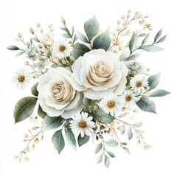

**Classic Bridal Hair & Makeup Package**

Bridal hair design

Placement of veil or hairpiece

Full makeup with conventional foundation

Brow shaping

Contour bronzer and shimmer

$ 175

**Attendant Hair & Makeup**

Hair style

Full makeup with conventional foundation

(price given with consultation)

