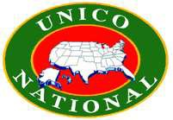
WESTWOOD CHAPTER

SUPPORT AUTISM!
Join WESTWOOD UNICO for
Our 14th Annual Pasta Dinner
TO BENEFIT CHILDREN WITH AUTISM & CHARITIES SUPPORTED BY WESTWOOD UNICO!
(Food, Tricky Tray, Raffles, Crafts for the Kids, and More)
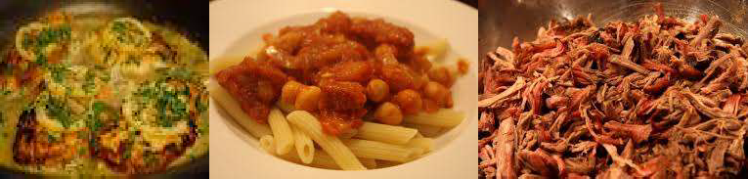

WHEN: Saturday, April 25th , 2026 at 5:00PM PLACE: Westwood Community Center
55 Jefferson Avenue, Westwood, NJ 07675 TICKETS: $30 Adults, Children 5-16 yrs. - $15,
Children under 5 are FREE!
To Purchase Tickets: Venmo @Stephen-Bifulco

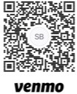

Contact allin4autism@yahoo.com or biffer@optonline.net for questions/information.
Walk-ins Welcome!

