This is an ICA (Independent Contract Agreement) for a 1099-MISC position for me the IC (Independent contractor) ____________ through FREEUM-LEOCMA LLC on the Arise Virtual Solutions Inc. platform. I understand that neither I the IC ____________ nor FREEUM-LEOCMA LLC work for Arise, and That I the IC ____________ am an IC with FREEUM-LEOCMA LLC who is an IBO (Independent Business Owner)/ VCC (Virtual Call Canter) on/with Arise. As the IC__________ I am responsible for my equipment, class time, background check, servicing time, schedule picking and metrics and all other requirements to work on the Arise Platform and keep an active SOW (Statement Of Work). FREEUM-LEOCMA LLC will maintain support and assistance in any faucet we can.

FREEUM-LEOCMA LLC is a Ministerial Business and is owned, operated, and conducted as so. We are founded and believe in the GOSPEL OF JESUS THE CHRIST. We are an Employment Embassy and hire all people within the Biblical and Legal perimeters. The core principles for FREEUM-LEOCMA LLC are as follows.
- DEUTERONOMY 8:18
- COLOSSIANS 3:22-24
- 2 THESSALONIANS 3:10
- ROMANS 13: 1-14
- PROVERBS 10:4-5
- PROVERBS 30: 5-6
- PROVERBS 14:23
- GALATIANS 6:4-5

Arise charges a Platform Usage Fee. The VCC agrees to pay Arise a bimonthly usage fee for the Arise Services (the “Platform Usage Fee”) of $19.75 for each of its Authorized Users listed in the Authorized User Appendix attached hereto. Arise will invoice VCC and VCC will pay the Platform Usage Fees on a bi-monthly basis (the “Invoice Periods”). The Invoice Periods will be from the 1st to the 15th of each month and the 16th to the end of the month.
EXAMPLE
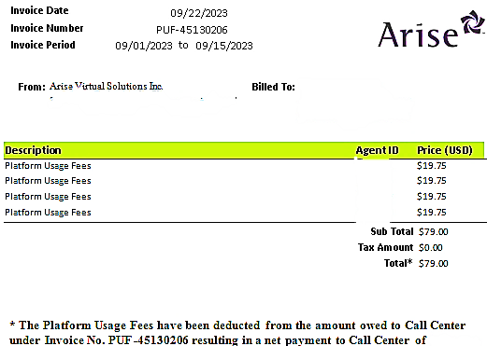

FREEUM-LEOCMA LLC does not charge the IC for the Platform Fee. FREEUM-LEOCMA LLC charges a Recruitment and Retention Fee at a Staffing Bill Rate of $60.00 on a bi-monthly basis for the invoice periods of the 1st to the 15th of each month and the 16th to the end of the month. No matter how many SOW’s you obtain or how much you earn the Recruitment and Retention Fee will stay the same. We don’t skim off the top; if the job pays $17.00 you get $17.00. Since you are an IC the Recruitment and Retention Fee comes from your NET. As an IC you will be given a 1099-MISC at the end of the year, WHICH HOLDS YOU SOLELY RESPONSIBLE FOR YOUR TAXES. FREEUM-LEOCMA LLC has the Next Business Day Direct Deposit, ease of access tax forms, digital and physical paystubs, and other incentives.

The sole purpose of this FREEUM-LEOCMA LLC ARISE ICA is for pure transparency on the job and company. If there is anything that you don’t understand or need clarification on with this FREEUM-LEOCMA LLC ARISE ICA, please do not hesitate to contact FREEUM-LEOCMA LLC. We can be contacted by PHONE (762) 444-3497, EMAIL: freeum.leocma@gmail.com or the website: https://freeumllc.com/. And lastly please make sure you understand everything within this contract and agree with it before you sign it. Welcome to the FREE FAM.

Head Steward/ Servant
Charles L Langston JR

FREE CREW
________________

DATE: ____________

