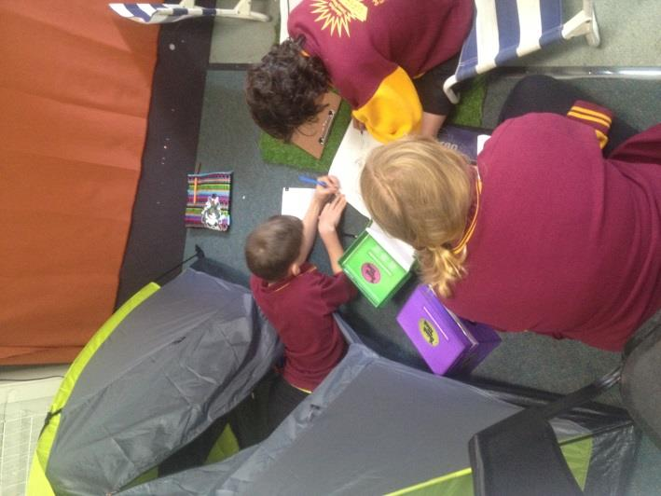 Our School community values:

Respectful interactions;

Effective communication;

Positive and active involvement in the process of learning;

Recognition of participation and achievement; and

Positive involvement in the community.

## As parents, staff and students we work together to support one another to uphold:

Respectful interactions.

* + A willingness to listen with an open mind;
  + Polite tone and use of language; and
  + Positive body language.

Effective communication.

* + 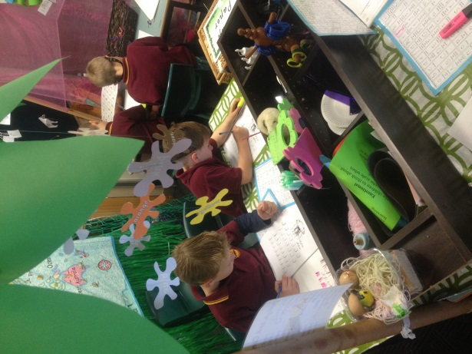Timely;
  + Conversations and meetings to be held at an agreed time;
  + To actively listen and take turns;
  + Keep calm and clear when presenting a point of view;
  + Direct concerns to the individual involved;
  + Use a variety of communication methods;
  + The responsibility to clearly communicate expectations; and
  + We work towards a solution even when we agree to disagree.

Positive and active participation in the learning process.

* + Encourage and support the learner;
  + Willing to take a risk/have a go;
  + Persistence;
  + Value the process of student centred learning;
  + All welcome to be part of the learning process;
  + Parents, students and staff working together to support the learning process;
  + Giving and receiving constructive feedback; and
  + The desire to challenge ourselves.

Recognition of participation and achievement.

* + Verbal and non-verbal praise;
  + We share milestones and progress through the newsletter;
  + We value the process and not just the end product;
  + Feedback from peers and self-assessment according to our 3 star work; and
  + Timely communication with students and parents regarding progress.

Positive involvement in the community.

* + Students show pride when representing our school within the community;
  + Parents, student and staff to show integrity during community involvement; and
  + Reciprocal relationships to foster community spirit.