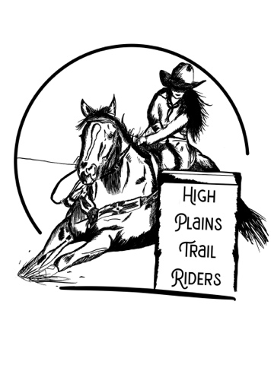

High Plains Trail Riders

Sponsor Form

|  |  |
| --- | --- |
| *GOLD*  *$250+* | *Platinum*  *$500+* |
| +Name/Business to be listed on our website.  +Flyers posted at all events.  +Recognition at our Year-End Awards. | + Name/Business to be listed on our website.  + Flyers posted at all events.  +Recognition at our Year-End Awards.  +Banner provided by HPTR to be posted at all events  + Logo/Name on HPTR T-shirts |

Amount of Sponsorship:

** Please attach a business card or art that you would like to be used for your advertisement.

|  |  |  |  |
| --- | --- | --- | --- |
| **Name:** |  | **Company:** |  |
| **Address:** |  | **City:** |  |
| **State/Zip:** |  | **Phone:** |  |
| **Email:** |  | **Web Address:** |  |

**Thank you for your support!**

[www.highplainstrailriders.com](http://www.highplainstrailriders.com)

[info@highplainstrailriders.com](mailto:info@highplainstrailriders.com)

(303)249-2956