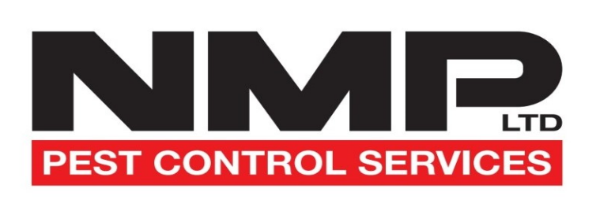
Issue 7 – January 2026
Working Hours
Quotation is based on work being carried out during normal working hours (Mon/Friday > 0830-1700). Work required to be carried out outside normal working hours will need to be advised in advance and quotation given if required.
Pricing
The price you will pay as a consumer (domestic) customer will, unless specified otherwise include VAT and the price you will pay as a commercial (business) client or customer will be excluding VAT. The confirmed price will be either sent over via email or over phone conversation, service agreements will need to be signed and agreed with customers.
Termination
This agreement shall begin on the date you accept our quotation as set out in the service agreement.
If we are performing regular service visits then unless otherwise stated, this agreement shall continue for a minimum of one year and a rolling service will just continue.
After the minimum period, the agreement will continue on a yearly basis unless terminated.
To terminate there must be at least 3 months written notice of termination given and valid reasons why.
If the customer cancels early they agree to pay half of the remaining agreed contract value.
Payment terms
Payment terms are agreed on the service agreement form and payment needs to be made within 30 days of the invoice. (Unless stated differently)
Callouts
Callouts during normal working hours (Mon/Friday > 0830-1700) will be free of charge anything relating to Rats or Mice only unless specified in the service agreement.
Other charges have been detailed in the contact information.
All prices given exclude VAT
Vat No: 389909422
Company Reg: 12308078
Address: C/O Crown Group Office, 247 Broad Street, Crewe, CW1 4JJ
Email: info@nmplimited.co.uk

