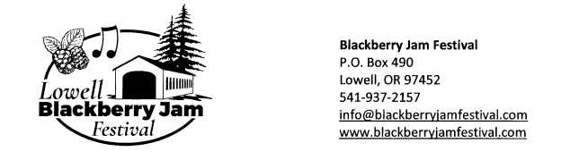Dear Friends,

The Lowell Blackberry Jam Committee is pleased to let you know that we will be having the festival again this year. We know it has been a tough couple of years for us all and are looking forward to bringing the community together on July 30th and 31st in downtown Lowell Oregon.

We appreciate your support in the past and we hope that you will consider giving again this year. Due to not having the festival for a couple of years we are scaling back some activities but promise a good time for all. We will not have the multiple sponsorship levels that we have had in the past and would ask that you give what you feel you can.

All sponsors are welcome to provide us with a banner to be displayed on the Lowell Amphitheatre stage and will have your name announced throughout the festival as a sponsor.

The sponsorship deadline is July 15th as well as you need to have your banner to Lowell City Hall by July 15th to have it placed at the festival.

**Checks can be mailed to**:

City of Lowell

ATTN: Black Berry Jam Committee

PO Box 490

Lowell, Or 97452

**Please make checks payable to City of Lowell add BBJ in memo please.**

For more information or questions, you may please contact Rustie Ackland @ 541-726-7211 or 541-731-4146.

Name of business: ___________________________________________________________

$100 _____

$200 _____

$500 ______

Other ______

Thank you so much for your sponsorship and we hope to see you at the Festival!

Rustie Ackland

Blackberry Jam Festival Committee member