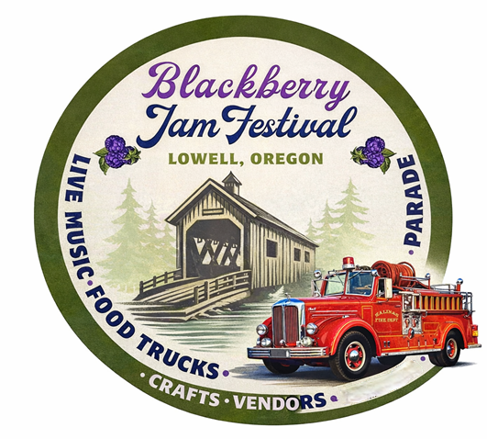
Blackberry Jam Festival
P.O. Box 490
Lowell, OR 97452
www.blackberryjamfestival.com

Yes! I would like to be a Sponsor for the
2026 Blackberry Jam happening July 24-26, 2026.
Sponsors are entitled to have their company name printed on the Blackberry Jam Festival T-shirt which is given to all registered Car Jam participants and sold at the event. Deadline to have your name/logo printed on the T-shirt is May 1, 2026.

- The opportunity to promote my business through donations for the goody bags given to all Car Jam participants.

- My choice of level of sponsorship is:

* Platinum BBJ Jam Sponsor: ______$1000 *Silver BBJ Jam Sponsor: ______$300
* Gold BBJ Jam Sponsor: ________ $500 *Bronze BBJ Jam Sponsor: _____$150
Thank you in advance for your participation in the Blackberry Jam Festival. Please indicate above your choice of sponsorship, and return with check to:
Blackberry Jam Festival, P.O. Box 490, Lowell, OR 97452.

To pay by credit card call 541-937-2157 M-Th 8–12 & 1-5:30 (forms can be submitted via email to sam.dragt@lowelloregon.gov) or return this portion of the form with payment. For tax purposes you may use tax reference #93-6011170.

Name ________________________________ Company Name ____________________________________
Phone Number _____________________ E-Mail Address ________________________________________
Banner that you would like to have displayed? Drop off at 70 N Pioneer prior to event.

Deadline for sponsor’s name/logo to be on the T-shirt is May 1, 2026.

As is our tradition, great events are planned to happen every day of the Blackberry Jam Festival. These events include, Parade, Horseshoes, Classic Car Show “Car Jam”, Greased Pole Climb to name of few, crafters and continuous live music on the Main Stage every day. We have always experienced great participation from the local community as well as visitors from outside the immediate area. We hope that you will join us!
Logo attached _______________

