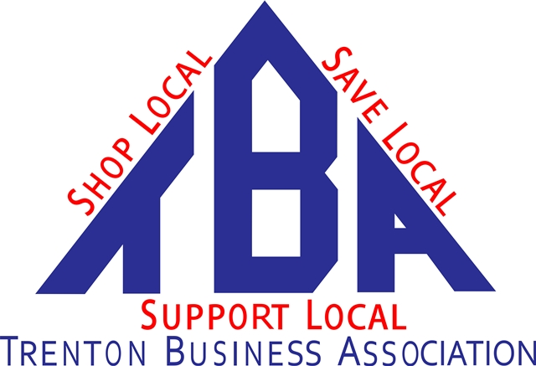
In Trenton We Mean Business!

TBA President Job Description-Updated

Amends Article VII-Officers 11/8/19

Responsibilities:
Oversee all elements of the organization and enlist the participation of other TBA members to accomplish goals and objectives
- Actively recruit new members
- Follow up on all potential members as directed by board
- Send input for Monthly e-mail to Admin
- Run TBA booths at various Business/Social Events-Host Toast to Trenton Elected Officials, Represent TBA at State of the City Event, present Business of the year
- Work with admin to update Web site after monthly meeting with photo, new members, and changed events/venues
- Set Locations for meetings, order food as needed, call in counts to meeting locations with admin
- Conduct monthly board and membership meeting and provide monthly agenda

Oversee chair positions:
Marketing-Send press releases, ideas for communicating better to members
Membership-Recruit new members, update and coordinate member labels, listings, web site monthly
Events-Communicate all relevant Trenton events to membership
Elections-Conduct election search beginning in September with nominations

