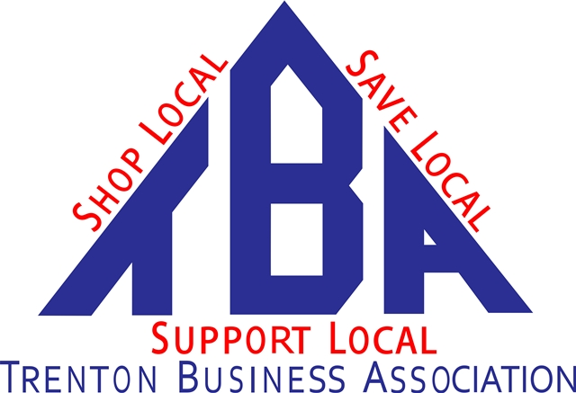
In Trenton We Mean Business!

TBA Treasurer Job Description-Adopted

Amends Article VII-Officers 11/8/19

Responsibilities:
- Actively recruit new members
- Follow up on all potential members as directed by board
- Provide ideas, suggestions, comments for TBA advancement at monthly meetings and at board meetings
- Check PO Box weekly and distribute mail to board as needed
- Send monthly mailing out by the 1st of the month
- Account of all funds and report at monthly meetings
- Provide an annual report and budget
- Help run TBA booths at various Business/Social Events

