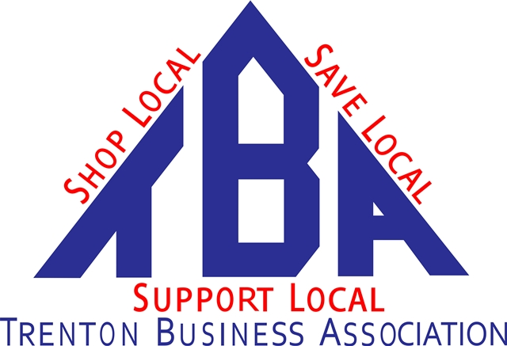
In Trenton We Mean Business!

TBA Vice President Job Description-Adopted

Amends Article VII-Officers 11/8/19

Responsibilities:
- Actively recruit new members
- Follow up on all potential members as directed by board
- Help update Biz Directory Yearly with Park & Rec
- Help run TBA booths at various Business/Social Events
- Provide ideas, comments, suggestions for advancement of TBA at meetings
- Run monthly board and/or member meeting in absence of President

Consider chair positions:
Marketing-Send press releases, ideas for communicating better to members
Membership-Recruit new members, update and coordinate member labels, listings, web site monthly
Events-Communicate all relevant Trenton events to membership
Elections-Conduct election search beginning in September with nominations

