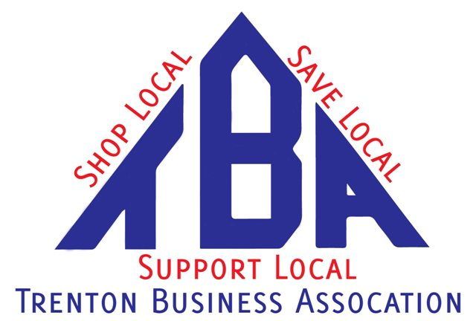
TBA Leadership Scholarship Award
The Trenton Business Association is offering 2 $500 scholarships to a Class of 2026 graduating senior attending Trenton High School or a current Trenton resident who will graduate from another area high school this coming spring.

Additional qualifications for applying for this annual award include: A minimum 2.5 grade-point average, demonstration of some degree of community involvement, the intention to enroll at a college, university or trade school.

The application also requests brief answers to 3 out of 5 of the following questions:
- What non-academic accomplishment of yours are you most proud of?
- What has been your greatest inspiration?
- What is happening in the world right now that makes you hopeful?
- What is happening in the world right now that you would work to change?
- What ideas do you have to improve your community?
Note: Content plagiarism will be checked and grammar and punctuation will be considered. Top candidates will be invited to interview with the TBA board.

Trenton High students can obtain the application from the counseling office. It also can be downloaded from the TBA’s Web site at www.trentonbiz.com, or be obtained by mail by calling 676-9561.

The TBA comprises more than 75 businesses operating in Trenton and nearby communities. The organization is dedicated to promoting its members and the Trenton community at-large through sponsorships of community programs, by developing business relationships, holding networking meetings and through the media.

Along with providing the TBA Business Scholarship, the organization also sponsors programs to recognize Trenton’s “Business of the Year”.

New members are always welcome to join. Annual dues are $175.

Students scholars and a guest will also be invited to the Salute to Education lunch with the TBA and Trenton Rotary to be recognized.

The Trenton Business Association is offering 2- $500 scholarship’s to a class of 2026 (The Bradley Davidson Scholarship and the TBA Leadership Scholarship) THS/Resident of Trenton student with the following qualifications:

- GPA= 2.5
- Demonstrate some degree of community involvement
- Enrolled at a college, university or trade school
- The application also requests brief answers to 3 out of 5 of the following questions:
- What non-academic accomplishment of yours are you most proud of?
- What has been your greatest inspiration?
- What is happening in the world right now that makes you hopeful?
- What is happening in the world right now that you would work to change?
- What ideas do you have to improve your community?
*Note: Content plagiarism will be checked and grammar and punctuation will be considered. Top candidates will be invited to interview with the TBA board.

Also… a promise to follow up with the group after school begins to tell us how you’re doing.
TBA Leadership Scholarship Award

Name______________________________

GPA_______________________________

College Attending_________________________________________________________

Curriculum______________________________________________________________

* Attach your 3 answers to the above questions

*$500 (min) Scholarship

Return form to counseling office by: March 1, 2026
Or
TBA att: Scholarship Committee
PO Box 4
Trenton, MI. 48183

