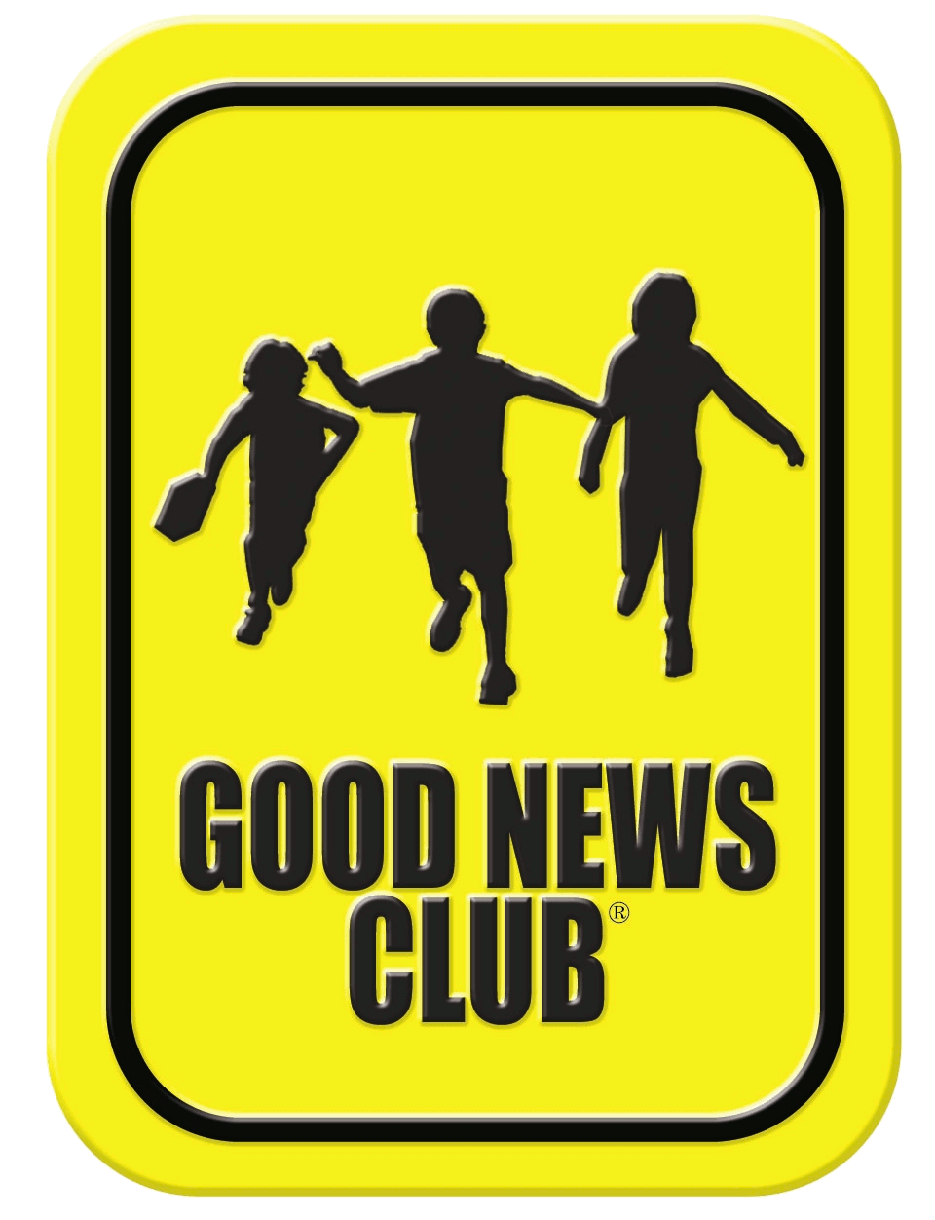
Thank you for your interest in our online Good News Club. All children are welcome with their parent’s permission. Parents are also welcome.
Online Good News Club® Registration Form

This registration is for the online Good News Club hosted by: Hope Fellowship Church, Branson West, Missouri
Dates: Mondays from Nov 9, 2020 through Apr 26, 2021. (No club on December 21, December 28, January 4, and March 15.)
Time: 4:00 – 5:00 P.M.
List children’s names and grades.
First Name: Click or tap here to enter text.  Last Name: Click or tap here to enter text.  Grade: Click or tap here to enter text. | First Name: Click or tap here to enter text.  Last Name: Click or tap here to enter text.  Grade: Click or tap here to enter text.
First Name: Click or tap here to enter text.  Last Name: Click or tap here to enter text.  Grade: Click or tap here to enter text. | First Name: Click or tap here to enter text.  Last Name: Click or tap here to enter text.  Grade: Click or tap here to enter text.

Name of School: Click or tap here to enter text.
County: Click or tap here to enter text. State: Click or tap here to enter text.

Family email address: Click or tap here to enter text.

Family phone number: Click or tap here to enter text.

☐ My children, listed on this form, have permission to attend the CEF online Good News Club.

Parent/guardian signature: Click or tap here to enter text. Date: Click or tap to enter a date.
(NOTE: On electronic forms, your typed signature has the same effect as your written signature.)

When we receive your completed registration form we will send information on how to access the online Good News Club. For your child’s safety, only children with permission from parents may attend. Also, teachers in our clubs have been screened according to the Child Protection Policy of Child Evangelism Fellowship.

Children may invite friends by using a copy of this Registration Form and/or Invitation Flyers which are available by contacting Brenda Rosser, brendarosser@aol.com.

Return completed form to brendarossser@aol.com or print and mail to:
Brenda Rosser
Hope Fellowship Church
PO Box 614
Kimberling City, MO 65686

Please feel free to contact us with questions. BRENDA ROSSER, brendarosser@aol.com, 636-290-1328.

Good News Club is a ministry of Child Evangelism Fellowship®.

