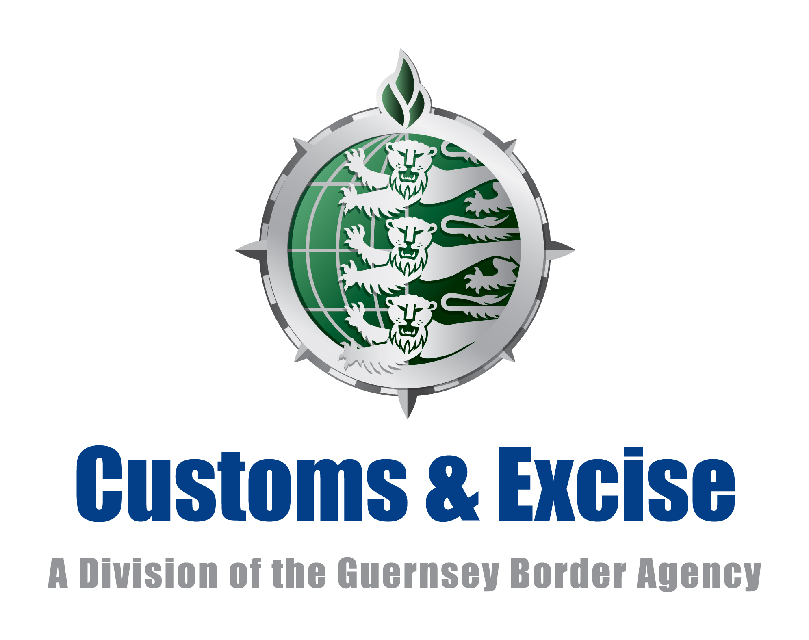 | Importation into the Bailiwick of Guernsey  of personal or household effects  from within the Customs Union | C15

The countries of the Customs Union are:-
United Kingdom, Isle of Man & the Channel Islands.

Details of Consignment

Name in Full:

Address:

Number of packages
Date imported into Guernsey
Vessel / aircraft
Country from which imported

Importers’ Declaration

ANY UNTRUE STATEMENT MAY LEAD TO PENALTIES AND FORFEITURE OF THE GOODS CONCERNED.

You MUST DECLARE the quantity and description of the following articles.
If NONE write ‘NONE’ against each item of the category of goods listed below.

 | Description | Quantity
Spirits & Liqueurs
Wine
Cigarettes
Cigars & Cigarillos
Tobacco
Prohibited* or Restricted** Goods
Goods for Commercial Use

*Prohibited goods

There are some goods that you cannot bring into Guernsey. They will be seized by Customs and you may be prosecuted. These goods include:

- Illegal drugs – such as heroin, cocaine, cannabis and derivatives, synthetic cannabinoids, amphetamines, ketamine,, LSD and MDMA (ecstasy)
- Offensive Weapons – such as flick knives, butterfly knives, knuckledusters, sword sticks, batons, throwing stars, samurai swords and some martial arts equipment
- Self-defence sprays i.e. pepper spray, CS gas, mace
- Electric shock devices such as stun guns
- Indecent and obscene materials

**Restricted goods

Some goods are restricted and you will need a specific licence to bring them into Guernsey. Without such a licence they may be seized by Customs and you may be prosecuted. These goods include:

- Firearms and component parts of firearms, ammunition and explosives (including fireworks)
- Animals & Birds
- Certain medicinal products (including prescription medication)
- Cash including bullion, travellers cheques and precious metals
- Endangered Species whether alive or dead, including goods made from them like fur, ivory and reptile leather.
- Uncooked meats and poultry
- Certain plants, trees, shrubs, potatoes, fruit and vegetables

Signature | Date

