The Air Of The Dog LTD  
www.theairofthedog.co.uk 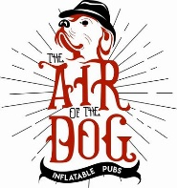  
Instagram: @theairofthedog

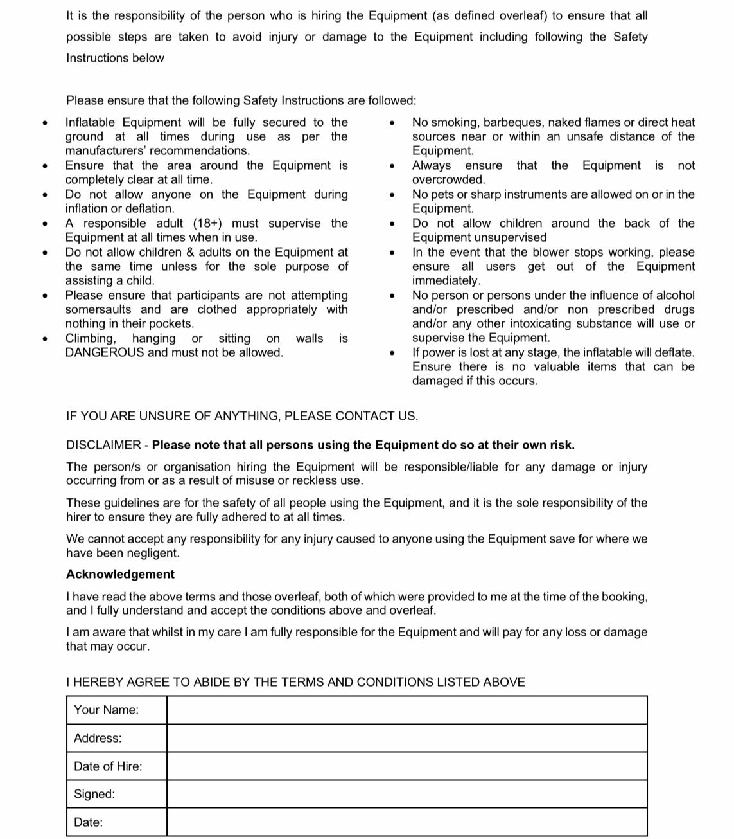





Cleaning – At the end of the hire, it is your responsibility to ensure that the pub is clear of rubbish and any additional items that is not provided by us are removed before we arrive to collect. Failure to do so will see a cleaning charge of £100. Strictly no smoking in the inflatable pub. Evidence of smoking will see the organiser responsible for £100 fine. It’s the lead bookers responsibility to highlight any road restrictions located at the venue. This includes permits and permissions. Any fines fall to the lead booker. Please note lead booker is responsible for ANY damages to the pub whilst in their care.

Please note when booking you are agreeing to suitable access of 1.2m. If we arrive at the venue to access below that we will endeavour to try our best to install the equipment. If we are unable to install any equipment to to limited access then these items are not eligible for a refund.



BY PAYING A DEPOSIT AND BOOKING WITH THE AIR OF THE DOG YOU AGREE TO ALL T&Cs LISTED ABOVE

The Air Of The Dog  
www.theairofthedog.co.uk   
Instagram: theairofthedog 

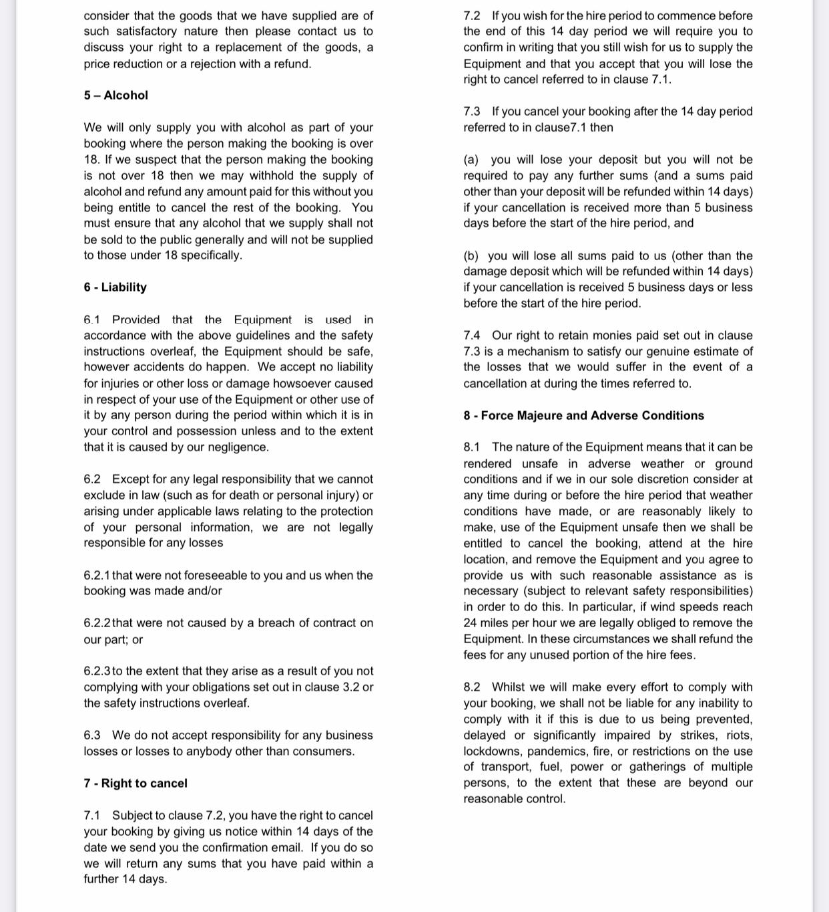

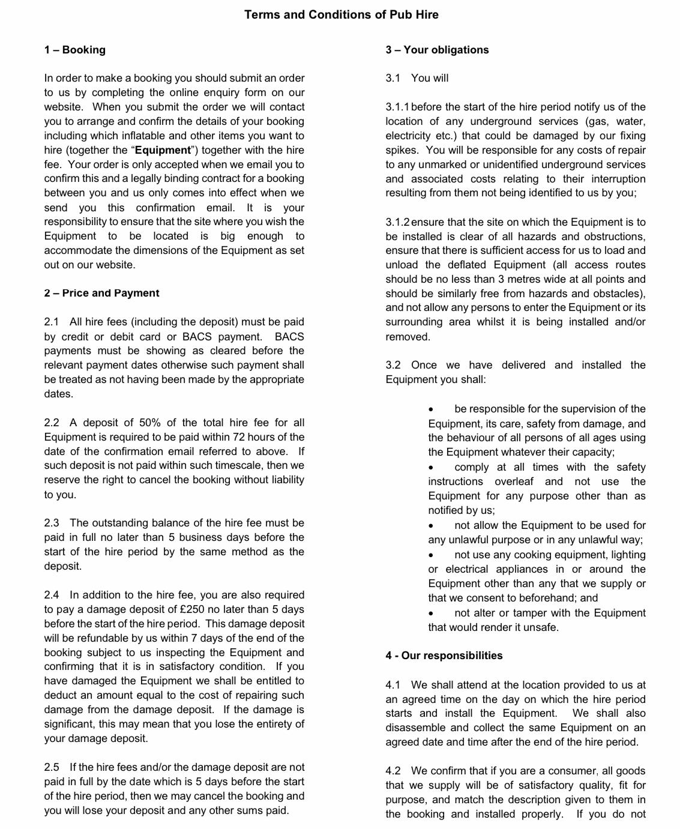The Air Of The Dog  
[www.theairofthedog.co.uk](http://www.theairofthedog.co.uk)  
Instagram: theairofthedog

4 weeks

A deposit of £75