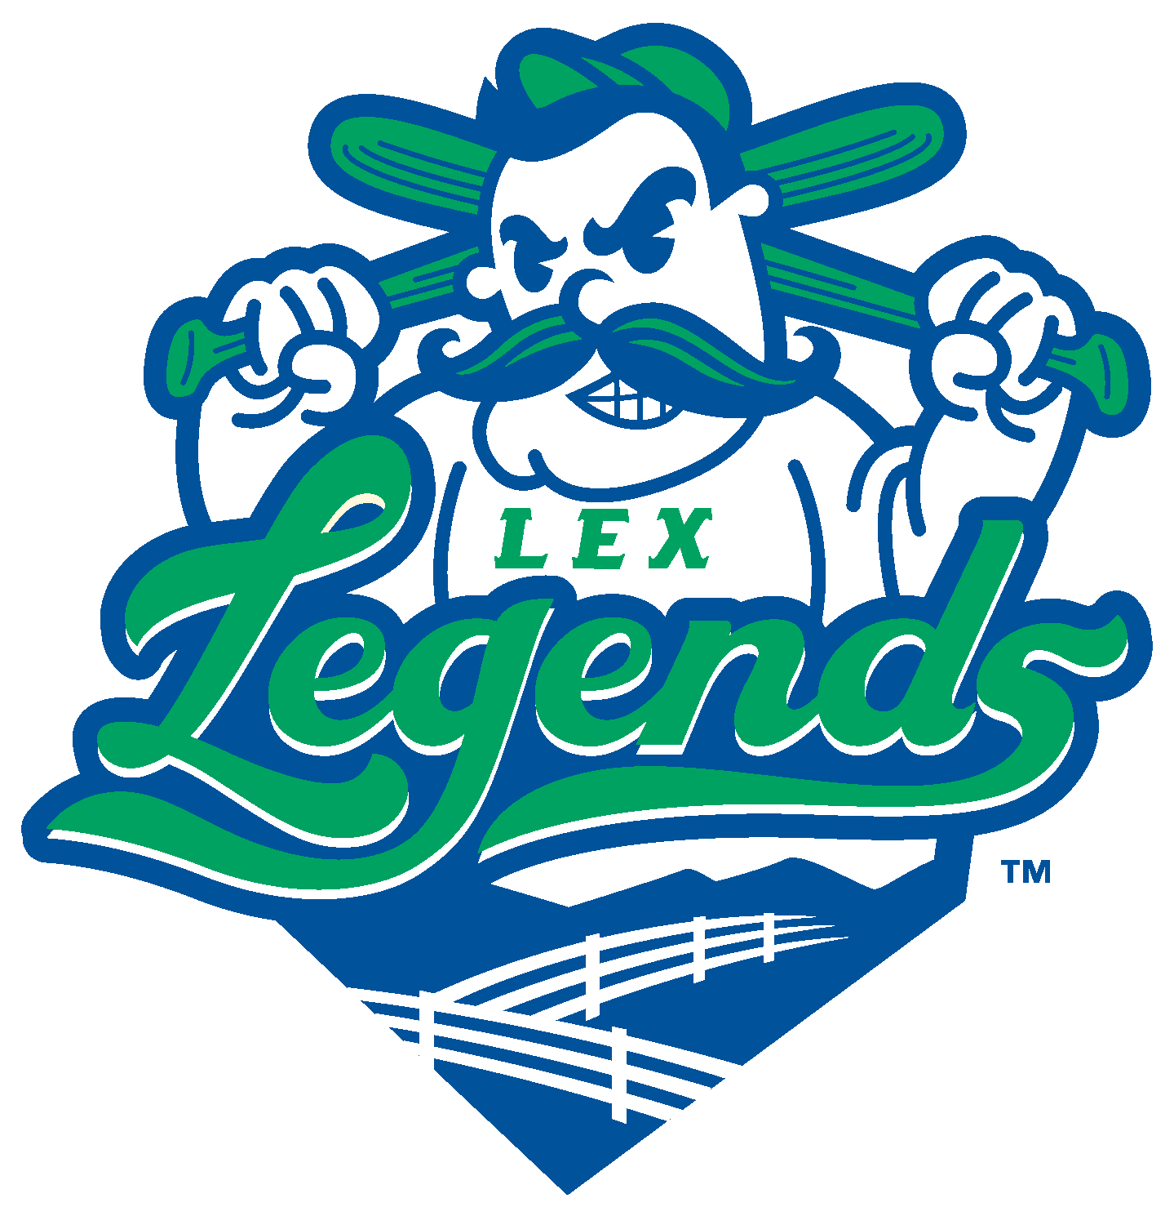

PRESS RELEASE
Media Contact: Andrew Murphy For Immediate Release
P: 314-566-7511 September 9th, 2020
E: amurphy@lexingtonlegends.com

Lexington Legends Announce Postseason Activities
Historic Battle of the Bourbon Trail to be extended by a week

Lexington, KY — The Lexington Legends are proud to announce postseason plans, which will serve as the conclusion for this year’s unique Battle of the Bourbon Trail season! All of the following events will be open to the media and general public in accordance with COVID-19 rules and regulations.

The postseason kicks off at 7:00 pm on Wednesday, September 16th with a bang, as eight Legends/Leyendas players will swing for the fences in the Battle of the Bourbon Trail Home Run Derby. Fans will be treated to 25-cent hot dogs, presented by Kentucky Coal Association!

The festvities will continue Thursday, September 17th, with one final Stache Showdown! The Lexington Legends and Leyendas de Lexington will face off in what is sure to be an electric final exhibition game between two talented and star-studded home teams. Plus, join us as always for Thirsty Thursday, presented by Lexington Brewing and Distilling Company! Drink specials include $2 domestic cans and $3 Kentucky Ale products. First pitch is at 6:50 pm.

The fun lives on all the way through the weekend! All-star teams from Florence and Lexington will battle out a best-of-three playoff series on September 18th and 19th in Florence and Lexington respectively. First pitch for both games is scheduled for 6:50 pm. If a third game is necessary, the two teams will play in Lexington on Sunday, September 20th at 2:15 pm to determine the series winner and Battle of the Bourbon Trail Champion!

All of these events will be the last chances this year for fans to see MLB stars such as Ben Revere, Brandon Phillips, and Robbie Ross Jr. sport a Lexington uniform.

In a time where so many in sports have been told “No,” the Lexington Legends have proudly persevered and worked hard towards a baseball season to be enjoyed by the resilient and dedicated citizens of the city of Lexington. We hope you will join us at Whitaker Bank Ballpark for the finale to this historic and innovative season!

