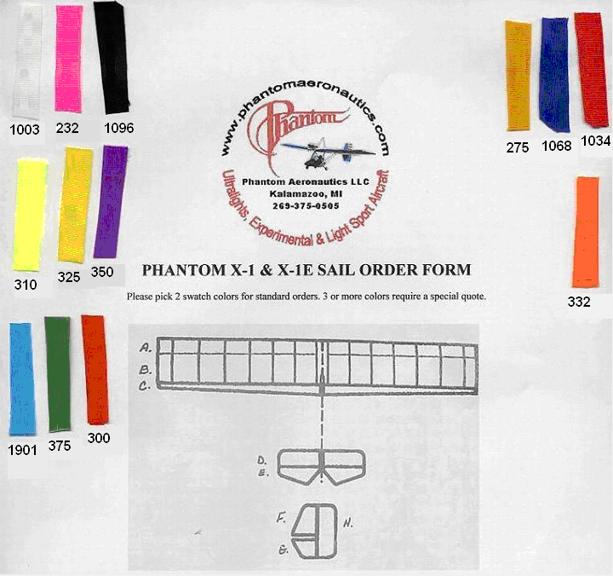
Fill in Color Choices here.
A_______________ B_______________ C_______________ D_______________

E_______________ F_______________ G_______________ H_______________

Name: _________________________________________________________________________________

Address: _______________________________________________________________________________

Phone: ________________________________________________________________________________
Phantom Factory Fax: 269-592-5908 Phantom Factory Phone: 269-375-0505
(1003 – White) (232 – Pink) (1096 – Black) (310 – Fluorescent Green) (325 – Yellow)
(350 – Purple) (1901 – Light Blue) (375 – Green) (300 – Red Orange)
(275 – Gold) (1068 – Blue) (1034 – Red) (332 – Florescent Orange)

