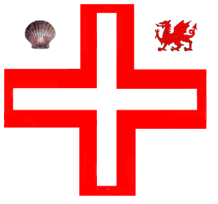

Province of South Wales
(Talaith De Cymru)
Toast list
(January 2023)

The Commemoration
(to be drunk silently, seated and with the left hand.)
"To the Pious Memory of St. Thomas à Becket and the
Glorious Memory of the Knights of the Order who fought in the Crusades"
The King

The Most Worthy Grand Master
Sir Melvyn of Wud Plumpton, KH

The Most Eminent Grand Prior
Sir Philip of Hamilton, KH
and the rest of Grand Officers, present and past

The Right Worthy Grand Preceptor
Sir Wayne of Waunarlwydd, KC

The Right Eminent Provincial Grand Prior
Sir Nigel of Twyn
and the rest of the Provincial Grand Officers, present
and past

The Worthy Master

The Newly Installed Knight(s)*

The Visitors*

The Sentry's Toast
"To our next Merry Meeting"

* All mandatory except the Newly Installed Knight(s) and the Visitors.

