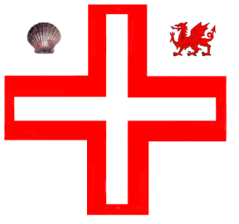

Province of South Wales

(Talaith De Cymru)

**Toast list**

The Commemoration   
(to be drunk silently, seated and with the left hand.)

"To the Pious Memory of St. Thomas à Becket and the

Glorious Memory of the Knights of the Order who fought in the Crusades"

The Queen

The Most Worthy Grand Master

Sir Melvyn of Wud Plumpton, KH

The Most Eminent Grand Prior

Sir Lee of Bromley by Bow, KH

and the rest of Grand Officers, present and past

The Right Worthy Grand Preceptor

Sir Wayne of Waunarlwydd, KC

The Right Eminent Provincial Grand Prior

Sir Vivian of Margam

and the rest of Provincial Grand Officers, present and past

The Worthy Master

The Newly Installed Knight(s)*

The Visitors*

The Sentry's Toast  
"To our next Merry Meeting"

* All mandatory except the Newly Installed Knight(s) and the Visitors.