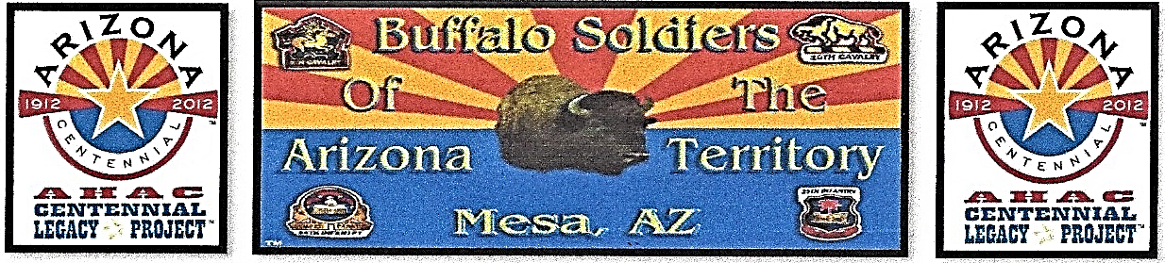
BUFFALO SOLDIERS AZ TERRITORY MONUMENT
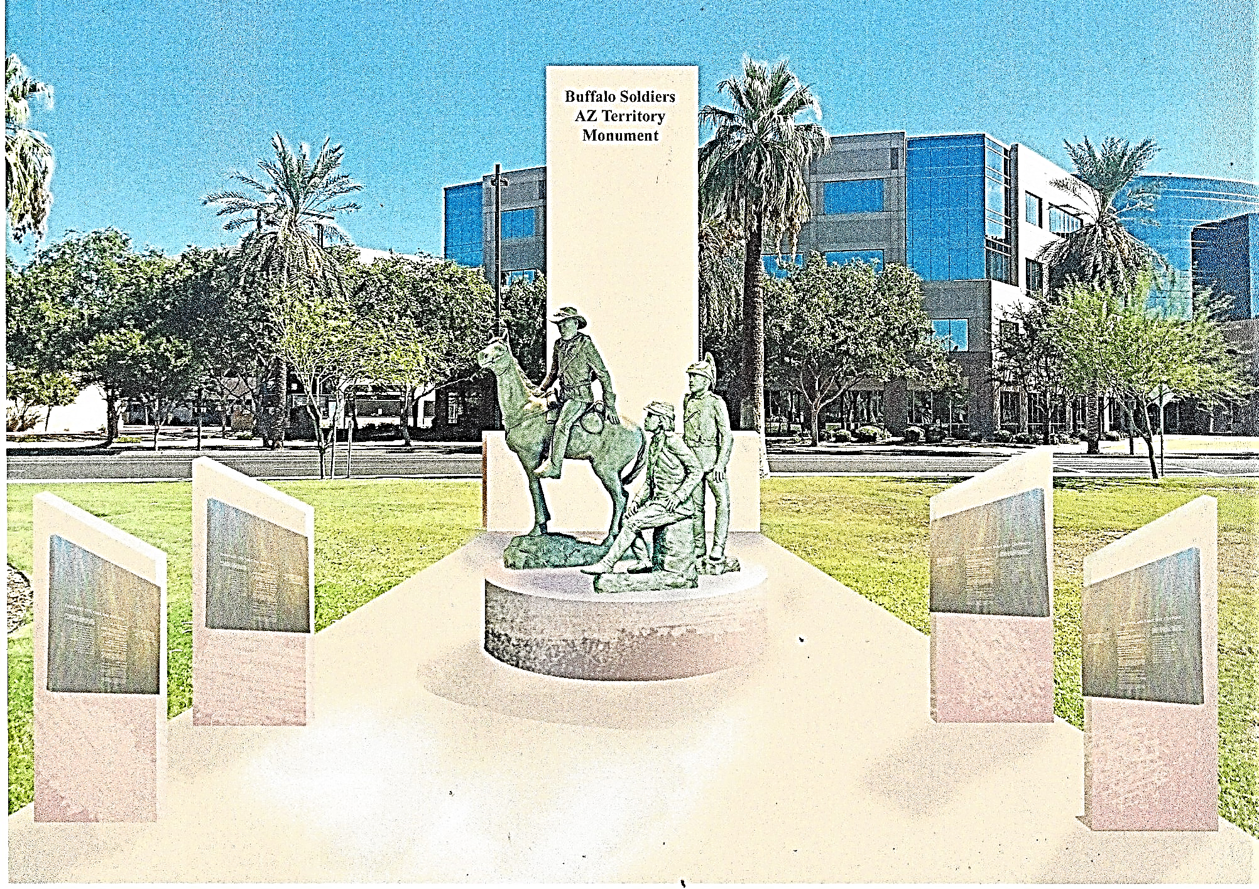
Arizona State Capitol Wesley Bolin Memorial Plaza, Phoenix, Arizona
Help Our Cause – Fundraiser $440,436.00
SPONSORSHIP
Greetings Sponsor,

Let us introduce ourselves to you. We are Commander Fred Marable and Deputy Commander Michelle London-Marable, founders of the Official Arizona Centennial Legacy Buffalo Soldiers of the Arizona Territory – Ladies and Gentlemen of the Regiment, Headquarters Mesa, Arizona. Founded: December 3, 2007. We had participated in 330 events. October 28, 2016, Commander Fred Marable was inducted into The Arizona Veterans Hall of Fame as a Vietnam Veteran and a Buffalo Soldier re-enactor. Proponent of the Official State Proclamation ‘Buffalo Soldiers Day’, June 19, 2009 to present. In 2011, Best of the West True Source Book and True West History of Frontier named the organization as the ‘Historical Societies Group’ for the State of Arizona. In 2011, Featured in the Centennial Legacy ARIZONA 100 Years Grand Book. We are an Independent Organization and a Non-profit 501(c)(3) and Federal Tax-Exempt EIN: 51-0662449. Arizona Corporation Commission, Filed Number: 28871971.

The purpose and mission of the organization is ‘Keeping History Alive’ by educating people about the significant contributions of the Buffalo Soldiers, 9th and 10th Cavalry and 24th and 25th Infantry, 1866 – 1902 legacy.
On April 5, 2018, Senate Bill 1179: Memorial Buffalo Soldiers Monument was approved and signed by Arizona Governor Doug Ducey. Our organization is the proponent for the SB1179 Bill Memorial: Buffalo Soldiers and is solely commissioned with responsibility to erect a monument located at the State Capitol Wesley Bolin Memorial Plaza.
Buffalo Soldiers were very active and posted from Montana in the Northwest to Texas, New Mexico and Arizona in the Southwest. The State of Arizona now wishes to honor those courageous Black men and women by establishing a monument in their honor. The State has authorized and dedicated land for a Buffalo Soldiers AZ Territory Monument in the governmental mall area in front of the State Capitol in Phoenix.
GOALS
- One year to raise the funds, Year: 2018 through December 2019
- One year to erect the monument
- Unveiling date proposal: Year 2020

Websites - BUFFALO SOLDIERS AZ TERRITORY MONUMENT: https://www.buffalosoldiersazterritorymonument.com.
BUFFALO SOLDIERS OF THE ARIZONA TERRITORY – LADIES AND GENTLEMEN OF THE REGIMENT, MESA, ARIZONA https://www.buffalosoldiersaztrtry.smugmug.com. GOFUNDME – Buffalo Soldiers AZ Territory Monument

I you have any questions, we can be reached at email: mlondon3@cox.net and Cell: 480-415-5439.

Sincerely,
Commander Fred Marable, Founder Date: April 5, 2018
Deputy Commander Michelle London-Marable, Founder
Board of Directors: Commander Fred Marable, Deputy Commander Michelle London-Marable, Representative Richard Andrade, Reggie Yates, Major USA Retired Army (Unified Arizona Veterans), Robert E. Welch, Colonel USA Retired Army (Unified Arizona Veterans), Hal Stewart (Artist), Lemuel Yorahee (Buffalo Soldier of the Arizona Territory), Sharon Kilmer (Film Production), Gary Williams and John Robinson (West Point Academy Graduates).
Page 1 of 3 Copyright © BSAZTRTY-LGR 2007 – 2019
ALL SPONSORS WILL HAVE THEIR NAMES INCLUDED ON A PERMANENT PLAQUE ON THE MEMORIAL WALL

BUFFALO SOLDIERS AZ TERRITORY MONUMENT DINNER
SPONSORSHIP OPPORTUNTIES

MEDAL OF HONOR SPONSOR Event Sponsor - $25,000
- Logo recognition on invitation and event program.
- Logo recognition on all secured in-kind prints, electronic advertisements and organization website.
- One color full-page advertisement in event program.
- Two tables of 10 to attend the annual Buffalo Soldiers AZ Territory Monument Dinner.
- VIP seating at the Buffalo Soldiers AZ Territory Monument Dinner.
- Special Remarks at the dinner.
- Sponsor will receive an 11” x 17” framed organization picture, Buffalo Soldier plaque, Organization’s portfolio book and acknowledgement certificate.
VALOR SPONSOR - $20,000
- Logo recognition on invitation and event program
- Logo recognition on all secured in-kind prints, electronic advertisements and organization website.
- One color full-page advertisement in event program.
- One table of 10 to attend the annual Buffalo Soldiers AZ Territory Monument Dinner.
- VIP seating at the Buffalo Soldiers AZ Territory Monument Dinner.
- Sponsor will receive an 11” x 17” framed organization picture, Buffalo Soldier plaque, Organization’s portfolio book and acknowledgement certificate.
SILVER STAR SPONSOR - $15,000
- Logo recognition on invitation and event program
- Logo recognition on all secured in-kind prints, electronic advertisements and organization website.
- One color full-page advertisement in event program.
- One table of 10 to attend the annual Buffalo Soldiers AZ Territory Monument Dinner.
- Sponsors will receive an 11” x 17” framed organization picture, Buffalo Soldier plaque, Organization’s portfolio book and acknowledgement certificate.

BRONZE STAR SPONSOR - $10,000
- One half page ad in program book
- Logo recognition on all secured in-kind prints, electronic advertisements and organization website.
- Sponsor recognition during program event
- Eight tickets to the Buffalo Soldiers AZ Territory Monument Dinner.
- Sponsor will receive a 10” x 12” framed organization picture, Buffalo Soldier plaque and acknowledgement certificate.

Page 2 of 3 Copyright © BSAZTRTY-LGR 2007 - 2019
BUFFALO SOLDIERS AZ TERRITORY MONUMENT DINNER
SPONSORSHIP OPPORTUNTIES

BUFFALO SOLDIERS - $5,000
- One half page ad in program book
- Logo recognition on all secured in-kind prints, electronic advertisements and organization website.
- Sponsor recognition during program event
- Six tickets to the Buffalo Soldiers AZ Territory Monument Dinner
- Sponsor will receive 10” x 12” framed organization picture, Buffalo Soldier plaque and acknowledgement certificate.

MERITORIOUS SERVE SPONSOR - $2,500
- Name in the program book.
- Logo recognition on all secured in-kind prints, electronic advertisements and organization website.
- An Assigned Table of 4
- Sponsor will receive a 10” x 12” framed organization picture, two Buffalo Soldiers of the Arizona Territory’s Polo shirts, and acknowledgement certificate.

Sponsors and Partners
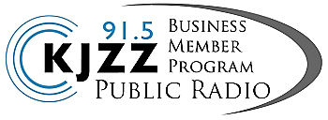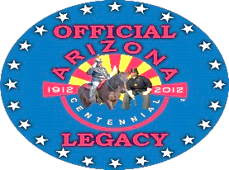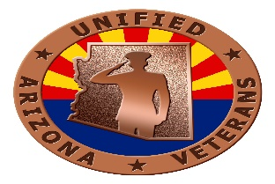
Page 3 of 3 Copyright © BSAZTRTY-LGR 2007 - 2019

