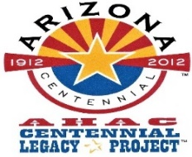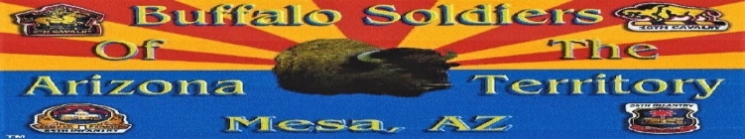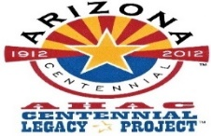
Buffalo Soldiers AZ Territory Monument
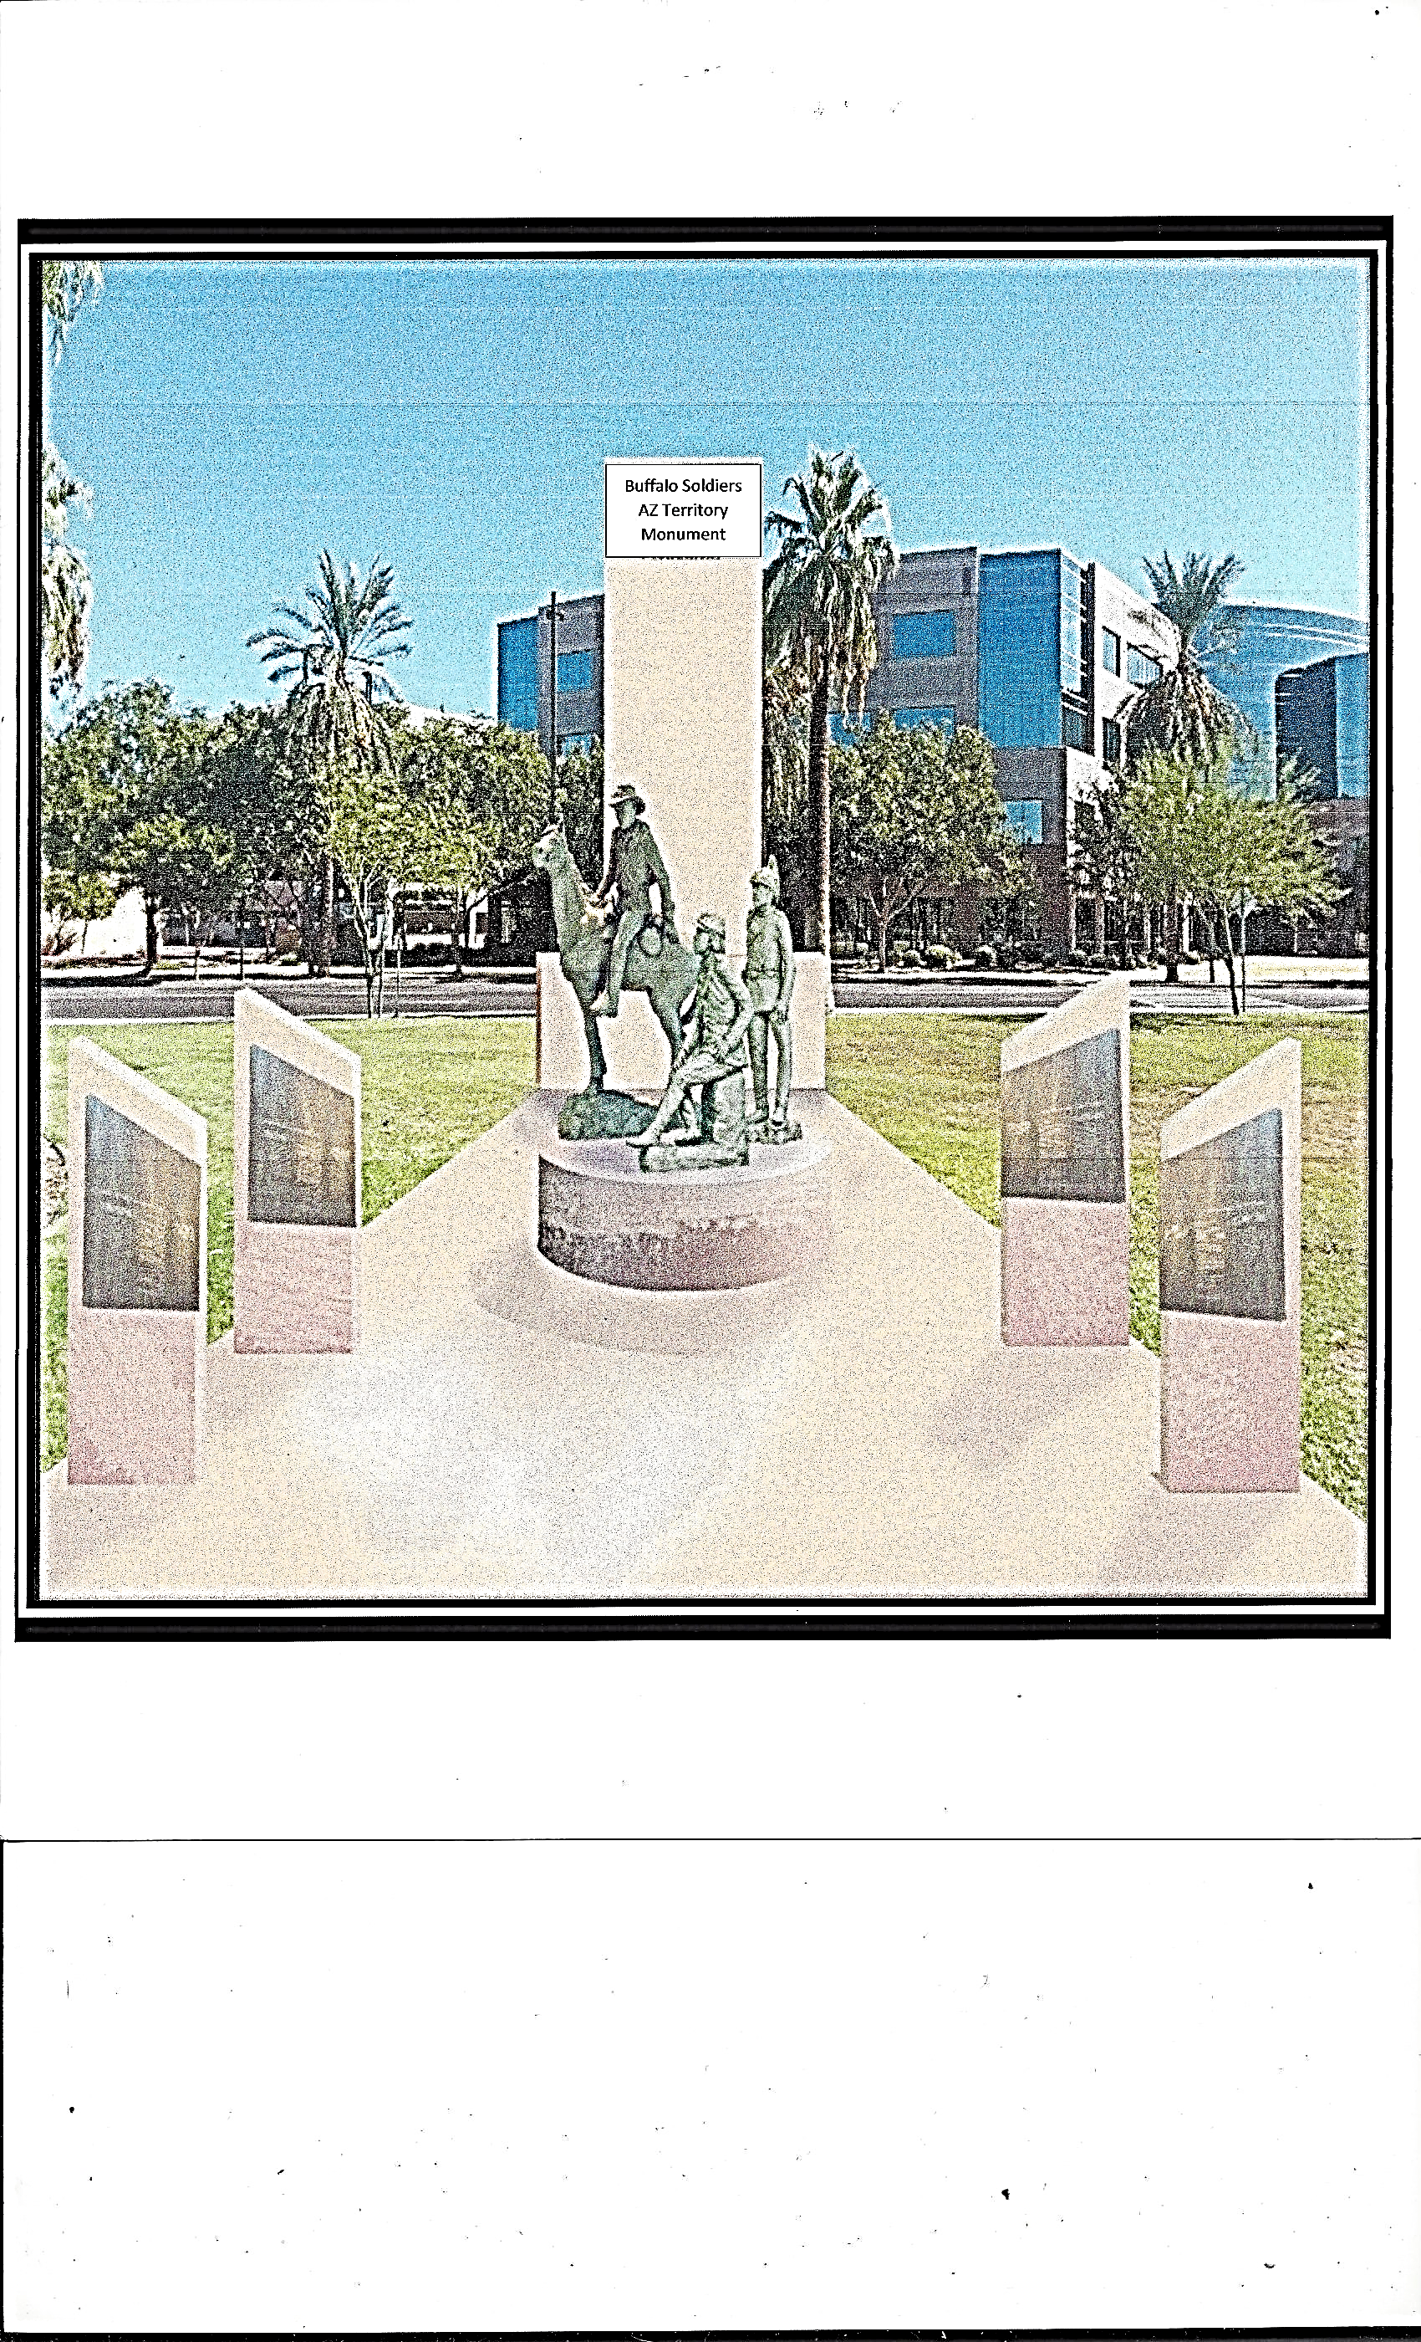
Arizona State Capitol’s Wesley Bolin Plaza, Phoenix, Arizona

HELP OUR CAUSE – FUNDRAISER
$440,436.00
Donation

The Official Arizona Centennial Legacy Buffalo Soldiers of the Arizona Territory – Ladies and Gentlemen of the Regiment based in Mesa, Arizona is an Independent Organization, Non-profit 501(c)(3) and Federal Tax-Exempt, EIN 51-0662449 organization. Title: Buffalo Soldiers AZ Territory Monument, Arizona Corporation Commission, Filed Number: 28871971. The goal to erect three bronze life-size Buffalo Soldiers that will be placed at the Arizona State Capitol’s Wesley Bolin Memorial Plaza in Phoenix. The organization is solely commissioned with the responsibility to erect the monument. We have until August 2020 to raise funds and complete this memorial. Any amount donated to the Buffalo Soldiers AZ Territory Monument is appreciated.
- Goals: One year to raise the funds, Year: 2018 – 2019
- One year to erect the monument
- Unveiling date proposal: Year 2020
Use our donation form for your donation.
PayPal: Website: https://www.buffalosoldiersazterritorymonument.com.
Organization’s website: https://buffalosoldiersaztrty.smugmug.com .
You will receive an acknowledgement receipt for your donation for your tax deductible .

Donor Information Mr. _______ Ms. _______ Mr. and Mrs. _______

_____________________________________________ ___________________________________________
First Name Last Name
_________________________________________________ ________________ _________ _________
Address City State Zip
_________________________________________________ _______________________________________
Email Telephone
Please make check payable to: Buffalo Soldiers AZ Territory Monument
Check #:____________ Enclosed is a donation of $ _________ Date: _____________________
Mail to:
Buffalo Soldiers of the Arizona Territory
P.O. Bx 20883
Mesa, Arizona 85277-0883
If you have any questions, we can be reached at (480) 415-5439 or Email: mlondon3@cox.net
Thank you for your support! Board of Directors: Commander Fred Marable, Deputy Commander Michelle London-Marable, Representative Richard Andrade, Reggie Yates, Major USA Retired Army (Unified Arizona Veterans), Robert Welch, Colonel USA Retired Army (Unified Arizona Veterans) , Hal Stewart (Artist), Lemuel Yorahee (Buffalo Soldier of the Arizona Territory), Sharon Kilmer (Film Production), Gary Williams and John Robinson (West Point Academy Graduates)
Sponsors and Partners
