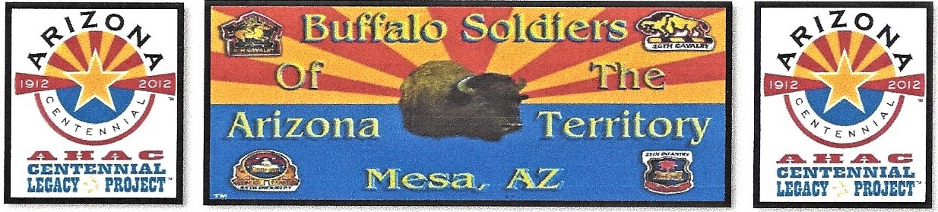

**Buffalo Soldiers AZ Territory Monument, SB1179**

Fundraising Memorial Bricks and Donation Form

Check on box:

* $100 for 4 x 8” Brick

3 lines 20 characters per line

* $200 for 8 x 8” Brick

6 lines OR your logo & some text

* Corporate logos add $50

Print Name:_____________________________________________________ Date: ______________________________

**All tax-deductible funds raised go directly towards erecting a monument including your bricks located at the Arizona State Capitol Wesley Bolin Memorial Plaza in Phoenix, Arizona.**

Business Name: ________________________________________ Address: ____________________________________

City: __________________________________ State: ____________ Zip Code: _________________________________

Email: ________________________________________________ Telephone: ___________________________________

**Make check payable to:** Buffalo Soldiers AZ Territory Monument **Address:** P.O. Box 20883, Mesa, AZ 85277-0883 **Check #:** _______________ **Enclosed** **Donation:** $__________________ O **Memorial Brick** O **Enclosed Donation**

If you have any questions, we can be reached at email: [mlondon3@cox.net](mailto:mlondon3@cox.net) or Cell: (480) 415-5439

Websites: <https://www.buffalosoldiersazterritorymonument.com> Or <https://www.buffalosoldiersaztrtry.smugmug.com>.

**

Referral by: ________________________________________

Thank you for your support!

**Project by:** Official Arizona Centennial Legacy Buffalo Soldiers of the Arizona Territory – Ladies and Gentlemen of the Regiment, Headquarters Mesa, Arizona. **(Independent Organization)** Non-Profit 501(c)(3) and IRS Federal Tax-Exempt. EIN: 51-0662449.

**Board Members:** Commander Fred Marable, Army Vietnam Veteran, Deputy Commander Michelle London-Marable, Executive Director, Representative Richard Andrade, Reggie Yates, Major USA Retired Army, Robert E. Welch, Colonel USA Retired Army, Hal Stewart, Artist, Lemuel Yorahee, Buffalo Soldier of the Arizona Territory, Sharon Kilmer, Film Production, Gary Williams and Michael Goodwin, West Point Academy Graduates. **MINISTERS:** Pastor David L. Wade, Mt. Calvary Baptist Church, Pastor Juan M. Brown, Progressive Baptist Church, and Rev. Albert and First Lady Yolanda, The Lawrence Memorial AMEZ Church, Mesa, Arizona