17311 E Dalton Ave Spokane Valley WA 99216 509.994.6907

Thank you for purchasing your Quick Clip Wheel Kit from Motion Engineering & Fabrication

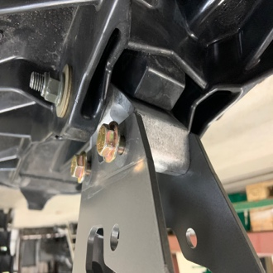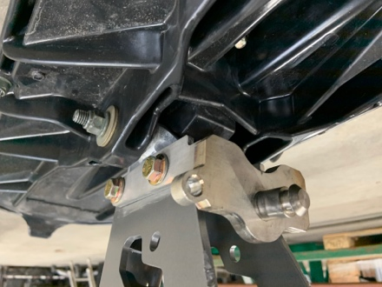

1) Remove OEM bolts (15mm) through the spindle allowing the ski to drop.
(No need to relieve the pressure in the TRIO if you have one.)

2) Place the provided Quick Clip spindle bracket over the Timbersled spindle. Reinstall the ski using the provided nuts (ARO:17mm , MH:9/16”) and longer bolt (ARO:15mm , MH:9/16”) starting with the front bolt. Ensure that the nuts are on the riders’ right side of the bike to allow room for the locking pin on the opposite side.

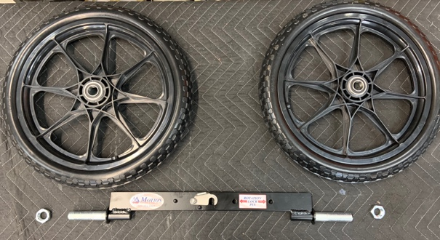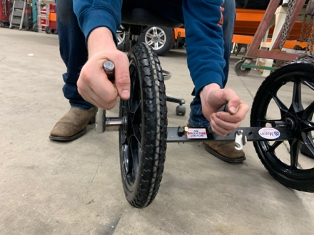

3) Using a $1\frac{1}{16}$” socket and a screwdriver through the pin hole for stabilization, tighten the nuts on to the axle enough for minimal wiggle room for the wheel but still allowing it to spin freely.
(The wheels are identical on both sides so orientation does not matter)

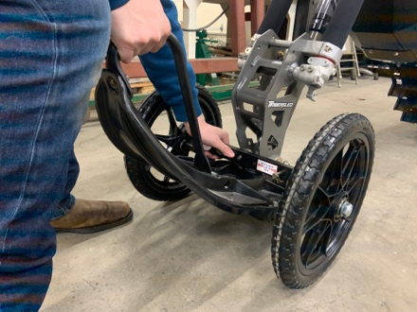

4) Pick up on the front of the ski and slide the spindle bracket into the hole in the axle. Rotate the quick clip onto the spindle bracket and the axle is locked in place. In this position you will have full handle bar rotation. Move the locking pin into the other hole and the handle bars will lock into place and the bike will be more stable.

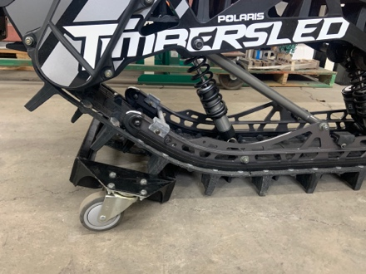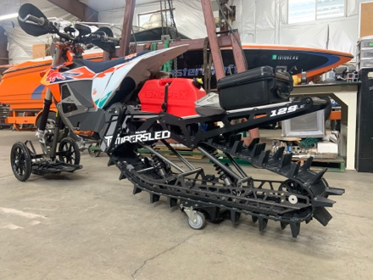

5) The Track Basket can either be installed by simply lifting the bike into the basket (we recommend having the wheels on and the pin in the lock position before attempting this method) or set the basket in front of the track and ‘brap’ the throttle until it is in place.

*The Quick Clip system is not intended for riding use*

Please contact Motion Engineering & Fabrication if you have any questions or concerns.
To see a full install video please visit YouTube search:
Quick Clip Wheel Kit – How To Dudes
https://www.youtube.com/watch?v=akmD_w_8Zvs&t=7s

Lucas Humble Erik Humble
lucas@motionengfab.com erik@motionengfab.com
509.993.6667 509.994.6907

