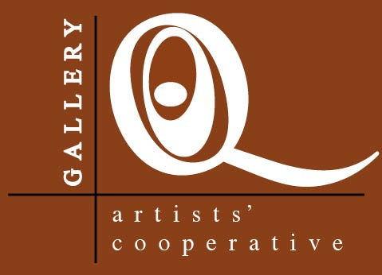

Q Artists Cooperative

Application for Exhibiting Membership

Q Artists Cooperative is looking for artists whose work and résumé clearly demonstrate professional quality and outstanding workmanship. Applicants must also be willing to abide by the Cooperative’s values and bylaws and take on the responsibilities of membership/ownership.

Membership is granted through a juried selection process to ensure high quality art that compliments and enhances the Cooperative’s existing body of work. Applicants must value hard work and integrity, work well with others and be committed to their personal development as artists.

Responsibilities of member/owners include sharing gallery staffing duties, and active participation in at least one of the various committees.

If you would like to apply for membership in Q Artists Cooperative, read and complete this entire form, send an email with digital images showing ten to twelve recent examples of your work, or a link to your website. You will be notified of the jury’s decision shortly after the committee meeting.

Contact Information:

Name__________________________________________________________________________________________

Address_______________________________________________________________________________________

Phone number (s)____________________________________________________________________________

Email__________________________________________________________________________________________

Web site_______________________________________________________________________________________

Artistic Medium ____________________________________________________________________

Agreement:

Attendance at membership meetings
Active participation in at least one committee
Sharing gallery staffing duties (equally divided among members)
Purchase of one share of equity in the business ($250)
Timely payment of membership dues

In return for membership participation, you will receive
Exhibition of your work in a high quality, high visibility gallery venue
Very low gallery commission (you keep more of your sales revenue)
Promotion and marketing of your work through gallery advertising and website
Direct link from the gallery website to yours

Checklist
Please return this completed application to the gallery with the following items

A Brief artists statement about your work
A resume of exhibitions and gallery representation
Digital access to at least 10-12 images of current (within the last 3 years) work for each medium you wish the membership committee to consider or a link to your website.

I agree to the above terms of the Q Artist’s Gallery

Signed_________________________________________________________Date_________________________

