**Development of Reference Design Values for Eurotec Screws**

The design values in the tables that follow were developed with the provisions of the 2018 National Design Specification for Wood Construction (NDS). Geometric and material properties for the Eurotec screws were taken from the European Technical Assessment No. ETA-11/0024 dated 2 March 2017. No attempt was made to develop design values by format conversion from the provisions of Eurocode 5. In some cases, engineering judgement was applied when interpreting and applying the NDS provisions, and those cases are discussed in light type as warranted.

**Reference Withdrawal Design Values, W**

Reference design values for withdrawal are based upon NDS Equation (12.2-1) for lag screws. As discussed in the NDS Commentary, Section C12.2.1, this equation represents an effective factor of safety of 4.0 applied to the average results from ultimate load tests of joints made with five different species of wood and seven sizes of lag screws. The design value applies for a unit (1-inch) length of thread penetration into side grain of the main member of the connection. The length of the tapered tip is not to be included as part of the thread penetration.

For Eurotec screws, the length of the tapered tip is estimated to be the same as the nominal diameter of the screw. Use of Equation (12.2-1) is assumed to be appropriate and conservative for Eurotec screws because the latter have higher material strength, sharper threads, and a larger ratio of nominal diameter to root diameter than conventional lag screws.

NDS Equation (12.2-1) applies for screws inserted into side grain of a wood member and loaded directly in withdrawal. For screws inserted into end grain, the reference withdrawal value is reduced by the end-grain factor, Ceg

= 0.75. However, reference design values for screws inserted at other angles to the grain are not specified. Eurocode 5 uses a form of the Hankinson formula to determine the withdrawal design value for screws at any angle to the grain. The corresponding form of the Hankinson formula applied to the withdrawal values in the following tables is:

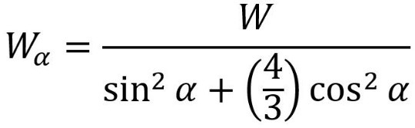

where *α* is the angle to the grain of the screw. For example, for *α* = 45o, W*α* = 0.857 W.

The withdrawal capacity of a screw, given by the unit value W multiplied by the length of thread penetration in the main member and the appropriate adjustment factors in NDS Table 11.3.1., shall not exceed the allowable tension capacity listed in the table.

The allowable tension capacity for each screw includes a factor of safety of 2.0 applied to the tensile yield strength of the screw at its root diameter, as reported in ETA 11/0024.

**Reference Head-Pull-Through Design Values,** WH

Reference design values for head pull-through are based upon NDS Equation (12.2-6) for fasteners with round heads. The equation includes an effective factor of safety of 5.0 applied to average results from physical tests. The design values listed in the table shall be multiplied by the appropriate adjustment factors in NDS Table 11.3.1. After application of any adjustment factors, the pull-through capacity shall not be taken as greater than the allowable tension capacity given in the table. As stated in NDS Section 12.2.5, use of Equation (12.2-6) is limited to fastener head diameters, material specific gravity, and net side-member thickness within the ranges given in NDS Table 12.2F.

The following tables for Eurotec screws extend use of Equation (12.2-6) for head diameter

greater than 1/2”, specific gravity greater than 0.50, and net side-member thickness greater than 1 1/2”. The applicability of Equation (12.2-6) outside the ranges given in NDS Table 12.2F is not recognized by the NDS provisions, so users of these design values are cautioned to apply them with appropriate engineering judgement.

**Reference Lateral Design Values, Z**

Reference lateral design values for Eurotec screws are based upon the yield limit equations presented in NDS Section 12.3.1, Tables 12.3.1 and 12.3.1B, with the provisions for dowel bearing strength, dowel bearing length, and dowel diameter in Sections 12.3.3, 12.3.5 and 12.3.7, respectively. Geometric parameters given in ETA 11/0024 for the screws are used directly in the yield limit equations. The NDS references the methods provided in ASTM F1575 for determining dowel bending yield strength. Those methods are based on a definition of yield using the 5% offset method.

Dowel bending yield strengths for the Eurotec screws were determined from the characteristic yield moment of the fasteners reported in ETA 11/0024, which may differ from the results that would be obtained by testing according to ASTM F1575. Nevertheless, the dowel bending yield strengths derived from the ETA are within the range of typical values for high-strength screws. Hence, use of those values is regarded as reasonable and safe.

|  |  |  |  |  |  |  |  |  |  |  |  |  |
| --- | --- | --- | --- | --- | --- | --- | --- | --- | --- | --- | --- | --- |
| **Lateral Design Values *Z* (lb) - Both Members Loaded Parallel to Grain** | | | | | | | | | | | | |
| **Nominal Screw Diameter** | | **Dowel Bending Yield (psi)** | **Side Member Thickness (in)** | **Min. Screw Length (in)** | **Specific Gravity** | | | | | | | |
| **(mm)** | **(in)** | 0.31 | 0.36 | 0.42 | 0.46 | 0.50 | 0.55 | 0.67 | 0.73 |
| 4.0 | 0.157 | 184,000 | 3/4 | 2 1/2 | 37 | 44 | 54 | 61 | 68 | 78 | 97 | 105 |
| 1 1/2 | 3 1/4 | 48 | 55 | 63 | 69 | 74 | 81 | 97 | 105 |
| 4.5 | 0.177 | 199,000 | 3/4 | 2 1/2 | 43 | 51 | 62 | 70 | 78 | 89 | 118 | 128 |
| 1 1/2 | 3 1/4 | 58 | 67 | 77 | 83 | 90 | 98 | 118 | 128 |
| 5.0 | 0.197 | 153,000 | 3/4 | 2 3/4 | 53 | 63 | 76 | 86 | 95 | 109 | 144 | 160 |
| 1 1/2 | 3 1/2 | 70 | 83 | 96 | 104 | 113 | 123 | 148 | 160 |
| 6.0 | 0.236 | 145,000 | 3/4 | 3 1/4 | 72 | 85 | 101 | 112 | 125 | 141 | 184 | 208 |
| 1 1/2 | 4 | 90 | 111 | 133 | 145 | 156 | 171 | 205 | 221 |
| 3 1/2 | 6 | 101 | 116 | 133 | 145 | 156 | 171 | 205 | 221 |
| 8.0 | 0.315 | 117,000 | 3/4 | 3 3/4 | 103 | 120 | 140 | 154 | 169 | 189 | 241 | 270 |
| 1 1/2 | 4 1/2 | 118 | 144 | 178 | 203 | 226 | 247 | 296 | 321 |
| 3 1/2 | 6 1/2 | 146 | 167 | 193 | 210 | 226 | 247 | 296 | 321 |
| 10.0 | 0.394 | 128,000 | 3/4 | 4 1/2 | 120 | 150 | 174 | 191 | 207 | 229 | 286 | 317 |
| 1 1/2 | 5 1/4 | 140 | 168 | 204 | 230 | 259 | 296 | 377 | 407 |
| 3 1/2 | 7 1/4 | 185 | 213 | 245 | 266 | 288 | 314 | 377 | 407 |

|  |  |  |  |  |  |  |  |  |  |  |  |  |
| --- | --- | --- | --- | --- | --- | --- | --- | --- | --- | --- | --- | --- |
| **Lateral Design Values *Z* (lb) - Both Members Loaded Perpendicular to Grain** | | | | | | | | | | | | |
|  | | **Dowel Bending Yield (psi)** | **Side Member Thickness (in)** | **Min. Screw Length (in)** | **Specific Gravity** | | | | | | | |
| **(mm)** | **(in)** | 0.31 | 0.36 | 0.42 | 0.46 | 0.50 | 0.55 | 0.67 | 0.73 |
| 4.0 | 0.157 | 184,000 | 3/4 | 2 1/2 | 37 | 44 | 54 | 61 | 68 | 78 | 97 | 105 |
| 1  1/2 | 3 1/4 | 48 | 55 | 63 | 69 | 74 | 81 | 97 | 105 |
| 4.5 | 0.177 | 199,000 | 3/4 | 2 1/2 | 43 | 51 | 62 | 70 | 78 | 89 | 118 | 128 |
| 1  1/2 | 3 1/4 | 58 | 67 | 77 | 83 | 90 | 98 | 118 | 128 |
| 5.0 | 0.197 | 153,000 | 3/4 | 2 3/4 | 53 | 63 | 76 | 86 | 95 | 109 | 144 | 160 |
| 1 1/2 | 3 1/2 | 70 | 83 | 96 | 104 | 113 | 123 | 148 | 160 |
| 6.0 | 0.236 | 145,000 | 3/4 | 3 1/4 | 72 | 85 | 101 | 112 | 125 | 141 | 184 | 208 |
| 1  1/2 | 4 | 90 | 111 | 133 | 145 | 156 | 171 | 205 | 221 |
| 3  1/2 | 6 | 101 | 116 | 133 | 145 | 156 | 171 | 205 | 221 |
| 8.0 | 0.315 | 117,000 | 3/4 | 3 3/4 | 83 | 96 | 112 | 124 | 136 | 151 | 193 | 216 |
| 1  1/2 | 4 1/2 | 94 | 115 | 142 | 163 | 181 | 198 | 237 | 256 |
| 3  1/2 | 6 1/2 | 117 | 134 | 154 | 168 | 181 | 198 | 237 | 256 |
| 10.0 | 0.394 | 128,000 | 3/4 | 4 1/2 | 96 | 120 | 139 | 152 | 166 | 183 | 229 | 253 |
| 1  1/2 | 5 1/4 | 112 | 134 | 163 | 184 | 207 | 237 | 301 | 326 |
| 3  1/2 | 7 1/4 | 148 | 170 | 196 | 213 | 230 | 251 | 301 | 326 |

|  |  |  |  |  |  |  |  |  |  |  |
| --- | --- | --- | --- | --- | --- | --- | --- | --- | --- | --- |
| **Withdrawal Design Values *W* (lb/in)** | | | | | | | | | | **Allowable Tension Capacity (lb)** |
| **Nominal Screw Diameter** | | **Specific Gravity** | | | | | | | |
| (mm) | (in) | 0.31 | 0.36 | 0.42 | 0.46 | 0.50 | 0.55 | 0.67 | 0.73 |
| 4.0 | 0.157 | 78 | 97 | 122 | 140 | 159 | 184 | 247 | 281 | 560 |
| 4.5 | 0.177 | 85 | 106 | 134 | 153 | 174 | 200 | 270 | 307 | 720 |
| 5.0 | 0.197 | 92 | 115 | 145 | 166 | 188 | 217 | 292 | 332 | 890 |
| 6.0 | 0.236 | 105 | 132 | 166 | 190 | 216 | 249 | 334 | 380 | 1,240 |
| 8.0 | 0.315 | 131 | 163 | 206 | 236 | 268 | 309 | 415 | 472 | 2,250 |
| 10.0 | 0.394 | 154 | 193 | 244 | 279 | 316 | 365 | 491 | 558 | 3,150 |

|  |  |  |  |  |  |  |  |  |  |  |  |  |  |
| --- | --- | --- | --- | --- | --- | --- | --- | --- | --- | --- | --- | --- | --- |
| **Paneltwistec AG Countersunk Head 60o Screw -**  **Head Pull-Through Design Values P (lb)** | | | | | | | | | | | | | **Allowable Tension Capacity (lb)** |
| **Nominal Screw Diameter** | | **Head Diameter** | | **Side Member Thickness (in)** | **Specific Gravity** | | | | | | | |
| **(mm)** | **(in)** | **(mm)** | **(in)** | 0.31 | 0.36 | 0.42 | 0.46 | 0.50 | 0.55 | 0.67 | 0.73 |  |
| 4.0 | 0.157 | 6.00 | 0.236 | 3/4 | 29 | 39 | 53 | 64 | 76 | 91 | 136 | 161 | 560 |
| 1 1/2 | 29 | 39 | 53 | 64 | 76 | 91 | 136 | 161 |
| 3 1/2 | 29 | 39 | 53 | 64 | 76 | 91 | 136 | 161 |
| 4.5 | 0.177 | 7.00 | 0.276 | 3/4 | 40 | 53 | 73 | 87 | 103 | 125 | 185 | 219 | 720 |
| 1 1/2 | 40 | 53 | 73 | 87 | 103 | 125 | 185 | 219 |
| 3 1/2 | 40 | 53 | 73 | 87 | 103 | 125 | 185 | 219 |
| 5.0 | 0.197 | 7.25 | 0.285 | 3/4 | 42 | 57 | 78 | 93 | 110 | 134 | 198 | 235 | 890 |
| 1 1/2 | 42 | 57 | 78 | 93 | 110 | 134 | 198 | 235 |
| 3 1/2 | 42 | 57 | 78 | 93 | 110 | 134 | 198 | 235 |
| 6.0 | 0.236 | 11.00 | 0.433 | 3/4 | 68 | 91 | 124 | 149 | 176 | 213 | 316 | 375 | 1,240 |
| 1 1/2 | 98 | 132 | 179 | 215 | 254 | 307 | 456 | 542 |
| 3 1/2 | 98 | 132 | 179 | 215 | 254 | 307 | 456 | 542 |
| 8.0 | 0.315 | 13.00 | 0.512 | 3/4 | 80 | 108 | 147 | 176 | 208 | 252 | 374 | 443 | 2,250 |
| 1 1/2 | 136 | 184 | 250 | 300 | 355 | 429 | 637 | 756 |
| 3 1/2 | 136 | 184 | 250 | 300 | 355 | 429 | 637 | 756 |
| 10.0 | 0.394 | 16.40 | 0.646 | 3/4 | 101 | 136 | 185 | 222 | 262 | 318 | 471 | 559 | 3,150 |
| 1 1/2 | 202 | 272 | 370 | 444 | 525 | 635 | 942 | 1,119 |
| 3 1/2 | 217 | 293 | 399 | 478 | 565 | 683 | 1,014 | 1,204 |

|  |  |  |  |  |  |  |  |  |  |  |  |  |  |  |  |
| --- | --- | --- | --- | --- | --- | --- | --- | --- | --- | --- | --- | --- | --- | --- | --- |
| **Paneltwistec AG Countersunk Head 60o Screw - dimensions** | | | | | | | | | | | | | | | |
| **Nominal Size** |  | **3.5**  **mm** | **#6** | **4.0**  **mm** | **#8** | **4.5**  **mm** | **#10** | **5.0**  **mm** | **#12** | **6.0**  **mm** | **¼”** | **8.0**  **mm** | **5/16”** | **10.0**  **mm** | **3/8”** |
| d | min max | 3.30  3.65 | .130  .144 | 3.75  4.05 | .148  .159 | 4.25  4.55 | .278  .303 | 4.70  5.10 | .185  .201 | 5.75  6.15 | .226  .242 | 7.60  8.20 | .299  .323 | 9.70  10.30 | .382  .406 |
| di | min max | 2.00  2.25 | .079  .089 | 2.35  2.65 | .093  .104 | 2.60  2.80 | .171  .193 | 3.00  3.45 | .118  .136 | 3.80  4.20 | .150  .165 | 5.10  5.50 | .201  .217 | 6.00  6.50 | .236  .256 |
| dh | min max | 4.50  5.50 | .177  .217 | 5.50  6.50 | .217  .256 | 6.00  8.00 | .394  .472 | 6.50  8.00 | .256  .315 | 10.00  12.00 | .394  .472 | 12.00  14.00 | .472  .551 | 15.40  17.40 | .606  .685 |
| hh | min max | 1.75  2.10 | .069  .083 | 2.00  2.50 | .079  .098 | 2.25  2.75 | .148  .181 | 2.50  3.00 | .098  .118 | 3.00  4.00 | .118  .157 | - | - | - |  |
| p | min max | 2.02  2.46 | .080  .097 | 2.27  2.77 | .089  .109 | 2.52  3.08 | .169  .206 | 2.79  3.41 | .110  .134 | 4.41  5.39 | .174  .212 | 5.04  6.16 | .198  .243 | 5.94  7.26 | .234  .286 |
| ds | min max | 2.20  2.40 | .087  .094 | 2.60  2.80 | .102  .110 | 2.80  3.10 | .189  .205 | 3.60  3.80 | .142  .150 | 4.50  4.50 | .177  .177 | 5.70  5.90 | .224  .232 | 6.90  7.20 | .272  .283 |
| dm | min max | 2.65  2.85 | .104  .112 | 2.85  3.05 | .112  .120 | 3.35  3.55 | .217  .232 | 3.75  3.95 | .148  .156 | 4.80  5.00 | .189  .197 | 6.60  6.80 | .260  .268 | 7.90  8.10 | .311  .319 |
| dt | min max | 1.90  2.10 | .075  .083 | 2.20  2.40 | .087  .094 | 2.40  2.60 | .161  .177 | 2.80  3.00 | .110  .118 | 3.30  3.50 | .130  .138 | 5.10  5.50 | .201  .217 | 6.00  6.50 | .236  .256 |
| t | min max | 3.30  3.50 | .130  .138 | 3.80  4.00 | .150  .157 | 4.30  4.50 | .280  .295 | 4.80  5.00 | .189  .197 | 4.80  5.00 | .189  .197 | 5.00  5.20 | .197  .205 | 6.00  6.20 | .236  .244 |
| dc | min max | 3.30  3.70 | .130  .146 | 3.75  4.25 | .148  .167 | 5.15  5.65 | .278  .313 | 5.75  6.25 | .226  .246 | 6.95  7.45 | .274  .293 | 7.65  8.35 | .301  .329 | 9.60  10.40 | .378  .409 |
| hhc | min max | 3.70  3.90 | .146  .154 | 4.20  4.40 | .165  .173 | 4.70  4.90 | .311  .327 | 5.30  5.50 | .209  .217 | 5.60  5.80 | .220  .228 | 6.00  6.30 | .236  .248 | 6.50  6.80 | .256  .268 |
| dh2 | min max | - |  | 5.30  5.70 | .209  .224 | 6.65  7.15 | .209  .224 | 8.25  8.75 | .325  .344 | 11.00  11.50 | .433  .453 | - | - | - |  |
| p2 | min max | - |  | 7.50  10.00 | .295  .394 | 8.40  11.20 | .295  .394 | 9.30  12.40 | .366  .488 | 14.70  19.60 | .579  .772 | 16.80  22.40 | .661  .882 | 26.40  33.00 | 1.039  1.299 |
| dm2 | min max |  |  | 2.70  2.90 | .106  .114 | 3.10  3.30 | .106  .114 | 3.70  3.90 | .146  .154 | 4.50  4.70 | .177  .185 | 6.10  6.30 | .240  .248 | 7.10  7.30 | .280  .287 |
| tx | size | tx20 |  | tx20 |  | tx20 |  | tx20 |  | tx30 |  | tx40 |  | tx50 |  |

|  |  |  |  |  |  |  |  |  |  |  |  |  |  |  |  |
| --- | --- | --- | --- | --- | --- | --- | --- | --- | --- | --- | --- | --- | --- | --- | --- |
| **Paneltwistec AG Countersunk Head 60o Screw –**  **thread length** | | | | | | | | | | | | | | | |
| **L**  **metric** | **L**  **Inches** | **3.5**  **mm** | **#6** | **4.0**  **mm** | **#8** | **4.5**  **mm** | **#10** | **5.0**  **mm** | **#12** | **6.0**  **mm** | **¼”** | **8.0**  **mm** | **5/16”** | **10 mm** | **3/8”** |
| 25 | 0.98 | 15 | 0.59 | 15 | 0.59 |  |  |  |  |  |  |  |  |  |  |
| 30 | 1.18 | 18 | 0.71 | 18 | 0.71 |  |  |  |  |  |  |  |  |  |  |
| 40 | 1.57 | 24 | 0.94 | 24 | 0.94 | 24 | 0.94 | 24 | 0.94 |  |  |  |  |  |  |
| 45 | 1.77 | 27 | 1.06 | 27 | 1.06 | 27 | 1.06 | 27 | 1.06 |  |  |  |  |  |  |
| 50 | 1.97 | 30 | 1.18 | 30 | 1.18 | 30 | 1.18 | 30 | 1.18 | 30 | 1.18 |  |  |  |  |
| 60 | 2.36 |  |  | 36 | 1.42 | 36 | 1.42 | 36 | 1.42 | 36 | 1.42 |  |  |  |  |
| 70 | 2.76 |  |  | 42 | 1.65 | 42 | 1.65 | 42 | 1.65 | 42 | 1.65 |  |  |  |  |
| 80 | 3.15 |  |  | 48 | 1.89 | 48 | 1.89 | 48 | 1.89 | 48 | 1.89 | 48/50 | 1.83/ 1.97 | 48/50 | 1.83/ 1.97 |
| 90 | 3.54 |  |  |  |  |  |  | 54 | 2.13 | 54 | 2.13 | 54 | 2.13 |  |  |
| 100 | 3.94 |  |  |  |  |  |  | 60 | 2.36 | 60 | 2.36 | 60 | 2.36 | 60 | 2.36 |
| 110 | 4.33 |  |  |  |  |  |  | 66 | 2.60 | 70 | 2.76 | 80 | 3.15 | 90 | 3.54 |
| 120 | 4.72 |  |  |  |  |  |  | 70 | 2.76 | 70 | 2.76 | 80/70 | 3.15 /2.76 | 90/70 | 3.54/ 2.76 |
| 140 | 5.51 |  |  |  |  |  |  |  |  | 70 | 2.76 | 80 | 3.15 | 90/80 | 3.54/ 3.15 |
| 160 | 6.30 |  |  |  |  |  |  |  |  | 70 | 2.76 | 80/90 | 3.15/ 3.54 | 90 | 3.54 |
| 180 | 7.09 |  |  |  |  |  |  |  |  | 70 | 2.76 | 80/100 | 3.15/ 3.54 | 90/100 | 3.54/ 3.94 |
| 200 | 7.87 |  |  |  |  |  |  |  |  | 70 | 2.76 | 80/100 | 3.15/ 3.54 | 90/100 | 3.54/ 3.94 |
| Plus 20 mm steps |  |  |  |  |  |  |  |  |  | 70 | 2.76 | 80/100 | 3.15/ 3.54 | 90/100 | 3.54/ 3.94 |
| 300 | 11.81 |  |  |  |  |  |  |  |  | 70 | 2.76 | 80/100 | 3.15/ 3.54 | 90/100 | 3.54/ 3.94 |
| 320 | 12.60 |  |  |  |  |  |  |  |  |  |  | 80/100 | 3.15/ 3.54 | 90/100 | 3.54/ 3.94 |
| Plus 20 mm steps |  |  |  |  |  |  |  |  |  |  |  | 80/100 | 3.15/ 3.54 | 90/100 | 3.54/ 3.94 |
| 460 | 18.11 |  |  |  |  |  |  |  |  |  |  | 80/100 | 3.15/ 3.54 | 90/100 | 3.54/ 3.94 |
| 480 | 18.90 |  |  |  |  |  |  |  |  |  |  | 80/100 | 3.15/ 3.54 | 90/100 | 3.54/ 3.94 |

|  |  |  |  |  |  |  |  |  |  |  |  |  |  |  |  |
| --- | --- | --- | --- | --- | --- | --- | --- | --- | --- | --- | --- | --- | --- | --- | --- |
| **L**  **metric** | **L**  **Inches** | **3.5**  **mm** | **#6** | **4.0**  **mm** | **#8** | **4.5**  **mm** | **#10** | **5.0**  **mm** | **#12** | **6.0**  **mm** | **¼”** | **8.0**  **mm** | **5/16”** | **10 mm** | **3/8”** |
| 500 | 19.69 |  |  |  |  |  |  |  |  |  |  | 80/100 | 3.15/ 3.54 | 90/100 | 3.54/ 3.94 |
| 550 | 21.65 |  |  |  |  |  |  |  |  |  |  | 80/100 | 3.15/ 3.54 | 90/100 | 3.54/ 3.94 |
| 600 | 23.62 |  |  |  |  |  |  |  |  |  |  | 80/100 | 3.15/ 3.54 | 90/100 | 3.54/ 3.94 |



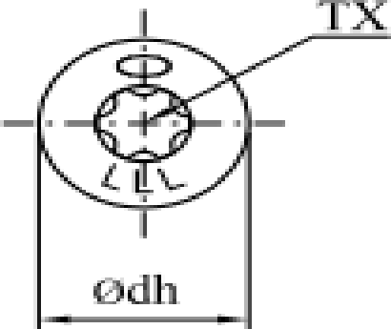

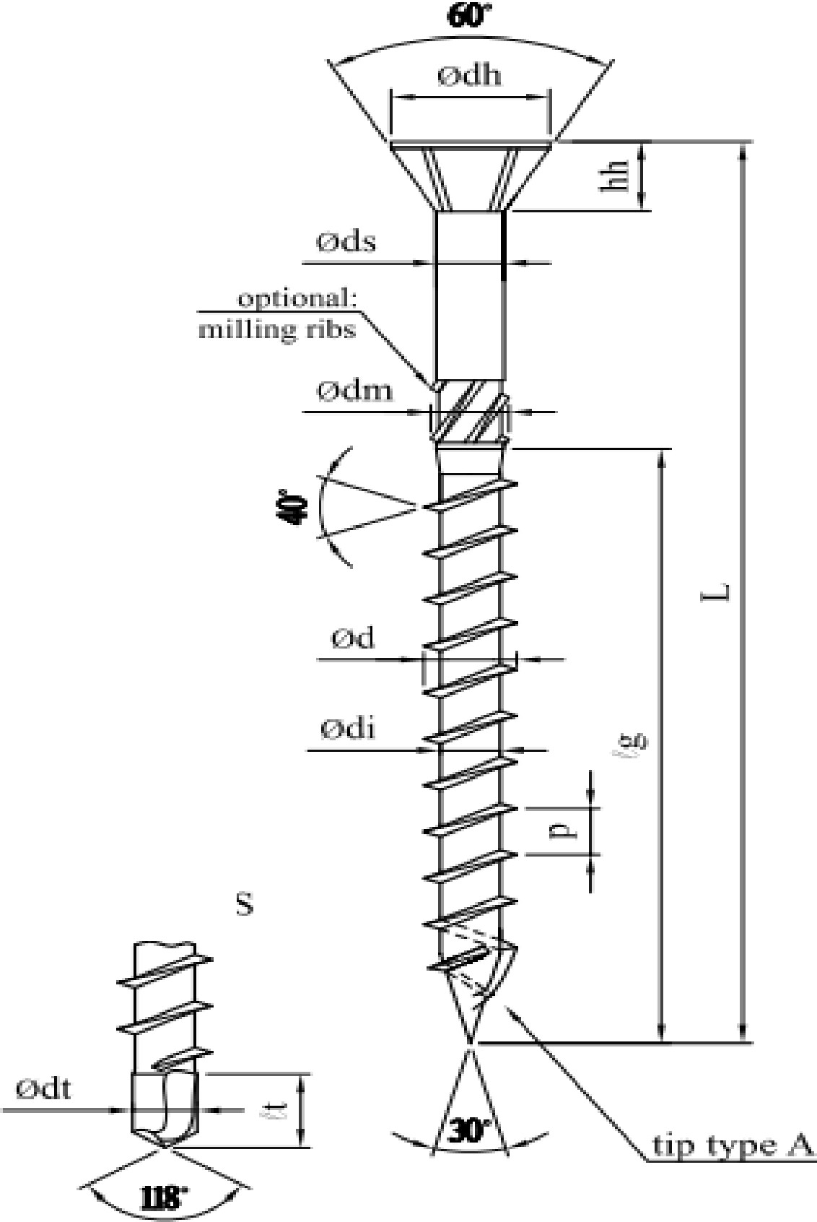

**tip type B-**

**G**



|  |  |  |  |  |  |  |  |  |  |  |  |  |  |
| --- | --- | --- | --- | --- | --- | --- | --- | --- | --- | --- | --- | --- | --- |
| **Paneltwistec AG Countershunk Head 90o Screw -**  **Head Pull-Through Design Values P (lb)** | | | | | | | | | | | | | **Allowable Tension Capacity (lb)** |
| **Nominal Screw Diameter** | | **Head Diameter** | | **Side Member Thickness (in)** | **Specific Gravity** | | | | | | | |
| **(mm)** | **(in)** | **(mm)** | **(in)** | 0.31 | 0.36 | 0.42 | 0.46 | 0.50 | 0.55 | 0.67 | 0.73 |
| 4.0 | 0.157 | 7.75 | 0.305 | 3/4 | 48 | 64 | 88 | 105 | 124 | 150 | 223 | 264 | 3 |
| 1 1/2 | 48 | 65 | 89 | 107 | 126 | 153 | 226 | 269 |
| 3 1/2 | 48 | 65 | 89 | 107 | 126 | 153 | 226 | 269 |
| 4.5 | 0.177 | 8.75 | 0.344 | 3/4 | 54 | 73 | 99 | 119 | 140 | 169 | 251 | 298 | 720 |
| 1 1/2 | 62 | 83 | 113 | 136 | 161 | 195 | 289 | 343 |
| 3 1/2 | 62 | 83 | 113 | 136 | 161 | 195 | 289 | 343 |
| 5.0 | 0.197 | 9.75 | 0.384 | 3/4 | 60 | 81 | 110 | 132 | 156 | 189 | 280 | 333 | 890 |
| 1 1/2 | 77 | 103 | 141 | 169 | 200 | 242 | 358 | 426 |
| 3 1/2 | 77 | 103 | 141 | 169 | 200 | 242 | 358 | 426 |
| 6.0 | 0.236 | 11.75 | 0.463 | 3/4 | 72 | 97 | 133 | 159 | 188 | 228 | 338 | 401 | 1,240 |
| 1 1/2 | 111 | 150 | 205 | 245 | 290 | 351 | 521 | 618 |
| 3 1/2 | 111 | 150 | 205 | 245 | 290 | 351 | 521 | 618 |
| 8.0 | 0.315 | 14.50 | 0.571 | 3/4 | 89 | 120 | 164 | 196 | 232 | 281 | 417 | 495 | 2,250 |
| 1 1/2 | 170 | 229 | 312 | 374 | 442 | 534 | 793 | 941 |
| 3 1/2 | 170 | 229 | 312 | 374 | 442 | 534 | 793 | 941 |
| 10.0 | 0.394 | 17.80 | 0.701 | 3/4 | 109 | 148 | 201 | 241 | 285 | 345 | 511 | 607 | 3,150 |
| 1 1/2 | 219 | 295 | 402 | 482 | 570 | 689 | 1,023 | 1,214 |
| 3 1/2 | 256 | 345 | 469 | 563 | 665 | 805 | 1,195 | 1,418 |

|  |  |  |  |  |  |  |  |  |  |  |  |  |  |  |  |  |  |
| --- | --- | --- | --- | --- | --- | --- | --- | --- | --- | --- | --- | --- | --- | --- | --- | --- | --- |
| **Paneltwistec AG Countershunk Head 90o Screw - dimensions** | | | | | | | | | | | | | | | | | |
| **Nomin al Size** | **3.5 mm** | **#6** | | **4.0**  **mm** | **#8** | **4.5**  **mm** | **#10** | **5.0**  **mm** | **#12** | **6.0**  **mm** | **¼”** | **8.0**  **mm** | **5/16”** | **10.0**  **mm** | **3/8”** | **12.0**  **mm** | **½”** |
| d | 3.30 3.65 |  | .130 .144 | 3.75  4.05 | .148  .159. | 4.25  4.55 | .167  .179 | 4.70  5.10 | .185  .201 | 5.75  6.15 | .226  .242 | 7.60  8.20 | .299 .323 | 9.70  10.30 | .382  .406 | 11.50  12.30 | .453 .484 |
| di | 2.00 2.25 |  | .079 .089 | 2.35  2.65 | .093  .104 | 2.60  2.80 | .102  .110 | 3.00  3.45 | .118  .136 | 3.80  4.20 | .150  .165 | 5.10  5.50 | .201 .217 | 6.00  6.50 | .236  .256 | 6.90  7.40 | .272 .291 |
| dh | 6.60 7.00 |  | .260 .276 | 7.50  8.00 | .295  .315 | 8.50  9.00 | .335  .354 | 9.50  10.00 | .374  .394 | 11.50  12.00 | .453  .472 | 14.10  14.90 | .555 .587 | 17.40  18.20 | .685  .717 | 19.00  21.00 | .748 .827 |
| hh | 3.25 3.65 |  | .128 .144 | 3.75  4.25 | .148  .167 | 4.15  4.65 | .163  .183 | 4.55  5.05 | .179  ,199 | 5.40  5.90 | .213  .232 | 6.50  7.50 | .256 .295 | 8.20  9.20 | .323  .362 | 8.90  9.70 | .350 .382 |
| p | 2.02 2.46 |  | .080 .097 | 2.27  2.77 | .089  .109 | 2.52  3.08 | .099  .121 | 2.79  3.41 | .110  .134 | 4.41  5.39 | .174  .212 | 5.04  616 | .198 .248 | 5.94  7.26 | .234  .286 | 5.94  7.26 | .234 .286 |
| ds | 2.20 2.40 |  | .087 .094 | 2.60  2.80 | .102  .110 | 2.80  3.10 | .110  .122 | 3.60  3.80 | .142  .150 | 4.30  4.50 | .169  .177 | 5.70  5.90 | .224 .232 | 6.90  720 | .272  .283 | 7.90  8.20 | .311 .323 |
| dm | 2.65 2.85 |  | .104 .112 | 2.85  3.05 | .112  .120 | 3.35  3.55 | .132  .140 | 3.75  3.95 | .148  .156 | 4.80  5.00 | .189  .197 | 6.60  6.80 | .260 .268 | 7.90  8.10 | .311  .319 | 9.40  9.80 | .370 .386 |
| dc | 2.30 3.70 |  | .091 .146 | 3.75  4.25 | .148  .165 | 5.15  5.65 | .203  .222 | 5.75  6.25 | .226  .246 | 6.95  7.45 | .274  .293 | 7.65  8.35 | .301 .329 | 9.60  10.40 | .378  .409 |  |  |
| hhc | 3.70 3.90 |  | .146 .154 | 4.00  4.40 | .157  .173 | 4.50  4.90 | .177  .193 | 5.10  5.50 | .201  .217 | 5.40  5.80 | .231  .288 | 7.00  7.50 | .276 .295 | 8.00  8.50 | .315  .335 |  |  |
| dh2 |  |  |  | 5.30  5.70 | .209  .224 | 6.65  7.15 | .262  .281 | 8.25  8.75 | .235  .344 | 11.00  11.50 | .433  .453 |  |  |  |  |  |  |
| p2 |  |  |  | 7.50  10.00 | .295  .394 | 8.40  11.20 | .331  .441 | 9.30  12.40 | .366  .488 | 14.70  19.60 | .579  .772 | 16.80  22.40 | .661 .882 | 26.40  33.00 | 1.039  1.299 |  |  |
| dm2 |  |  |  | 2.70  2.90 | .106  .114 | 3.00  3.30 | .118  .130 | 3.70  3.90 | .146  .154 | 4.50  4.70 | .177  .185 | 6.10  6.30 | .240 .248 | 7.10  7.30 | .280  .287 |  |  |
| TX | tx20 |  |  | tx20 |  | tx20 |  | tx20 |  | tx30 |  | tx40 |  | tx50 |  | tx50 |  |

|  |  |  |  |  |  |  |  |  |  |  |  |  |  |  |  |  |  |  |
| --- | --- | --- | --- | --- | --- | --- | --- | --- | --- | --- | --- | --- | --- | --- | --- | --- | --- | --- |
| **Paneltwistec AG Countersunk Head 90o Screw - thread length** | | | | | | | | | | | | | | | | | | |
| **L metric** | **L**  **Inches** | **3.5**  **mm** | **#6** | **4.0**  **mm** | **#8** | **4.5**  **mm** | **#10** | **5.0**  **mm** | **#12** | **6.0**  **mm** | **¼”** | **8 mm** | **5/16”** | **10.0 mm** | | **3/8”** | **12**  **mm** | **½”** |
| 25 | 0.98 | 15 | 0.59 | 15 | 0.59 |  |  |  |  |  |  |  |  | |  |  |  |  |
| 30 | 1.18 | 18 | 0.71 | 18 | 0.71 |  |  |  |  |  |  |  |  | |  |  |  |  |
| 40 | 1.57 | 24 | 0.94 | 24 | 0.94 | 24 | 0.94 | 24 | 0.94 |  |  |  |  | |  |  |  |  |
| 45 | 1.77 | 27 | 1.06 | 27 | 1.06 | 27 | 1.06 | 27 | 1.06 |  |  |  |  | |  |  |  |  |
| 50 | 1.97 | 30 | 1.18 | 30 | 1.18 | 30 | 1.18 | 30 | 1.18 | 30 | 1.18 |  |  | |  |  |  |  |
| 60 | 2.36 |  |  | 36 | 1.42 | 36 | 1.42 | 36 | 1.42 | 36 | 1.42 |  |  | |  |  |  |  |
| 70 | 2.76 |  |  | 42 | 1.65 | 42 | 1.65 | 42 | 1.65 | 42 | 1.65 |  |  | |  |  |  |  |
| 80 | 3.15 |  |  | 48 | 1.89 | 48 | 1.89 | 48 | 1.89 | 48 | 1.89 | 48/50 | 1.83/ 1.97 | | 48/50 | 1.83/  1.97 |  |  |
| 90 | 3.54 |  |  |  |  |  |  | 54 | 2.13 | 54 | 2.13 | 54 | 2.13 | |  |  |  |  |
| 100 | 3.94 |  |  |  |  |  |  | 60 | 2.36 | 60 | 2.36 | 60 | 2.36 | | 60 | 2.36 |  |  |
| 110 | 4.33 |  |  |  |  |  |  | 66 | 2.60 | 70 | 2.76 | 80 | 3.15 | | 90 | 3.54 |  |  |
| 120 | 4.72 |  |  |  |  |  |  | 70 | 2.76 | 70 | 2.76 | 80/70 | 3.15 /2.76 | | 90/70 | 3.54/  2.76 | 80 | 3.15 |
| 140 | 5.51 |  |  |  |  |  |  |  |  | 70 | 2.76 | 80 | 3.15 | | 90/80 | 3.54/  3.15 | 80 | 3.15 |
| 160 | 6.30 |  |  |  |  |  |  |  |  | 70 | 2.76 | 80/90 | 3.15/ 3.54 | | 90 | 3.54 | 80 | 3.15 |
| 180 | 7.09 |  |  |  |  |  |  |  |  | 70 | 2.76 | 80/100 | 3.15/ 3.54 | | 90/100 | 3.54/  3.94 | 80 | 3.15 |
| 200 | 7.87 |  |  |  |  |  |  |  |  | 70 | 2.76 | 80/100 | 3.15/ 3.54 | | 90/100 | 3.54/  3.94 | 80 | 3.15 |
| Plus 20 mm steps |  |  |  |  |  |  |  |  |  | 70 | 2.76 | 80/100 | 3.15/ 3.54 | | 90/100 | 3.54/  3.94 | 100 | 3.54 |
| 300 | 11.81 |  |  |  |  |  |  |  |  | 70 | 2.76 | 80/100 | 3.15/ 3.54 | | 90/100 | 3.54/  3.94 | 100 | 3.54 |
| 320 | 12.60 |  |  |  |  |  |  |  |  |  |  | 80/100 | 3.15/ 3.54 | | 90/100 | 3.54/  3.94 | 100 | 3.54 |
| Plus 20 mm steps |  |  |  |  |  |  |  |  |  |  |  | 80/100 | 3.15/ 3.54 | | 90/100 | 3.54/  3.94 | 120 | 4.17 |

|  |  |  |  |  |  |  |  |  |  |  |  |  |  |  |  |  |  |  |
| --- | --- | --- | --- | --- | --- | --- | --- | --- | --- | --- | --- | --- | --- | --- | --- | --- | --- | --- |
| **L metric** | **L**  **Inches** | **3.5**  **mm** | **#6** | **4.0**  **mm** | **#8** | **4.5**  **mm** | **#10** | **5.0**  **mm** | **#12** | **6.0**  **mm** | **¼”** | **8 mm** | **5/16”** | | **10.0 mm** | **3/8”** | **12**  **mm** | **½”** |
| 460 | 18.11 |  |  |  |  |  |  |  |  |  |  | 80/100 | 3.15/ 3.54 | 90/100 | | 3.54/  3.94 | 120 | 4.17 |
| 480 | 18.90 |  |  |  |  |  |  |  |  |  |  | 80/100 | 3.15/ 3.54 | 90/100 | | 3.54/  3.94 |  |  |
| 500 | 19.69 |  |  |  |  |  |  |  |  |  |  | 80/100 | 3.15/ 3.54 | 90/100 | | 3.54/  3.94 |  |  |
| 550 | 21.65 |  |  |  |  |  |  |  |  |  |  | 80/100 | 3.15/ 3.54 | 90/100 | | 3.54/  3.94 |  |  |
| 600 | 23.62 |  |  |  |  |  |  |  |  |  |  | 80/100 | 3.15/ 3.54 | 90/100 | | 3.54/  3.94 |  |  |

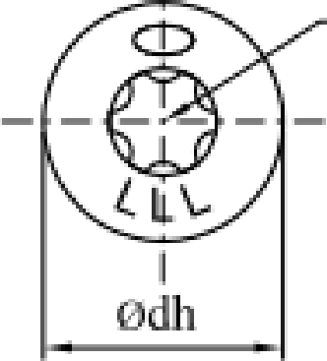

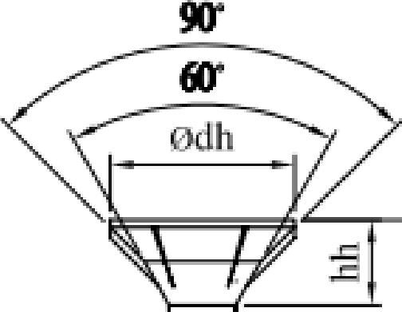

**tip typeN**

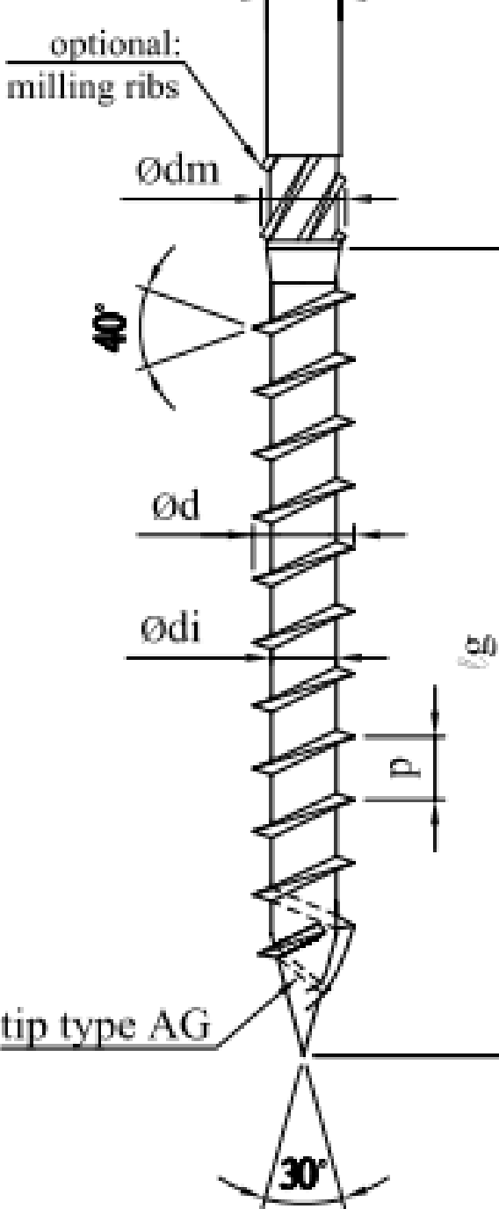

**0ds**

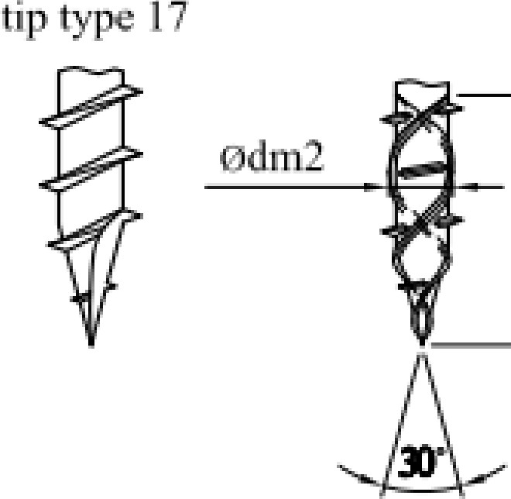

**tip type D** · **G**

- .

..·

.· .

. .

..· ··..

. · -

/.

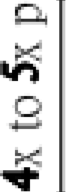

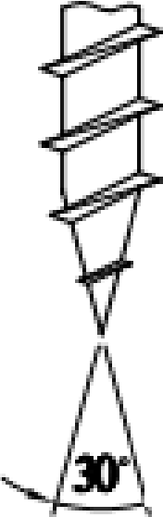. _,,,



|  |  |  |  |  |  |  |  |  |  |  |  |  |  |  |
| --- | --- | --- | --- | --- | --- | --- | --- | --- | --- | --- | --- | --- | --- | --- |
| **Paneltwistec AG Washer Head Screw -**  **Head Pull-Through Design Values P (lb)** | | | | | | | | | | | | | | **Allowable Tension Capacity (lb)** |
| **Nominal Screw Diameter** | | **Head Diameter** | | **Side Member Thickness (in)** | **Specific Gravity** | | | | | | | | |
| **(mm)** | **(in)** | **(mm)** | **(in)** | 0.31 | 0.36 | 0.42 | | 0.46 | 0.50 | 0.55 | 0.67 | 0.73 |
| 4.0 | 0.157 | 10.0 | 0.394 | 3/4 | 62 | 83 | 113 | 135 | | 160 | 194 | 287 | 341 | 560 |
| 1 1/2 | 81 | 109 | 148 | 178 | | 210 | 254 | 377 | 448 |
| 3 1/2 | 81 | 109 | 148 | 178 | | 210 | 254 | 377 | 448 |
| 4.5 | 0.177 | 11.0 | 0.433 | 3/4 | 68 | 91 | 124 | 149 | | 176 | 213 | 316 | 375 | 720 |
| 1 1/2 | 98 | 132 | 179 | 215 | | 254 | 307 | 456 | 542 |
| 3 1/2 | 98 | 132 | 179 | 215 | | 254 | 307 | 456 | 542 |
| 5.0 | 0.197 | 12.0 | 0.472 | 3/4 | 74 | 100 | 135 | 163 | | 192 | 232 | 345 | 409 | 890 |
| 1 1/2 | 116 | 157 | 213 | 256 | | 302 | 366 | 543 | 645 |
| 3 1/2 | 116 | 157 | 213 | 256 | | 302 | 366 | 543 | 645 |
| 6.0 | 0.236 | 14.0 | 0.551 | 3/4 | 86 | 116 | 158 | 190 | | 224 | 271 | 402 | 478 | 1,240 |
| 1 1/2 | 158 | 213 | 290 | 348 | | 412 | 498 | 739 | 877 |
| 3 1/2 | 158 | 213 | 290 | 348 | | 412 | 498 | 739 | 877 |
| 8.0 | 0.315 | 22.0 | 0.866 | 3/4 | 135 | 182 | 248 | 298 | | 352 | 426 | 632 | 750 | 2,250 |
| 1 1/2 | 271 | 365 | 497 | 596 | | 704 | 852 | 1,264 | 1,501 |
| 3 1/2 | 391 | 527 | 717 | 860 | | 1,016 | 1,230 | 1,825 | 2,167 |
| 10.0 | 0.394 | 25.0 | 0.984 | 3/4 | 154 | 207 | 282 | 339 | | 400 | 484 | 718 | 853 | 3,150 |
| 1 1/2 | 308 | 415 | 565 | 677 | | 800 | 968 | 1,437 | 1,705 |
| 3 1/2 | 505 | 680 | 926 | 1,111 | | 1,312 | 1,588 | 2,357 | 2,798 |

|  |  |  |  |  |  |  |  |  |  |  |  |  |  |
| --- | --- | --- | --- | --- | --- | --- | --- | --- | --- | --- | --- | --- | --- |
| **Paneltwistec AG Washer Head Screw - dimensions** | | | | | | | | | | | | | |
| **Nominal size** |  | **4.0**  **mm** | **\*8** | **4.5 mm** | **\*10** | **5.0**  **mm** | **\*12** | **6.0**  **mm** | **¼”** | **8.0**  **mm** | **5/16”** | **10.0mm** | **3/8”** |
| d | Min max | 3.75  4.05 | .148  .159 | 4.25  4.55 | .167  .179 | 4.70  5.10 | .185  .201 | 5.75  6.15 | .226  .242 | 7.80  8.20 | .307  .323 | 9.70  10.30 | .382  .406 |
| di | min max | 2.35  2.65 | .093  .104 | 2.60  2.80 | .102  .110 | 3.00  3.45 | .118  .136 | 3.60  4.10 | .142  .161 | 5.10  5.50 | .201  .217 | 6.00  6.50 | .236  .256 |
| dh | min max | 9.50  10.50 | .374  .413 | 10.50  11.50 | .413  .453 | 11.50  12.50 | .453  .492 | 13.50  14.50 | .531  .571 | 21.00  23.00 | .827  .906 | 24.00  26.00 | .945  1.024 |
| dc | min max | 4.50  5.10 | .177  .201 | 5.20  5.80 | .205  .228 | 5.70  6.30 | .224  .248 | 6.40  7.00 | .252  .276 | 9.50  10.50 | .374  .413 | 11.20  12.00 | .441  .472 |
| p | min max | 2.27  2.77 | .089  .109 | 2.52  3.08 | .099  .121 | 2.79  3.41 | .110  .134 | 4.41  5.39 | .174  .212 | 5.04  6.16 | .198  .243 | 5.94  7.26 | .234  .286 |
| ds | min max | 2.50  2.90 | .098  .114 | 2.80  3.20 | .110  .126 | 3.30  3.70 | .130  .146 | 3.80  4.50 | .150  .177 | 5.70  5.90 | .224  .232 | 6.90  7.20 | .272  .283 |
| dm | min max | 2.85  3.05 | .112  .120 | 3.35  3.55 | .132  .140 | 3.75  3.95 | .148  .156 | 4.80  5.10 | .189  .201 | 6.60  6.80 | .260  .268 | 7.90  8.10 | .311  .319 |
| p2 | min max | 7.50  10.00 | .295  .394 | 8.40  11.20 | .331  .441 | 9.30  12.40 | .366  .488 | 14.70  19.60 | .579  .772 | 16.80  22.40 | .661  .882 | 26.40  33.00 | 1.039  1.299 |
| dms | min max | 2.70  2.90 | .106  .114 | 3.10  3.30 | .122  .130 | 3.70  3.90 | .146  .154 | 4.50  4.70 | .177  .185 | 6.10  6.30 | .240  .248 | 7.10  7.30 | .280  .287 |
| tx | size | tx20 |  | tx20 |  | tx20 |  | tx30 |  | tx40 |  | tx40 |  |

|  |  |  |  |  |  |  |  |  |  |  |  |  |  |
| --- | --- | --- | --- | --- | --- | --- | --- | --- | --- | --- | --- | --- | --- |
| **Paneltwistec AG Washer Head Screw - thread length** | | | | | | | | | | | | | |
| **L**  **metric** | **In.** | **4.0**  **mm** | **#8** | **4.5**  **mm** | **#10** | **5.0**  **mm** | **#12** | **6.0**  **mm** | **¼’** | **8.0 mm** | **5/16”** | **10.0**  **mm** | **3/8”** |
| 25 | 0.98 | 15 | 0.59 |  |  |  |  |  |  |  |  |  |  |
| 30 | 1.18 | 18 | 0.71 |  |  |  |  | 30 |  |  |  |  |  |
| 40 | 1.57 | 24 | 0.94 | 24 | 0.94 | 24 | 0.94 | 40 |  |  |  | 40 | 1.57 |
| 45 | 1.77 | 27 | 1.06 | 27 | 1.06 | 27 | 1.06 |  |  |  |  |  |  |
| 50 | 1.97 | 30 | 1.18 | 30 | 1.18 | 30 | 1.18 | 30 | 1.18 |  |  | 50 | 1.97 |
| 60 | 2.36 | 36 | 1.42 | 36 | 1.42 | 36 | 1.42 | 36 | 1.42 |  |  | 36 | 1.42 |
| 70 | 2.76 | 42 | 1.65 | 42 | 1.65 | 42 | 1.65 | 42 | 1.65 |  |  |  |  |
| 80 | 3.15 | 48 | 1.89 | 48 | 1.89 | 48 | 1.89 | 48 | 1.89 | 48/50 | 1.89/  1.97 | 52/50 | 2.05/1.97 |
| 90 | 3.54 |  |  |  |  | 54 | 2.13 | 54 | 2.13 |  |  |  |  |
| 100 | 3.94 |  |  |  |  | 60 | 2.36 | 70/60 | 2.76/  2.36 | 60 | 2.36 | 80/60 | 2.36 |
| 110 | 4.33 |  |  |  |  | 66 | 2.60 | 70 | 2.76 |  |  |  |  |
| 120 | 4.72 |  |  |  |  | 70 | 2.76 | 70 | 2.76 | 80/70 | 3.15/  2.76 | 90/70 | 3.54/2.76 |
| 130 | 5.12 |  |  |  |  |  |  | 70 | 2.76 |  |  |  |  |
| 140 | 5.51 |  |  |  |  |  |  | 70 | 2.76 | 80 | 3.15 | 90/80 | 3.54/3.15 |
| 150 | 5.91 |  |  |  |  |  |  | 70 | 2.76 |  |  |  |  |
| 160 | 6.30 |  |  |  |  |  |  | 70 | 2.76 | 80/90 | 3.15/3.54 | 90 | 3.54 |
| 180 | 7.09 |  |  |  |  |  |  | 70 | 2.76 | 80/100 | 3.15/3.54 | 90/100 | 3.54/3.94 |
| Plus 20  mm steps |  |  |  |  |  |  |  | 70 | 2.76 | 80/100 | 3.15/3.54 | 90/100 | 3.54/3.94 |
| 300 | 11.81 |  |  |  |  |  |  | 70 | 2.76 | 80/100 | 3.15/3.54 | 90/100 | 3.54/3.94 |

|  |  |  |  |  |  |  |  |  |  |  |  |  |  |
| --- | --- | --- | --- | --- | --- | --- | --- | --- | --- | --- | --- | --- | --- |
| **L**  **metric** | **In.** | **4.0**  **mm** | **#8** | **4.5**  **mm** | **#10** | **5.0**  **mm** | **#12** | **6.0**  **mm** | **¼’** | **8.0 mm** | **5/16”** | **10.0**  **mm** | **3/8”** |
| Plus 20  mm steps |  |  |  |  |  |  |  |  |  | 80/100 | 3.15/3.54 | 90/100 | 3.54/3.94 |
| 460 | 18.11 |  |  |  |  |  |  |  |  | 80/100 | 3.15/3.54 | 90/100 | 3.54/3.94 |
| 480 | 18.90 |  |  |  |  |  |  |  |  | 80/100 | 3.15/3.54 | 90/100 | 3.54/3.94 |
| 500 | 19.69 |  |  |  |  |  |  |  |  | 80/100 | 3.15/3.54 | 90/100 | 3.54/3.94 |
| 550 | 21.65 |  |  |  |  |  |  |  |  | 80/100 | 3.15/3.54 | 90/100 | 3.54/3.94 |
| 600 | 23.62 |  |  |  |  |  |  |  |  | 80/100 | 3.15/3.54 | 90/100 | 3.54/3.94 |

.

**T**

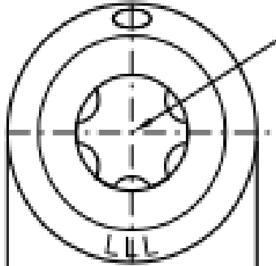

I

**0 dh**

**ti:p type**

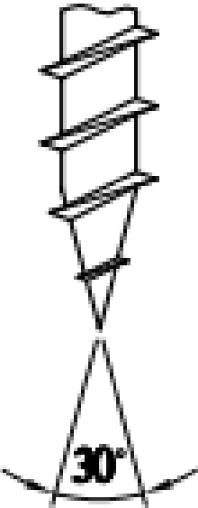

.

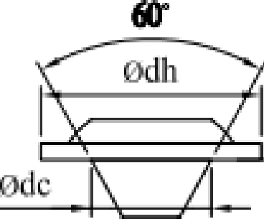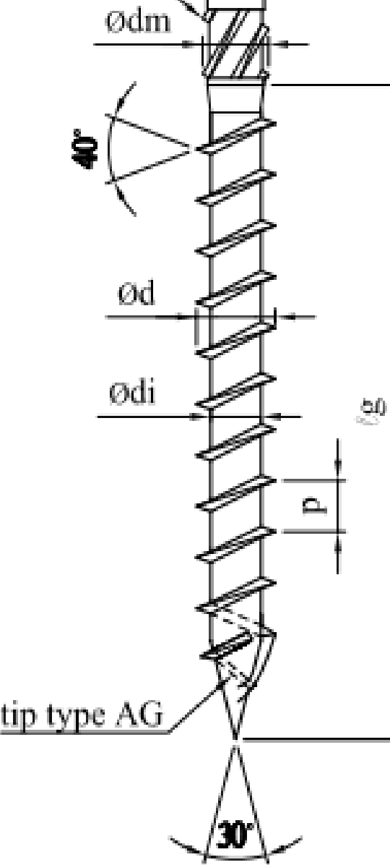

**0 d.**

**o ltional::**

**millbi.,g** ri

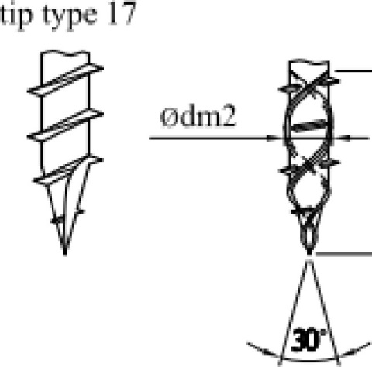

**tip type** D .·**G**

**0.**

".9'

I

·. ·

*:* ·.·.

.

......... . · . .. · ....

.· .·.

..·



|  |  |  |  |  |  |  |  |  |  |  |  |  |  |
| --- | --- | --- | --- | --- | --- | --- | --- | --- | --- | --- | --- | --- | --- |
| **Paneltwistec AG Small Washer Head Screw**  **Head Pull-Through Design Values P (lb)** | | | | | | | | | | | | | **Allowable Tension Capacity (lb)** |
| **Nominal Screw Diameter** | | **Head Diameter** | | **Side Member Thickness (in)** | **Specific Gravity** | | | | | | | |
| **(mm)** | **(in)** | **(mm)** | **(in)** | 0.31 | 0.36 | 0.42 | 0.46 | 0.50 | 0.55 | 0.67 | 0.73 |
| 8.0 | 0.315 | 18.0 | 0.709 | 3/4 | 111 | 149 | 203 | 244 | 288 | 349 | 517 | 614 | 2,250 |
| 1 1/2 | 221 | 299 | 406 | 488 | 576 | 697 | 1,034 | 1,228 |
| 3 1/2 | 262 | 353 | 480 | 576 | 680 | 823 | 1,222 | 1,450 |

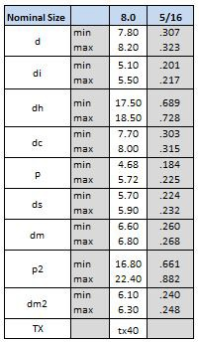**Paneltwistec AG Small Washer Head Screw Paneltwistec AG Small Washer Head Screw Dimensions thread length**

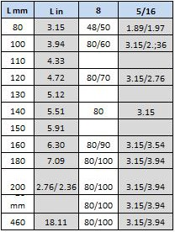

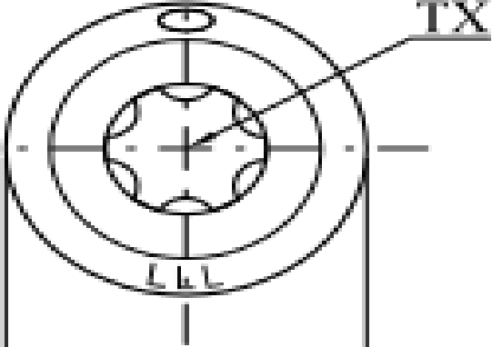

**0dh**

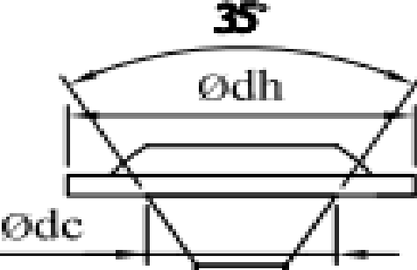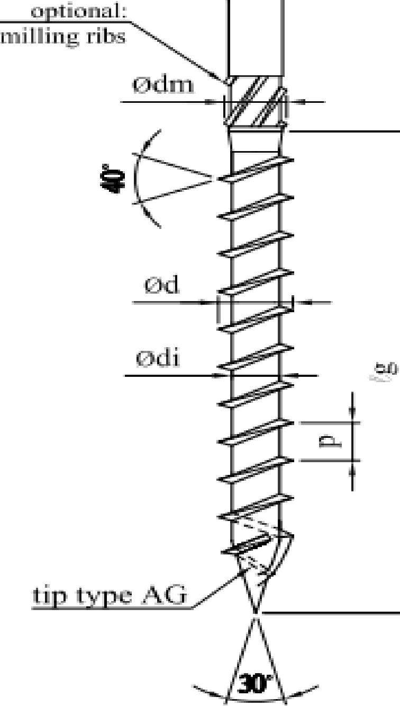

**d .**

...J

|  |  |  |  |  |  |  |  |  |  |  |  |  |
| --- | --- | --- | --- | --- | --- | --- | --- | --- | --- | --- | --- | --- |
| **KonstruX ST Lateral Design Values Z (lb) - Both Members Loaded Parallel to Grain** | | | | | | | | | | | | |
| **Nominal Screw Diameter** | | **Dowel Bending Yield (psi)** | **Side Member Thickness (in)** | **Min. Screw Length (in)** | **Specific Gravity** | | | | | | | |
| **(mm)** | **(in)** | 0.31 | 0.36 | 0.42 | 0.46 | 0.50 | 0.55 | 0.67 | 0.73 |
| 6.5 | 0.256 | 143,000 | 3/4 | 3 1/4 | 94 | 109 | 128 | 142 | 156 | 175 | 225 | 252 |
| 1 1/2 | 4 | 110 | 134 | 167 | 190 | 205 | 224 | 269 | 291 |
| 3 1/2 | 6 | 132 | 152 | 175 | 190 | 205 | 224 | 269 | 291 |
| 8.0 | 0.315 | 159,000 | 3/4 | 3 3/4 | 116 | 134 | 155 | 170 | 186 | 207 | 260 | 289 |
| 1 1/2 | 4 1/2 | 127 | 153 | 188 | 213 | 240 | 276 | 334 | 361 |
| 3 1/2 | 6 1/2 | 164 | 188 | 217 | 236 | 255 | 278 | 334 | 361 |
| 10.0 | 0.394 | 169,000 | 3/4 | 4 1/2 | 119 | 156 | 186 | 203 | 221 | 243 | 301 | 332 |
| 1 1/2 | 5 1/4 | 148 | 175 | 212 | 238 | 267 | 304 | 404 | 438 |
| 3 1/2 | 7 1/4 | 199 | 228 | 263 | 286 | 309 | 337 | 404 | 438 |

|  |  |  |  |  |  |  |  |  |  |  |  |  |
| --- | --- | --- | --- | --- | --- | --- | --- | --- | --- | --- | --- | --- |
| **KonstruX ST Lateral Design Values Z (lb) - Both Members Loaded Perpendicular to Grain** | | | | | | | | | | | | |
|  | | **Dowel Bending Yield (psi)** | **Side Member Thickness (in)** | **Min. Screw Length (in)** | **Specific Gravity** | | | | | | | |
| **(mm)** | **(in)** | 0.31 | 0.36 | 0.42 | 0.46 | 0.50 | 0.55 | 0.67 | 0.73 |
| 6.5 | 0.256 | 143,000 | 3/4 | 3 1/4 | 75 | 87 | 103 | 114 | 125 | 140 | 180 | 202 |
| 1 1/2 | 4 | 88 | 108 | 134 | 152 | 164 | 179 | 215 | 233 |
| 3 1/2 | 6 | 106 | 121 | 140 | 152 | 164 | 179 | 215 | 233 |
| 8.0 | 0.315 | 159,000 | 3/4 | 3 3/4 | 93 | 107 | 124 | 136 | 149 | 165 | 208 | 231 |
| 1 1/2 | 4 1/2 | 102 | 123 | 150 | 171 | 192 | 221 | 267 | 289 |
| 3 1/2 | 6 1/2 | 131 | 151 | 174 | 189 | 204 | 223 | 267 | 289 |
| 10.0 | 0.394 | 169,000 | 3/4 | 4 1/2 | 95 | 125 | 149 | 163 | 177 | 195 | 241 | 266 |
| 1 1/2 | 5 1/4 | 118 | 140 | 170 | 191 | 213 | 243 | 323 | 350 |
| 3 1/2 | 7 1/4 | 159 | 183 | 211 | 229 | 247 | 270 | 323 | 350 |

|  |  |  |  |  |  |  |  |  |  |  |
| --- | --- | --- | --- | --- | --- | --- | --- | --- | --- | --- |
| **KonstruX ST Withdrawal Design Values W (lb/in)** | | | | | | | | | | **Allowable Tension Capacity (lb)** |
| **Nominal Screw Diameter** | | **Specific Gravity** | | | | | | | |
| (mm) | (in) | 0.31 | 0.36 | 0.42 | 0.46 | 0.50 | 0.55 | 0.67 | 0.73 |
| 6.5 | 0.256 | 112 | 140 | 176 | 202 | 229 | 264 | 355 | 404 | 1,900 |
| 8.0 | 0.315 | 131 | 163 | 206 | 236 | 268 | 309 | 415 | 472 | 2,800 |
| 10.0 | 0.394 | 154 | 193 | 244 | 279 | 316 | 365 | 491 | 558 | 3,700 |

|  |  |  |  |  |  |  |  |  |  |  |  |  |  |
| --- | --- | --- | --- | --- | --- | --- | --- | --- | --- | --- | --- | --- | --- |
| **KonstruX ST Cylinder Head Screw -- Head Pull-Through Design Values P (lb)** | | | | | | | | | | | | | **Allowable Tension Capacity (lb)** |
| **Nominal Screw Diameter** | | **Head Diameter** | | **Side Member Thickness (in)** | **Specific Gravity** | | | | | | | |
| **(mm)** | **(in)** | **(mm)** | **(in)** | 0.31 | 0.36 | 0.42 | 0.46 | 0.50 | 0.55 | 0.67 | 0.73 |  |
| 6.5 | 0.256 | 8.0 | 0.315 | 3/4 | 49 | 66 | 90 | 108 | 128 | 155 | 230 | 273 | 1,900 |
| 1 1/2 | 52 | 70 | 95 | 114 | 134 | 163 | 241 | 286 |
| 3 1/2 | 52 | 70 | 95 | 114 | 134 | 163 | 241 | 286 |
| 8.0 | 0.315 | 10.0 | 0.394 | 3/4 | 62 | 83 | 113 | 135 | 160 | 194 | 287 | 341 | 2,800 |
| 1 1/2 | 81 | 109 | 148 | 178 | 210 | 254 | 377 | 448 |
| 3 1/2 | 81 | 109 | 148 | 178 | 210 | 254 | 377 | 448 |
| 10.0 | 0.394 | 13.0 | 0.512 | 3/4 | 80 | 108 | 147 | 176 | 208 | 252 | 374 | 443 | 3,700 |
| 1 1/2 | 136 | 184 | 250 | 300 | 355 | 429 | 637 | 756 |
| 3 1/2 | 136 | 184 | 250 | 300 | 355 | 429 | 637 | 756 |

|  |  |  |  |  |  |  |  |  |  |  |  |  |  |
| --- | --- | --- | --- | --- | --- | --- | --- | --- | --- | --- | --- | --- | --- |
| **KonstruX ST Countersunk Head 60o or 90o Screw - Head Pull-Through Design Values P (lb)** | | | | | | | | | | | | | **Allowable Tension Capacity (lb)** |
| **Nominal Screw Diameter** | | **Head Diameter** | | **Side Member Thickness (in)** | **Specific Gravity** | | | | | | | |
| **(mm)** | **(in)** | **(mm)** | **(in)** | 0.31 | 0.36 | 0.42 | 0.46 | 0.50 | 0.55 | 0.67 | 0.73 |
| 6.5 | 0.256 | 11.50 | 0.453 | 3/4 | 71 | 95 | 130 | 156 | 184 | 223 | 330 | 392 | 1,900 |
| 1 1/2 | 107 | 144 | 196 | 235 | 278 | 336 | 499 | 592 |
| 3 1/2 | 107 | 144 | 196 | 235 | 278 | 336 | 499 | 592 |
| 8.0 | 0.315 | 14.50 | 0.571 | 3/4 | 89 | 120 | 164 | 196 | 232 | 281 | 417 | 495 | 2,800 |
| 1 1/2 | 170 | 229 | 312 | 374 | 442 | 534 | 793 | 941 |
| 3 1/2 | 170 | 229 | 312 | 374 | 442 | 534 | 793 | 941 |
| 10.0 | 0.394 | 17.80 | 0.701 | 3/4 | 109 | 148 | 201 | 241 | 285 | 345 | 511 | 607 | 3,700 |
| 1 1/2 | 219 | 295 | 402 | 482 | 570 | 689 | 1,023 | 1,214 |
| 3 1/2 | 256 | 345 | 469 | 563 | 665 | 805 | 1,195 | 1,418 |

|  |  |  |  |  |  |  |  |
| --- | --- | --- | --- | --- | --- | --- | --- |
| **KonstruX ST Countersunk Head 60o or 90o Screw - dimensions** | | | | | | | |
| **Nominal size** |  | **6.5 mm** | **¼”** | **8.0 mm** | **5/16”** | **10 mm** | **3/8”** |
| d | min max | 6.20 6.80 | .126 .268 | 7.60 8.13 | .299 .327 | 9.60 10.20 | .378 .402 |
| di | min max | 4.20 4.80 | .165 .189 | 4.90 5.40 | .193 .213 | 5.70 6.10 | .224 .240 |
| dh | min max | 7.70 8.30 | .303 .327 | 9.50 10.50 | .374 .413 | 12.50 13.50 | .492 .531 |
| hh | min max | 5.00 6.00 | .197 .236 | 6.00 7.00 | .236 .276 | 6.00 7.00 | .236 .276 |
| p | min max | 2.70 3.30 | .106 .130 | 3.40 4.20 | .134 .165 | 4.10 5.10 | .161 .201 |
| dt | min max | 4.10 4.50 | .161 .177 | 4.70 5.10 | .185 .201 | 5.30 5.70 | .209 .224 |
| lt | min max | 3.50 5.00 | .138 .197 | 4.00 5.00 | .157 .197 | 5.00 6.00 | .197 .236 |
| dh2 | min max | 11.00  12.00 | .433 .472 | 14.00 15.00 | .551 .591 | 17.30 18.30 | .681 .720 |
| hh2 | min max | 5.40 5.90 | .213 .232 | 7.00 7.40 | .276 .291 | 7.30 7.70 | .287 .303 |
| dh3 | min max |  |  | 21.50 22.50 | .846 .886 | 19.50 20.50 | .768 .807 |
| dm | min max | 4.60 5.20 | .181 .205 | 5.40 6.20 | .213 .244 | 6.10 6.90 | .240 .272 |
| tx | size | tx30 |  | tx40 |  | tx50 |  |

|  |  |  |  |  |  |
| --- | --- | --- | --- | --- | --- |
| **KonstruX ST Countersunk Head 60o or 90o Screw -**  **thread lengths** | | | | | |
| **6.5**  **mm** | **¼”** | **8.0**  **mm** | **5/16”** | **10.0**  **mm** | **3/8”** |
| 80-2.0 | 3.15 | 95-2.0 | 3.74 | 125-2.0 | 4.92 |
| 100-2.0 | 3.94 | 125-2.0 | 4.92 | 155-2.0 | 6.1 |
| 120-2.0 | 4.72 | 155-2.0 | 6.1 | 195-2.0 | 7.68 |
| 140-2.0 | 5.51 | 195-2.0 | 7.68 | 220-3.0 | 8.66 |
| 160-2.0 | 6.30 | 220-3.0 | 8.66 | 245-3.0 | 9.65 |
| 195-2.0 | 7.68 | 245-3.0 | 9.65 | 270-3.0 | 10.63 |
|  |  | 275-3.0 | 10.83 | 300-3.0 | 11.81 |
|  |  | 295-3.0 | 11.61 | 330-4.0 | 12.99 |
|  |  | 330-4.0 | 12.99 | 360-4.0 | 14.17 |
|  |  | 375-4.0 | 14.76 | 400-4.0 | 15.75 |
|  |  | 400-4.0 | 15.75 | 450-5.0 | 17.72 |
|  |  | 430-5.0 | 16.93 | 500 5.0 | 19.69 |
|  |  | 480-5.0 | 18.9 | 550-5.0/+2.0 | 21.65 |
|  |  |  |  | 600-5.0/+2.0 | 23.62 |

**co nlersun** I ead -

**!lft**



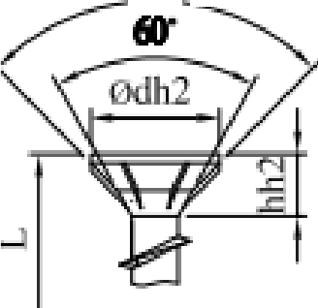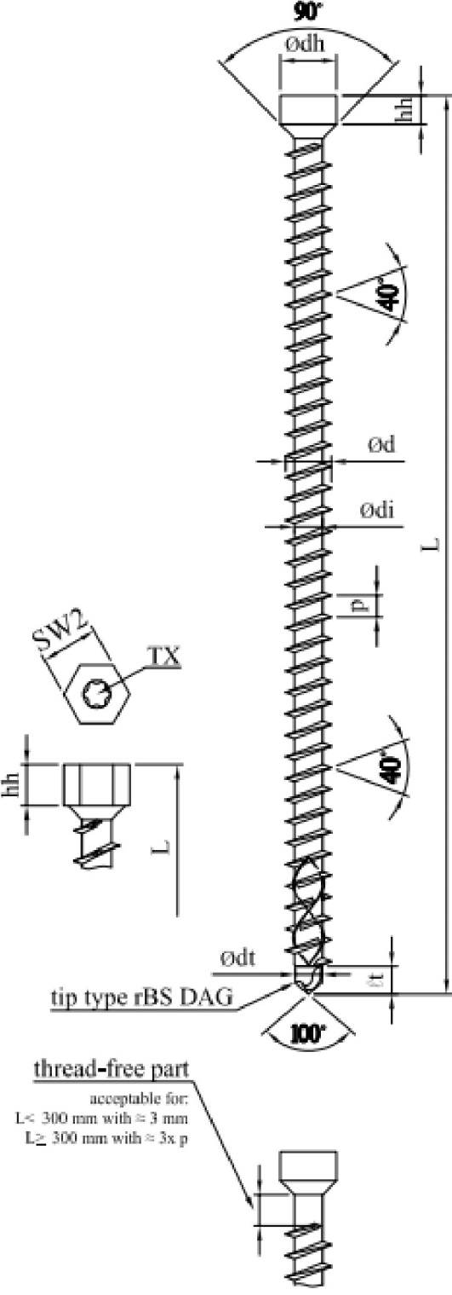

*1?· -*

**hexagon head 2**

**was**.**h**.**er head**

