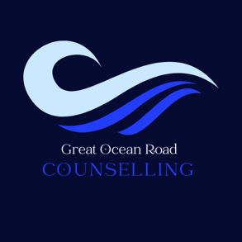
Self-Referral Form
Confidential
Please fill out this form and bring it to your 1st session info@greatoceanroadcounselling.com

- Name: Click or tap here to enter text.
- Date of birth: Click or tap here to enter text.
- Mobile number: Click or tap here to enter text.
- Email: Click or tap here to enter text.
- Reason for seeking counselling: Click or tap here to enter text.

- Additional needs: Interpreter (Language………………….) Hearing; Vision; Access, other: Click or tap here to enter text.
By signing below I consent to being contacted by Great Ocean Road Counselling for the purpose of making an appointment. The brief intake call (at no charge) is to ensure we are the right counselling service for you. This information will not be shared with anyone without your consent and will not be used for any marketing purposes. Your privacy is protected.
Your signature: Click or tap here to enter text.
Date: Click or tap here to enter text.

Great Ocean Road Counselling

- Address: 97 Great Ocean Road, Anglesea Victoria 3230 - OHM
- Reception /Bookings 03 5263 1001
- Wednesday only in Anglesea – OHM Ocean Road Allied Health & Movement
- Email: info@greatoceanroadcounselling.com
- Text: 045 123 4455

