**MERS 50th Reunion - Main Events**

**Reception - Private Tour of the Norman Rockwell Museum:**



**Date**: September 23, 2017

**Time:** 3:45 PM in the parking lot (be on time). Terrace Reception 5:30 – 7:00PM

**Tickets:** Purchase ticket in advance or add $16 ticket cost to Reunion Cost of $60 per alum’s & spouse/significant other. $60 for non-Class of 67 persons.

**Location:** Norman Rockwell Museum  
9 Glendale Road / Route 183

Stockbridge, MA 01262

**Website:** [www.nrm.org/visit](http://www.nrm.org/visit)

**Telephone:** 413-298-4100

**Brunch - Rawson Brook Farm – Home of Monterey Chevre:**

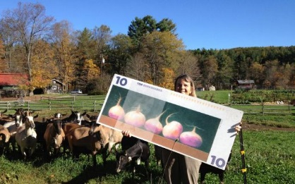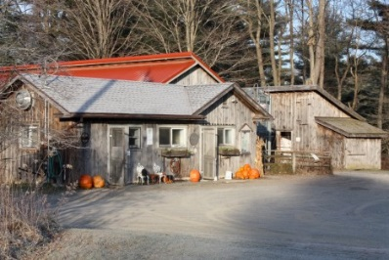

**Date:** September 24, 2017

**Time:** 10:00AM to 12:00PM

**Location:** 185 New Marlboro Road

Monterey, Massachusetts 01245

**Website:** facebook

**Telephone:** 413-528-2138

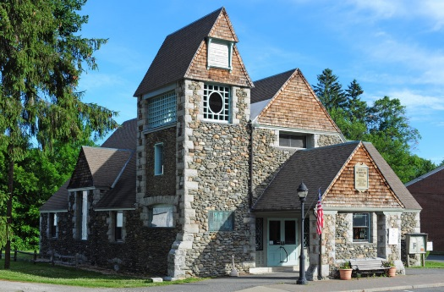**Catered Dinner – Dewey Memorial Hall:**

**Date:** September 24, 2017

**Time:** 6:00PM to 9:30PM

**Location:** 91 Main Street

Sheffield, Massachusetts 01257

**Website:** http://deweyhall.com

**Telephone:** 413-229-2357

**Food and Beverages for All Events**

**Beverages (all venues):**

Soft Drinks: Diet Coke, Root Beer, 7-up and Berkshire Bottled Water.

Coffee: Caffeinated and decaffeinated

BYOB Mixers: Tonic (quinine), Club Soda, 7-Up (bring your own distilled spirits).

Beer/Lager: Brooklyn Lager, India Pale Ale, Stella Artois, Bud Long Necks, Miller Lite bottles.

Wine: Red & White *(American)* selections by Rod Ruthel the Class of 1967 Sommelier.

**Lite Fare at Rockwell Museum:**

Terrace Reception after the tour - Sandwich Platter, Fruit Platter, Pasta Salad, Green Salad.

**Brunch at Rawson Brook Farm:**

Breakfast Sandwiches – egg & cheese, bacon egg & cheese, sausage egg & Cheese.

Fruit Bowl, hard boiled eggs, croissant, and pastries.

**Reunion Dinner – Dewey Memorial Hall**



*While we will put our best efforts into satisfying everyone’s Food and Beverage choices and we will make sure there is an entre for everyone, we simply cannot guarantee you will receive your first choices. All Food and Beverage items shown on the menu are subject to change in whole or in part. and we apologize in advance for any inconvenience that may result from such changes or lack of availability.*