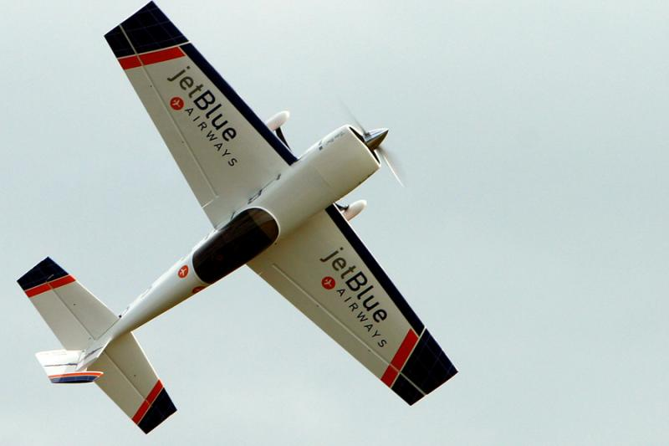
RICE COUNTY RADIO CONTROL FLYERS
NEW MEMBERSHIP APPICATION
NAME: ___________________________________
Address: __________________________________
City: ______________________________________
State: ___________________ Zip: ______________
E-Mail: ____________________________________
Phone Number: _____________________________
AMA Membership: __________________________

____ $ 135.00 1-year adult membership
____ $ 25.00 Field assessment (1 time new membership only)
____ $ 35.00 1-year youth membership (not yet 19 years of age)
____ $ 20.00 late fee if renewing your membership after 2/1 (renewal only, does not apply to new memberships.

Total Enclosed $ __________

I, the undersigned, hereby apply for membership in the Rice County Radio Control Flyers. I have read and understand the rules and field procedures and I agree to abide by these rules and procedures a as member of club.
(Signed): _________________________________ Date: _________________

Please send form and check or money order payable to: (Rice County Radio Control Flyers)

Tim Schulte
1009 Lacota Ln
Burnsville, MN 55337

