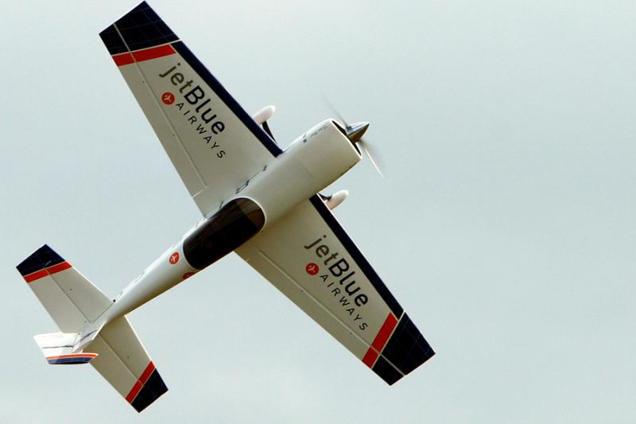**RICE COUNTY RADIO CONTROL FLYERS  
MEMBERSHIP APPICATION**

NAME: ___________________________________

Address: __________________________________

City: ______________________________________

State: ___________________ Zip: ______________

E-Mail: ____________________________________

Phone Number: _____________________________

AMA Membership: __________________________

____ $ 135.00 1-year adult membership

____ $ 25.00 Field assessment (1 time new membership only)

____ $ 35.00 1-year youth membership (not yet 19 years of age)

____ $ 20.00 late fee if renewing your membership after 2/1 (renewal only, does not apply to new memberships.

**Total Enclosed $ __________**

I, the undersigned, hereby apply for membership in the Rice County Radio Control Flyers. I have read and understand the rules and field procedures and I agree to abide by these rules and procedures a as member of club.

(Signed): _________________________________ Date: _________________

Please send form and check or money order payable to: (Rice County Radio Control Flyers)

Michael Dewar

2105 Lincoln Street South

Northfield MN 55057