Patient Registration & Health History

Name_______________________________ Date _______________Age _______________Sex: ☐ Male ☐ Female
Address_______________________________________City____________________State______Zip_________ Phone: Home___________________ Cell___________________ Patient Primary Language________________
E-mail___________________________________ SSN_____________________ Date of Birth________________ Occupation____________________________________ Employer’s Name _______________________________ ☐ Single ☐ Married ☐ Divorced ☐ Widowed Spouse’s Name_________________________________ In Case of Emergency Call________________________________________ Phone # _____________________
Who may we thank for referring you? ___________________________________________________________
Have you ever had Chiropractic care before? Yes ☐ No ☐ Date: ___________________
Insurance Information
Name of party responsible for payment _____________________________ Phone # _____________________________
Do you have health insurance? Yes ☐ No ☐ Name of company ___________________________________________
* If reason for visit is an auto accident, please provide: Auto Insurance Company Name _________________________
Contact Person ____________________ Phone: _____________________ Claim # ______________________________
Name of the insured ________________________________________________________________________
If you want us to bill to your Insurance, please sign this Assignment and Release
I certify that I, and/or my dependent(s), have insurance coverage with ___________ and assign directly to Dr.Jonathan Zuchowski, all insurance benefits, if any, otherwise payable to me for services rendered. I understand that I am financially responsible for all charges whether paid by insurance. I authorize the use of my signature on all insurance submissions . The above named doctor may use my health care information and may disclose such information to the above named Insurance Company(ies ) and their agents for the purpose of obtaining payment for services and determining insurance benefits or the benefits payable for related services.
Patient’s signature _______________________________________________ Date ____________________
Spouse’s or guardian’s signature ____________________________________ Date ____________________
Why Chiropractic? People go to Chiropractors for a variety of reasons. Some go for symptomatic relief of pain or discomfort (Relief Care). Others are interested in having the cause of the problem as well as the symptoms corrected and relieved (Corrective Care). Your doctor will weigh your needs and desires when recommending your treatment program. Please check the box for the type of care that best meets your needs.

☐
RELIEF CARE:
Relief Care is that care necessary to get rid of your symptoms or pain, but not the cause of it.
CORRECTIVE CARE:
Corrective care differs from relief care in that its goal is to get rid of the symptoms or pain while correcting the cause of the problem. Corrective care varies in length of time but is more lasting.

☐
Health History
Do you have any allergies? ☐Yes ☐No if yes Specify type(s)________________________________________________
Please Check All Current Problems You Have:
☐ Dizziness  ☐ Headaches  ☐ Vertigo  ☐ Ear Infections  ☐ Nausea  ☐ TMJ  ☐ Neck Pain  ☐ Migraines  ☐ Throat Issues  ☐ Chronic Sinus  ☐ Loss of Consciousness | ☐ Asthma  ☐ Numbness in Arms  ☐ Numbness in Hands  ☐ Mid Back Pain  ☐ Shoulder pain  ☐ Arm Pain  ☐ Chest Pain  ☐ Nasua/Vomiting  ☐ Heart Disorders  ☐ High/low Blood Pressure  ☐ Liver Disease | ☐ Stomach Disorders  ☐ Bladder Problems  ☐ Thyroid Problems  ☐ Kidney Problems  ☐ Low Back Pain  ☐ Numbness in Legs  ☐ Numbness in Feet  ☐ Sciatica  ☐ Leg Pain  ☐ Knee Pain  ☐ Hip Pain | ☐ Anxiety  ☐ ADHD/ADD  ☐ Depression  ☐ Nervousness  ☐ Epilepsy  ☐ Infertility  ☐ Menstrual Disorder  ☐ Chronic Fatigue  ☐ Gastric Reflux  ☐ Lupus  ☐ Fibromyalgia | ☐ Diabetes  ☐ Disc Problem  ☐ Broken/Fractured bones  ☐ Gout  ☐ Constipation/ Diarrhea  ☐ Other: 1.______________ 2.______________ 3.______________ 4.______________ 5.______________

Family Health History
Family History: Please write who the relation is and how old they were when had the disease, including yourself.
Alzheimer’s _____________________ Headache _____________________ Backache _____________________ Cancer _________________________ Heart Disease__________________ Depression____________________ Stroke__________________________ Dementia______________________ Diabetes (1/ 2)_________________ Osteoporosis____________________ Spinal Surgery__________________ Anxiety ____________________
Abdominal Aortic Aneurysm (AAA):__________________________________
High Blood Pressure______________________________________________

Primary Care Physician:
Physician Name: ___________________________________________________
Address: __________________________________________________________
Phone#: (______)___________________________________________________

Prescription Medications:
____________________________________________ date started ___/___/_____ date stopped ___/___/____ ____________________________________________ date started ___/___/_____ date stopped ___/___/____ ____________________________________________ date started ___/___/_____ date stopped ___/___/____ Please list any additional medications on the back of this form Vitamins / Supplements: ____________________________________________ prescribed by Dr? Y N ____________________________________________ prescribed by Dr? Y N ____________________________________________ prescribed by Dr? Y N

History of Health Concerns
If you have additional symptoms (3+) and require another symptom sheet, please ask for an “Additional Symptom” form

Please start at the top of your body and work your way down
Please mark on the diagram with the following letters to describe your symptoms:
R=Radiating B=Burning D=Dull A=Aching S=Sharp/Stabbing T=Tingling N=Numbness
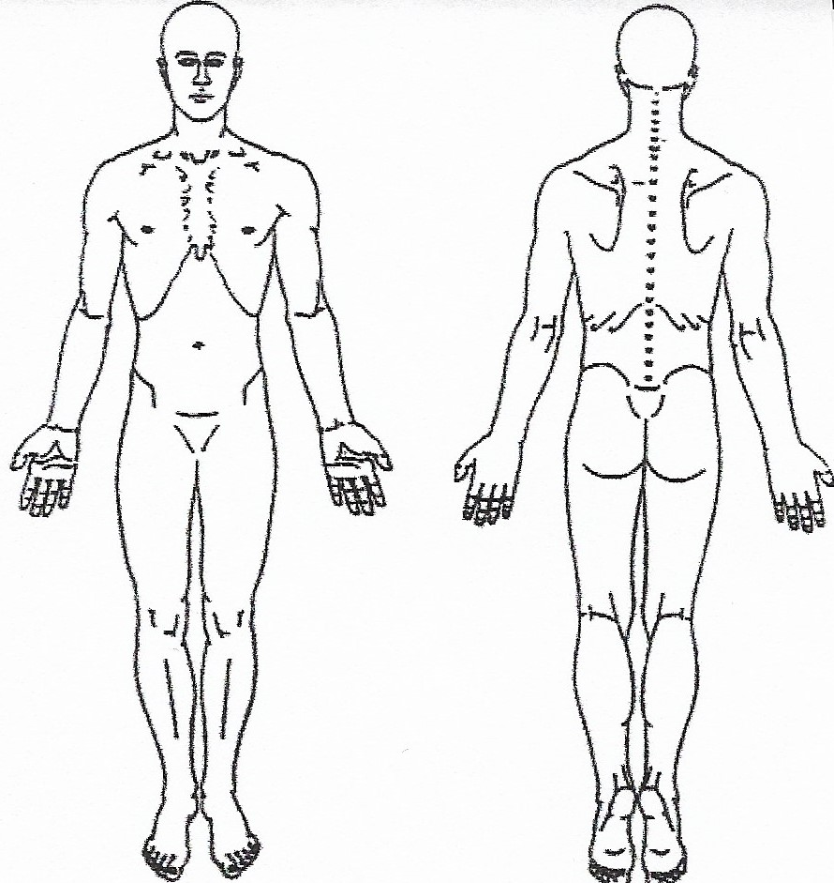
Symptom 1: ___________________________________________________
• On a scale of 1 – 10, 10 being the worst pain you’ve ever felt,
what is the severity of your symptom?
1 2 3 4 5 6 7 8 9 10
• What percent of the time do you feel the symptom?
0% 10% 20% 30% 40% 50% 60% 70% 80% 90% 100%
• When did this episode begin? __________________________
• Did it begin: ☐ Suddenly ☐ Gradually
• Describe how it began ___________________________________ _______________________________________________________
• Have you had the symptom in the past before? ☐ Yes ☐ No
• If yes, when was the first time you’ve ever felt the symptom: ________________________________________________________
• What makes the symptom worse? ________________________________________________________ • What makes the symptom better? ________________________________________________________ • Does the pain radiate? ☐ Yes ☐ No
• If yes, describe in detail where it radiates ________________________________________________________
________________________________________________________
________________________________________________________
• Does the pain feel worse at a particular time of day? ☐ Morning ☐ Afternoon ☐ Early evening ☐ Late at night ☐ Unchanged by time of day

Symptom 2: ___________________________________________________
Please mark on the diagram with the following letters to describe your symptoms:
R=Radiating B=Burning D=Dull A=Aching S=Sharp/Stabbing T=Tingling N=Numbness
• On a scale of 1 – 10, 10 being the worst pain you’ve ever felt,
what is the severity of your symptom?
1 2 3 4 5 6 7 8 9 10
• What percent of the time do you feel the symptom?
0% 10% 20% 30% 40% 50% 60% 70% 80% 90% 100%
• When did this episode begin? __________________________
• Did it begin: ☐ Suddenly ☐ Gradually
• Describe how it began ___________________________________ _______________________________________________________
• Have you had the symptom in the past before? ☐ Yes ☐ No
• If yes, when was the first time you’ve ever felt the symptom: ________________________________________________________
• What makes the symptom worse? ________________________________________________________ • What makes the symptom better? ________________________________________________________ • Does the pain radiate? ☐ Yes ☐ No
• If yes, describe in detail where it radiates ________________________________________________________
________________________________________________________
________________________________________________________
• Does the pain feel worse at a particular time of day? ☐ Morning ☐ Afternoon ☐ Early evening ☐ Late at night ☐ Unchanged by time of day
Patients Desire for Care Outcomes(s)
Are you interested in anything in particular as a result of your care, if so, please list below
1.________________________________________________________________________________________2.________________________________________________________________________________________3.________________________________________________________________________________________
*Patient Signature:___________________________________________________ Date:_______________________

Social History

Smoking: ☐Cigars ☐Pipe ☐Cigarettes ☐E-Cigarettes How Often? ☐Daily ☐Weekends ☐Occasionally ☐Never Alcoholic Beverages: Consumption occurs: ☐Daily ☐Weekends ☐Occasionally ☐Never Recreational Drug Use: ☐Daily ☐Weekends ☐Occasionally ☐Never Caffeine intake: ☐ Coffee ☐Tea ☐Energy Drink ☐Daily ☐Weekends ☐Occasionally ☐Never Do you exercise? ☐Yes ☐No 1x 2x 3x 4x 5x per week Other_________ If Yes Than What Activities? ☐Running/ Walking ☐Weight Training ☐Cycling ☐Yoga/Pilates ☐Other_________ Hobbies How does your present problem affect the following: ☐Recreational Activities ☐Exercise Regime Please Explain:_____________________________________________________________________________

Activities of Life
Please identify how your current condition is affecting your ability to carry out activities that are routinely part of your life:
Activities | No Effect | Painful (can do) | Painful (limits) | Unable to Perform
Carrying Groceries
Lifting Groceries
Sit to Stand
Climbing Stairs
Pet Care
Driving
Extended Computer Use
Household Chores
Lifting Children
Concentration (reading)
Bathing
Dressing
Shaving
Sexual Activities
Sleep
Static Siting
Static Standing
Yard Work
Walking
Washing/Bathing
Sweeping/ Vacuuming
Dishes
Laundry
Garbage
Dressing
Other:

