Purely By Chance Farm CSA 2018 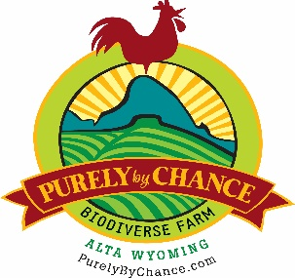
First Dibs
Sue and I would like to thank you for supporting Purely By Chance Farm for the past several years. We know that without your support and encouragement we would not be able to sustain the production of high quality, pasture-raised broiler chicken, turkeys, pigs and eggs. We feel blessed that you look to us when making decisions about how to feed yourselves and your families.
This year will be a little different in that we have some projects that need attention (deferred maintenance on the farm) so we will be producing fewer birds and participating in fewer Farmers Markets. We believe that we will sell out again this year by early August.
Because you have purchased from us in the past we are reaching out to you first before we “go public” with our plan for this year. We are asking you to reserve your chickens, turkeys or pork now. We want to make sure that those who have supported us get “first dibs”. Here’s how it will work:
Bulk Orders- 50% deposit required to reserve. Weights range from 3.5 lbs to 5+ lbs.
10 – 19 chickens $27/bird
20 – 29 chickens $26/bird
30 + chickens $25/bird

Pasture Raised Pork- 50% deposit required to reserve.
Whole- $900.00 Half- $450.00. Processing will be additional depending on your choice of processors. Ask us for referrals.
Turkey- $50 deposit required to reserve 10-14 lbs $90.00
15-19 lbs $95.00
20-24 lbs $100.00
25 lbs+ $105.00
Name____________________________________email________________________________Address___________________________________City_________________________________State_____________Zip___________Phone__________________________________________Payment____________________________________

A chicken per week- that’s all we ask…
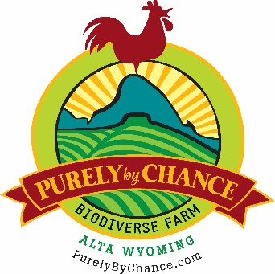
Terms and Conditions
First and foremost we encourage you to come visit our farm in Alta Wyoming to see what we are doing, why we are doing it and how. Call or email us to make sure we are here.
Bulk Broiler Chickens- Reserve your order with 50% deposit with balance due at delivery
Turkeys- Reserve yours with $40.00 deposit balance due on delivery.
Pigs- Reserve with 50% deposit with balance due at delivery.
Is there any risk? Yes. As with any farming enterprise there are potential circumstances that may prevent PBC from delivering on time. While we have a good history of growing delicious, nutrient dense chicken, turkey and pigs over the past several years, we live in an area with a full complement of predators as well as mountain weather beyond our control. Our practices take every precaution from solar powered electrified fencing, to our dogs, Obie and Bubs, but the reality is that we are just two responsible, passionate, high altitude farmers building a sustainable farm. We won’t make promises we can’t keep but we will do everything in our power to fulfill the obligation we have to you to deliver delicious, nutrient dense food that is raised in a sustainable way. Sorry, No Guarantees. You do risk with us. That’s the purpose behind the CSA concept.
How are the chickens raised? We receive day old chicks and place them in a warm brooder until they grow their feathers. That usually takes about two or three weeks. We then put them in portable shelters in groups of 35 to 50 birds out on pasture. These shelters are open on the bottom which allows them access to pasture grass and all the bugs they can catch. They are also fed free choice organic grains and always have fresh water. A portion of the shelter is covered with a tarp to protect them from rain and wind but a large part is open to abundant sunshine and clean air. We move these shelters every day onto fresh grass and that portion of the pasture is not grazed again until next year. This allows the soil to digest the significant nitrogen load that exists in chicken manure. Over the years this has built the soil and has helped heal the land.
Purely By Chance Biodiverse Farm 1955 Bustle Creek Road
Alta, WY 83414
Andy Heffron 307-699-3129 andy@purelybychance.com
Sue Heffron 208-351-0421 sue@purelybychance.com
www.purelybychance.com

