**Purely By Chance/ Mountain Meadows Pastured Poultry 2020**

**Grizzly Bear Approved!**

As many of you have heard, we had an abrupt end to our season last year. A hungry grizzly bear getting ready for hibernation forced his way into our remaining three pens of broiler chickens. Wyoming Game and Fish attempts to capture/relocate were unsuccessful as he moved on after a few nights.

To avoid future confrontations, our goal this year is to finish the season earlier so we are not tempting hyperphagic critters. Therefore, our plan is to close down the broiler operation by the first week of September.

We thank you for supporting our Farm for the past several years and we feel blessed that you consider us when looking for high quality pasture raised meats and eggs.

**2020 CSA Bulk Orders** 50% deposit required. Weights range: 3.5 lbs. to 5+ lbs.

10-19 Chickens $29.00/bird

20-29 Chickens $27.00/bird

30+ Chickens $26.00/bird

**Turkey**- $50.00 deposit required to reserve

10-14 lbs. $98.00

15-19 lbs. $104.00

20-24 lbs. $110.00

**Name_____________________________________________________________email_______________________**

**Address________________________________________________________________________________________**

**Phone ________________________________________________________**

**Payment_____________________________________________________**

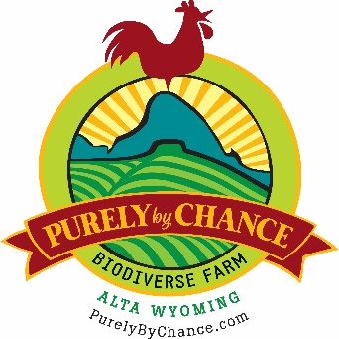

**Terms and Conditions**

First and foremost, we encourage you to come visit our farm in Alta Wyoming to see what we are doing, why we are doing it and how. Call or email us to make sure we are here.

**Bulk Broiler Chickens**- Reserve your order with 50% deposit with balance due at delivery

**Turkeys**- Reserve yours with $50.00 deposit balance due on delivery.

**Is there any risk?** Yes. As with any farming enterprise there are potential circumstances that may prevent PBC from delivering on time. While we have a good history of growing delicious, nutrient dense chickens and turkeys over the past several years, we live in an area with a full complement of predators as well as mountain weather beyond our control. Our practices take every precaution from solar powered electrified fencing, to our dogs, but the reality is that we are just two responsible, passionate, high altitude farmers building a sustainable farm. We won’t make promises we can’t keep but we will do everything in our power to fulfill the obligation we have to you to deliver delicious, nutrient dense food that is raised in a sustainable way. Sorry, No Guarantees. You do risk with us. That’s the purpose behind the CSA concept.

**How are the chickens raised?** We receive day old chicks from Dunlap Hatchery in Caldwell Idaho and place them in a warm brooder until they grow their feathers. That usually takes about two or three weeks. We then put them in portable shelters in groups of 35 to 50 birds out on pasture. These shelters are open on the bottom which allows them access to pasture grass and all the bugs they can catch. They are also fed free choice NON- GMO grains and always have fresh water. A portion of the shelter is covered with a tarp to protect them from rain and wind but a large part is open to abundant sunshine and clean air. We move these shelters every day onto fresh grass and that portion of the pasture is not grazed again until next year. This allows the soil to digest the significant nitrogen load that exists in chicken manure. Over the years this has built the soil and has helped heal the land.

**Purely By Chance Biodiverse Farm** 1955 Bustle Creek Road

Alta, WY 83414

Andy Heffron 307-699-2947 [andy@purelybychance.com](mailto:andy@purelybychance.com) or

Sue Heffron 208-351-0421

[sue@purelybychance.com](mailto:sue@purelybychance.com)

[www.purelybychance.com](http://www.purelybychance.com)