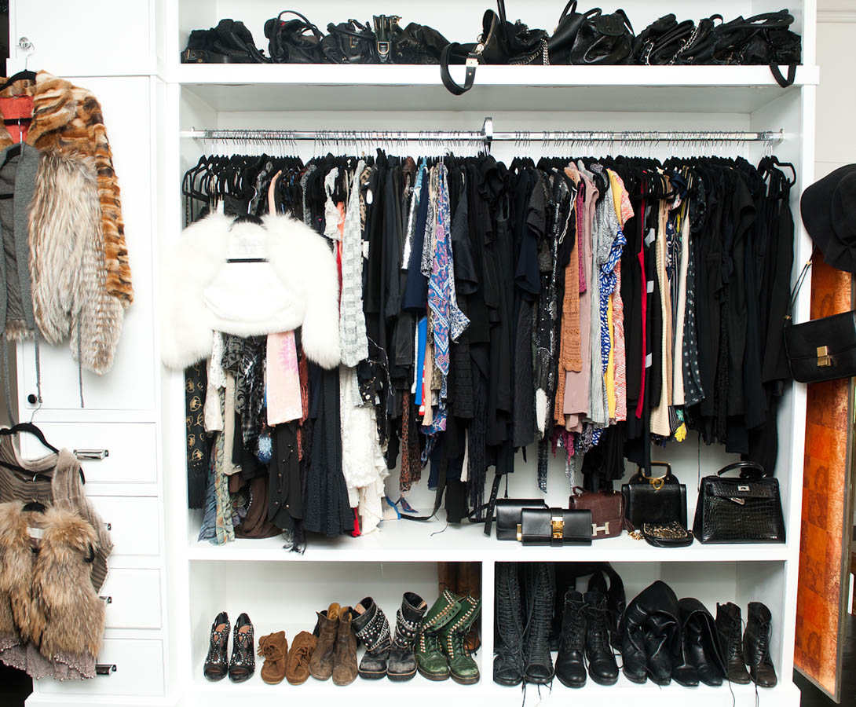

PLEASE STOP BY

POINT BLANK CIVIC CENTER

101 SOUTH COUNTS ROAD

FOR FREE

CHILDREN’S, WOMEN’S, AND MEN’S

CLOTHING

MONDAY AND WEDNESDAY

9:00 A.M. TO 12:00 P. M.