COMMUNITY EVENT
HOSTED BY: POINT BLANK COMMUNITY CHURCH

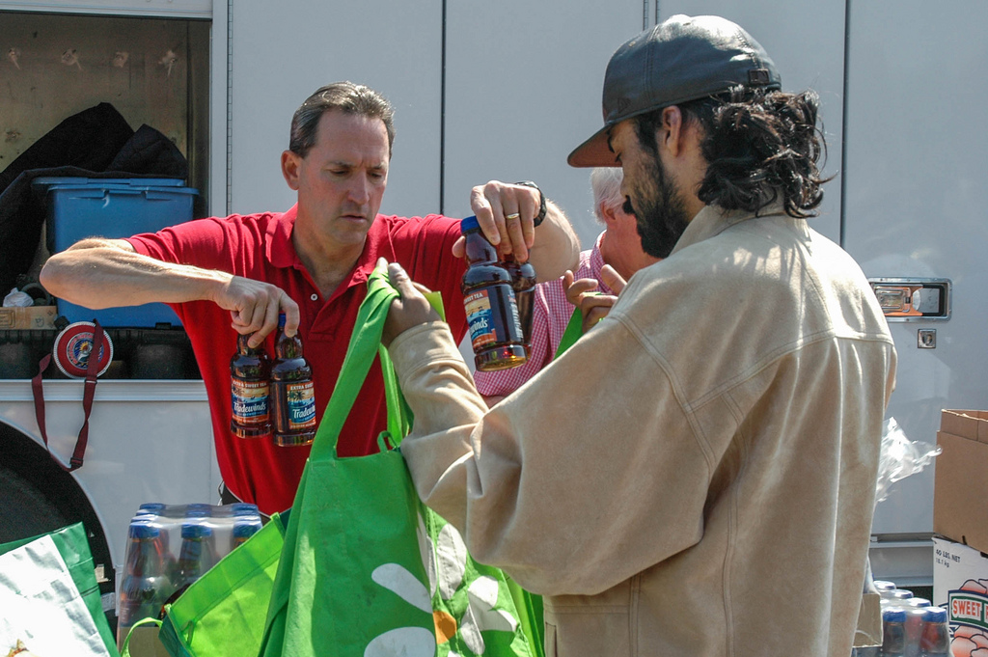
This Photo by Unknown Author is licensed under CC BY-NC-ND

Houston Food Bank Truck will come to
Point Bank Civic Center, 101 South Counts RD,
Point Blank, TX 77364

On the following Dates:

May 10, 2019
June 14, 2019
September 13, 2019
October 11, 2019
November 22, 2019

At
9:30 a.m. to 11:30 a.m.
The Date and Time are subject to change without notice.

