**Making a Picture Book Dummy**

1. First, print out your manuscript with 2.5” margins on both sides, with a double - double space where you envision a page break.
2. Then take 8 sheets of paper. Fold in half lengthwise.
3. Cut 4 sheets at the top and bottom: Cut 4 sheets in the middle:

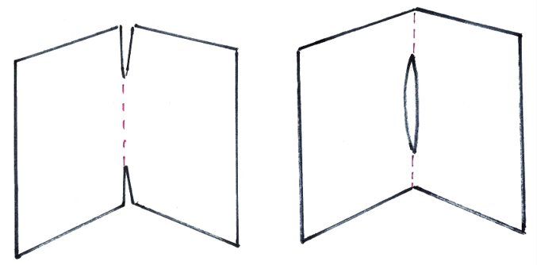

1. Roll the pages cut top and bottom and feed them through the hole in the other 4 pages, to create your 32 page book.
2. Cut your text into sections you envision for each page.
3. Use removable illustrator’s tape to secure your text on the pages.
4. Make notes or otherwise indicate what will be illustrated on each spread.

Remember your first 3 pages (approx.) will be used for the title page, dedication and copyright pages.