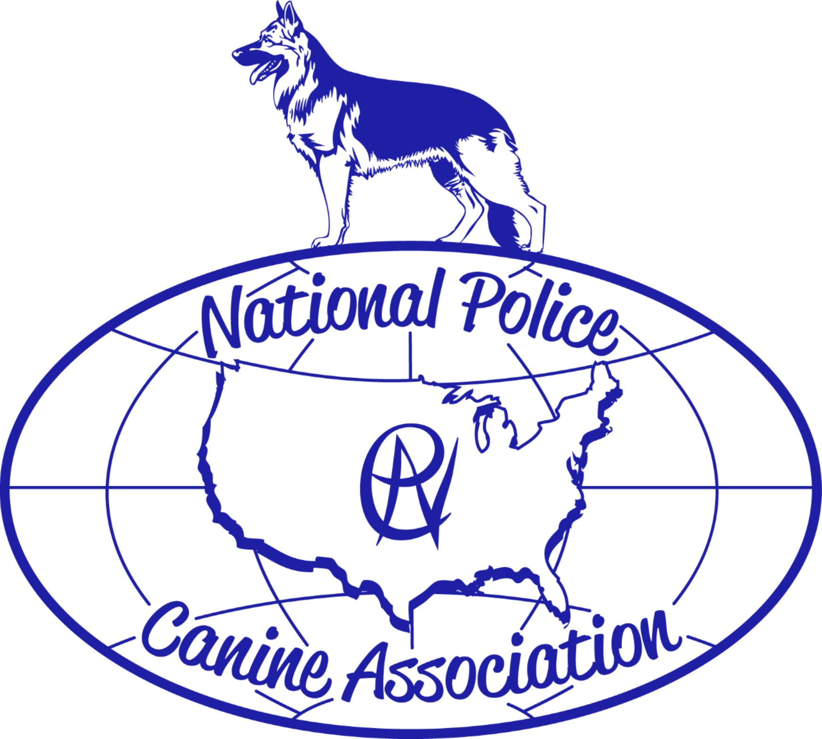

2023 National Training Seminar
Dog-less Seminar

Hilton Palacio Del Rio
200 South Alamo San Antonio, TX 78205

August 28-August 31, 2023

National Police Canine Association
2023 National Training Seminar
San Antonio, Texas
August 28, 2023 – August 31, 2023

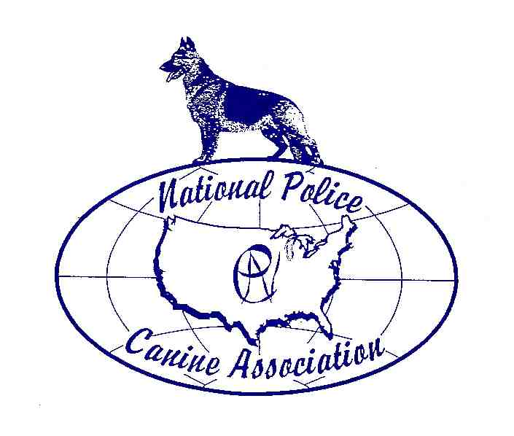
Registration Form:
(Please Print or Type as certificate will be produced from information)

Name:_________________________________________________________________________________

Mailing Address:_________________________________________________________________________

City:________________________________________________State:_________Zip code:______________

Home:(_____)______-____________Cell:(_____)________-__________

Email:________________________________ Phone # For Text Messages:__________________________

Agency:________________________________________________________________________________

Agency Address:_________________________________________________________________________

City:_______________________________________________State:___________Zip Code:____________

Work Phone:_______________________

Number of years with Law Enforcement K-9 experience: ______

Cost: Seminar Fee - $325.00 members $375.00 non-members
Registrations received by June 1st, 2023

(If you register more than one from your agency the fee or training group will be $300.00 per person for members and $350.00 per person for non-members)

After June 1st, 2023 $350.00 members $400.00 non-members
(If you register more than one from your agency or training group the fee will be $325.00 per person for members and $375.00 per person for non-members)

Membership Fee - $40.00

Register and Pay by June 1st, 2023 and receive a free conference hat.

Registration will be held on Monday August 28th, starting at 1600 hrs at the host hotel. Late Registration will be on August 29th, 0700 hrs.

Contact Information:
Katy Farnsworth/Mark Green
Cell# 623-826-2960/602-568-2134
Email-k.farnsworth@npca.net/m.green@npca.net

Hotel: Hilton Palacio Del Rio
200 South Alamo San Antonio, TX 78205
https://

Guest Rooms | Single Rate | Double Rate | Triple Rate | Quad Rate
Traditional Guest Rooms | $139 | $139 | $159 | $179

Rooms held at this rate plus tax, until July 28th, 2023, after cut-off, room rates range from $249-$300
Advise them “National Police Canine Group”

These rates are available for the event as well as 3 days prior to the event and 3 days after.

Send Registrations to: Katy Farnsworth PO Box 538 Waddell Arizona 85355
Make checks or money orders payable to N.P.C.A. for the Seminar, and Membership fees
Check out www.npcatraining.com for more information on the seminar. For membership and payments visit www.npca.net.

***SUBJECT TO CHANGE***

You will experience amazing Classes and Instructors, and the area is family friendly, with lots of fun things to do after class.

“We will continue to update the seminar website with more details and encourage you to frequently visit the seminar site www.npcatraining.com

