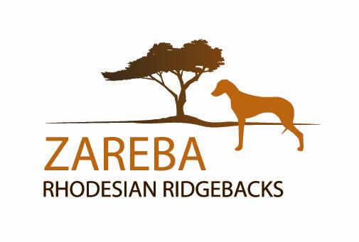
Since 1991
ZarebaRidgebacks.com
Marie Glodowski, 734-626-3131, ishowdogs@hotmail.com,
Belleville, Michigan
Lauren Michaels, 216-224-9004, lmmichaels84@gmail.com,
Columbus, Ohio

Dear Potential Ridgeback Owner:
Please complete and return this questionnaire. I understand some of these questions may seem very personal, but this information helps find the best home for our dog or puppy. Ridgebacks have individual personalities…some are shy, others are talkers, many are stubborn, and a few are lap dogs. It is important to match the owner and household to the dog, so everyone is happy. Thank you.
Name Street Address Mailing Address (if different)

Telephone (Home/Cell)

How did you find out about my Ridgebacks

I want (mark all that are true): Adult
Puppy
Male
Female
Any Ridgeback

Describe your living situation: house, farm, condo, apartment?

Do you have a fenced yard? Yes No

Is there a dog park close by? Yes No

How many adults live in the home? How many children?

Who wants to get a Ridgeback - Why?

Does anyone in the home have experience with Ridgebacks? Yes No

What do you know about the Ridgeback breed (good and bad)?

Where will the dog sleep at night?

Will the dog live in doors or outdoors?

Are you interested in owning a dog for (check all that are true)

Showing (If you want a show dog, also answer the questions on the last page)

Family companion Performance events (agility/lure-coursing/obedience)
Lure Coursing Breeding Hunting

Do you currently have any other pets or animals? List what kind and how many:

Do you own a dog crate? If NO, do you plan on crate training the dog?

Can you take a dog to work with you?

Will you socialize your dog after he is fully vaccinated (parks/walks etc)?

How?

Do you think puppies should be taken to obedience training classes? Yes No

What type of dog training skills do you have, and have you trained a dog before?

What will you do with the puppy when you can not supervise him, are away at work, on vacation etc?
Ridgebacks require exercise or will find their own “entertainment”. How active are you or your family? How would you plan to exercise your RR?

Have you read any dog training books, and do you have a favorite?
How do you punish a dog when he/she disobeys – spanking, ignore, kennel, time-out, chain up outside, scold or other?
If you could no longer provide proper care for your Ridgeback, Zareba requires the dog be returned to us and not to the local shelter or rescue or friend, etc. Are you willing to return your dog to us?
If you currently have pets, please list the name, address & phone number of your veterinarian as a reference:

We believe it is important for dogs to receive appropriate OFA health screening tests for hip and elbow dysplasia, eye disease and thyroid problems prior to being bred. Only Ridgebacks who pass these tests, are show quality, and have attained their AKC championship should be bred.
Are you willing to sign a contract agreeing to have a non-show dog spayed/neutered?
Yes No

If I don’t have any Ridgebacks available, would you like to be added to our waiting list?
Or, referred to another breeder?

Ridgebacks usually live about 12 years. If you are willing to commit to providing a home, love, food, shelter and healthcare for the entire life of the dog, then please sign, date and return this questionnaire.

Signature and Date:

Revised: 2010, 2016, 2019
SHOW PUPPY QUESTIONS
(Complete if you are interested in owning a show quality dog)

Have you been to a dog show? Yes No

Have you ever owned a show dog? Yes No

Do you want a dog to show or just a “show quality” dog?
Who would show the dog? Myself Family member Handler
Breeder
If you have never shown a dog before and want to, are you willing to take your puppy to a handling class so you both can learn?
Some buyers who live in our area or near us choose to allow the breeder or co-breeder to show their dog to its AKC championship. If you want a show quality dog are you willing to let the breeder or another experienced person show the dog for you if you do not wish to?
Yes No

Showing dogs can be a rewarding experience for you and your dog. Are you willing to work with the breeder for a show puppy to become an AKC Champion? Yes No

