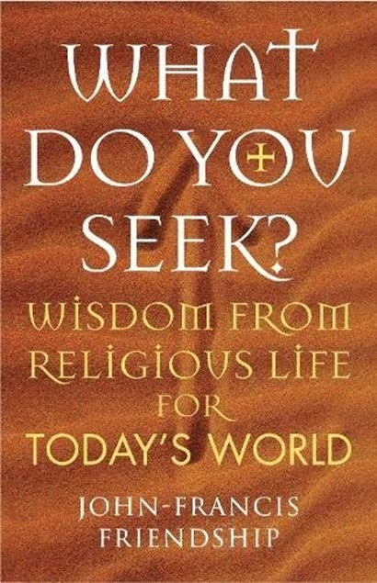
What Do You Seek?
Wisdom from religious life for today’s world

by John-Francis Friendship

CHURCH TIMES review, JANUARY 7, 2022

Dominic Walker reads a personal perspective
THE title of this book, What Do You Seek?, is the question traditionally asked of a novice standing before the altar and about to make his or her vows. The subtitle, Wisdom from religious life for today’s world, explains the purpose of the book. Nevertheless, it took me by surprise, because it is not a book that focuses on the ancient monastic traditions (although they are by no means ignored), but a book that looks more closely at the consecrated life, often called the “religious life” within the Anglican tradition, and it is a very personal reflection.
Perhaps I should not have been surprised, because the author, John-Francis Friendship, is a Franciscan priest who for 25 years was a friar in the First Order and is now a member of the Third Order. He writes from a wealth of personal experience of living in community as well as nurturing others in the tradition as a guardian of novices and as a spiritual director. He reflects on the ancient monastic and mendicant traditions and how Benedictine, Cistercian, Franciscan, Augustinian, and Carmelite spiritualities have helped to shape Anglican religious communities over the past nearly 200 years.
The author draws on the wisdom of Anglican religious founders and present-day religious, besides reflecting on the courage and vision of the early founders attempting to restore the religious life in the Church of England, often opposed by bishops, but gaining admiration for their selfless and sacrificial lives in serving the poor and sick. The author also looks at the present-day growth in dispersed and mixed communities and in the solitary and hermit vocation, and he provides an appendix of communities to which he has referred.
Archbishop Robert Runcie said that when leaders of various Orthodox Churches, somewhat suspicious of Anglicanism, visited Lambeth Palace, their fears were always allayed when they saw Anglican nuns living there, because for them monasticism was the bedrock of the Church.
What do you seek? It was the question that I asked a young novice at Tymawr Convent a few weeks ago as she made her monastic profession, but it is not just a question for aspiring monks and nuns, but for all the baptised, and, as the Bishop of Manchester says in the foreword, perhaps this book should be required reading for all exploring their vocation. Being a “vicar” may be the only model with which they are familiar.
This book has been well researched, and its personal testimony witnesses to the religious life as a living tradition. It does what it sets out to do by showing the relevance of the religious life for today’s world and for all who seek to be disciples of Jesus.
The Rt Revd Dominic Walker OGS is a former Bishop of Monmouth.
What Do You Seek? Wisdom from religious life for today’s world
Canterbury Press £16.99 (978-1-78622-345-6)
Church Times Bookshop £13.60

