Standing Order Mandate

1) Personal details

Title
First name
Surname
Mobile/Home Phone Numbers (please provide both if applicable)
Email
Address
Postcode
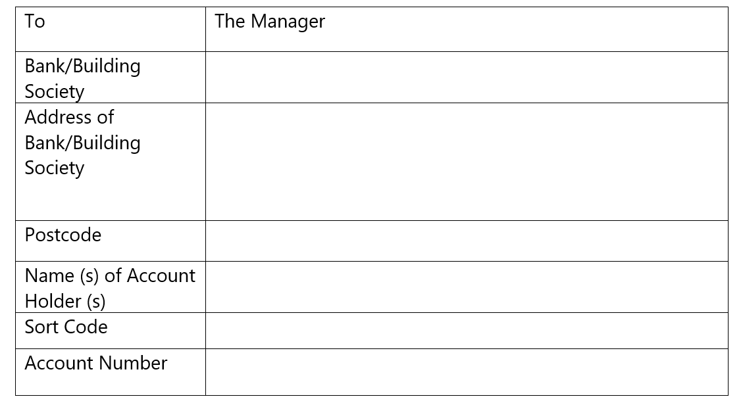
2) Instruction to your Bank or Building Society to pay by Standing Order

Please pay £10 ☐ £15☐ £20 ☐Other£ per month (please tick), starting on 1st ☐ 15th ☐………………………… (month)………………………………..(year) to THE PCC ST MARY S/C 30-93-82, ACCOUNT 00148903 3) Gift Aid Through Gift Aid any donation you give will be worth 25% more, at NO extra cost to you. Signing up to Gift Aid is simple, all you need to do is: Tick here ☐ if you would like Handsworth St Mary to reclaim the tax you have paid on all your donations made in the last four years, and any future donations you may make.* *To qualify for Gift Aid, you must pay as much UK income and/or capital gains tax as Handsworth St Mary (and any other organisation you may support) will reclaim in each tax year (6 April to 5 April), currently 25p for every £1 you donate. If you pay less it is your responsibility to pay back any difference. Gift Aid will be used to fund our general work.

Signature Date: …………………………………….
Please note you must use your written signature You can send us your form electronically via the email below (for your protection, please note we can only accept PDF files*) or you can enclose your completed form in an envelope and post to Handsworth St Mary – The Rectory, 288 Hamstead Road, Handsworth, Birmingham, B20 2RW *If you need assistance with saving file formats, please email us via the address below for a step-by-step visual guide.
Contact If you have any queries, please do not hesitate to contact us via email – DoM@handsworthstmary.org or via phone 0121 554 3407 / 07 535 656 768.
www.handsworthstmary.org
www.handsworthstmarysmusic.org Thank you for your support!

‘The Ecclesiastical Parish of Handsworth St Mary’ is a registered charity, regulated by the Charity Commission of England & Wales: Registered Charity Number 1171344

