Six Marble Track Challenges
Set-up” 5 8-inch Base Plates, 10 3/8-inch dowel rods, 10 Spacers, 10 Brackets (with #8-32 x ¾ Screws and Nuts), 4 track rails (4-foot #16 Galvanized wire threaded in ¼-inch Poly Tubing tubing), 5 small marbles, 1 2-inch x 3/8 inside diameter poly tube dowel rod extender. – Rich Maxwell marblekeeper@gmail.com www.MarbleKeeper.com

Challenge #1 build a Straight-away
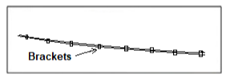
Basic to all DIY Marble Track projects is the art of building track that is perfectly straight, rails level with each other and running parallel. To master this technique, construct a straight-away track on brackets attached to dowel rods. Test the track with a marble by slightly elevating one end of the track.

Challenge #2 CREATE a Slope or a Hill
To construct a slope or a hill, beginning at the starting point of the track, attach one of the track rails to the spacers on the dowel rods. Then attach the second rail matching the profile of the first rail. The higher the starting point the greater the invisible forces of gravity; The steeper the incline the greater the acceleration and the more momentum the track creates.

Challenge #3 BUILD a Dual track
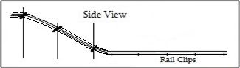
Build a dual track for racing two marbles. Assemble two spacers back-to-back and attached to each dowel rod. If you have enough track rails, attach a second track rail slanted in the opposite direction so you have track starting at both ends of the track. Discover how the definitions of Speed, Acceleration and Momentum are actually different terms.
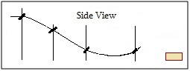
Challenge #4 CREATE a Jump ramp
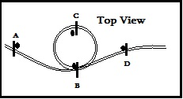
To create a Jump Ramp that launches a marble airborne in trajectory motion to a container past the end of the track, angle the end of the track upward, like a ski jump, at a 45-degree angle. Set up a team competition; longest distance in flight wins.
Challenge #5 Create circles and Corner turns
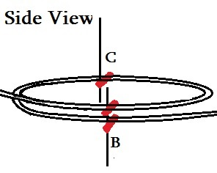
To create a Circle, set out dowel rods B and C as shown here to support the circle. Two spacers should be attached to dowel rod B. Attach the inside rail first, then the outside track. Test the track often with a marble from the beginning. Add extra rail clips around the circle to keep the track running parallel. Angle spacers B and C upward so the outside rail provides a bank and centripetal force, to keep the marbles from flying off the track.
Challenge #6 Create a Loop-de-loop
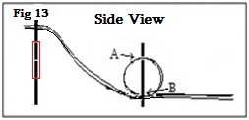
To create a Loop-de-loop, place three spacers on the dowel rod that will support the loop - one upside down at point A and one at point B on each side of the dowel. Shape the configuration of the inside rail of the loop first, then add the outside rail so the curvature of both rails match.
Test the track often with a marble from the beginning. Add extra rail clips around the loop to keep the rails running parallel.
To add height to the track’s release point, which will ensure the marbles have enough critical velocity to make the loop, stack two dowel rods end-to-end (Fig 13), coupled together inside the Dowel Rod Coupler, 3/8th inch inside diameter piece of clear vinyl tubing.

