Marbles roll all over the place. We solve this problem with large hula hoop-type rings. They are simple to make and decorate with colorful duct tape…the brighter the better. Pipe usually comes in 50-foot rolls, so make this a group activity. I carry three to six hoops with me to most marble events.
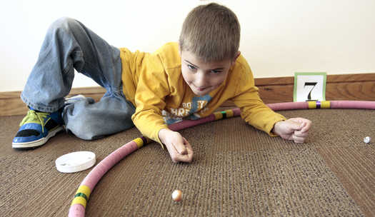
Supplies
- 13 ½ to 14 feet of 3/4-inch irrigation pipe per hoop
- 3/4" male-to-male nipple connector
- Hacksaw or PVC cutter
- Colorful duck tape (some reflect or glitter).
- Hair dryer
Instructions
- To estimate the pipe length, multiply the size of the ring (circle) by 3.14.
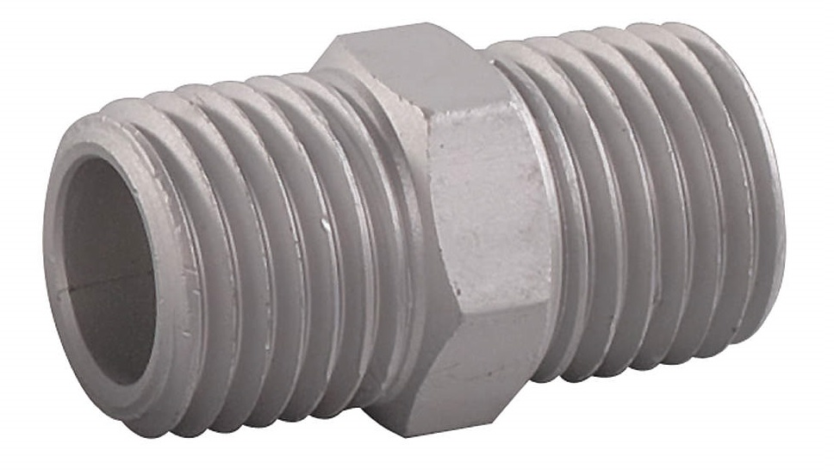
- For example, to make a 4-foot ring multiply 4 times 3.14, which means you will need 12 ½ feet of pipe.
- Cut the pipe to length with a hacksaw.
- You should be able to get 3 to 4 rings from a 50-foot roll of pipe.
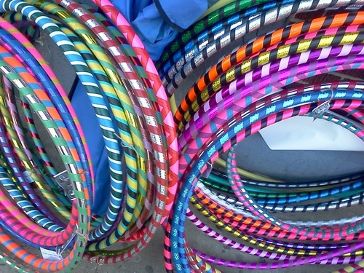
- Heat both ends of the pipe with a hair dryer and quickly pushes the two ends of the tube together over a male-to-male connector.
- Decorate the hoops, wrapping tape around the entire hoop, candy-cane style.
- Add a second color of tape, spiraling in the opposite direction around the pipe.

Activity:

The pipe I use from hardware supply stores come in 25 and 50-foot rolls. So, how many inches of pipe will you need to make a 4-foot ring (multiply 3.14 times the diameter)? And, how many 4-foot hoop rings can you get out of a 25-foot roll of pipe?

Note: When playing marble games on a hoop ring, such as Ringer (page 23), the rules are your hand must be touching the ring, when you shoot. A marble is out-of-bounds if it touches the edge of the ring.

