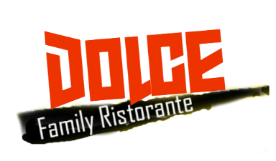

MOTHER’S DAY 4-COURSE SET MENU

Appetizer

Nona Soup *Leeks, cauliflower, bacon, potatoes, Arborio & spinach*

2nd Course

Capellini alla Primavera *Angel hair pasta, fresh vegetables in an olive oil & fresh garlic sauce*

*OR*

Butternut Squash *W/ shrimp in rosé sauce*

3rd Course

Eggplant Parmigama *Grilled Veal Chop with fresh rosemary, in a brandy demi glaze served with vegetables & potatoes*

*OR*

Veal Parmigiana *Breaded veal cutlet topped with tomato sauce & mozzarella served with vegetables & potatoes*

Dessert

Caramel Pecan Cheesecake

OR

Mini Cheesecake

**$45 HST & GRATIUIES NOT INCLUDED**