Live-edge Design Guide
by
Saint’s Woodworking Co.

The images contained herein are for reference only and are not created by Saint’s Woodworking LLC. They only represent possible designs for consideration.

Design: All these recommended designs may be modified to meet Client preferences to include other types of bases not provided here. Metal bases may be purchased, numerous options are available upon inquiry. I do not maintain a comprehensive catalogue, there are infinite possibilities for designs.

Price: Each $ represents a cost estimate. Overall estimated table price ranges from $1,200.00 to $15,000.00+ depending on desired design.

Wood prices are affected by supply and demand, influenced by the economy and seasonal trends, and vary by wood type and quality. Prices change frequently according to these factors.
Section 1: Materials.

Dimensions/Size of the Table (Length x Width x Height in Inches).

4 Person: 36 x 36 x 30.
5-6 Person: 94 x 30 x 30.
7-8 Person: 123 x 33 x 30

Size Note: All measurements are approximate and subject to change depending on Client discussions.

Type of Wood. Several live-edge options are available including walnut, oak, ash, maple, and hickory.

Hickory ($-$$)
Hard Maple ($-$$)
Ash ($-$$)
White Oak ($$-$$$)
Black Walnut ($$-$$$).

Curve. Live edge has varying degrees of curves therefore it’s good to decide how much curve is desirable. 1-6 inches between the inside and outside edges is relatively normal.
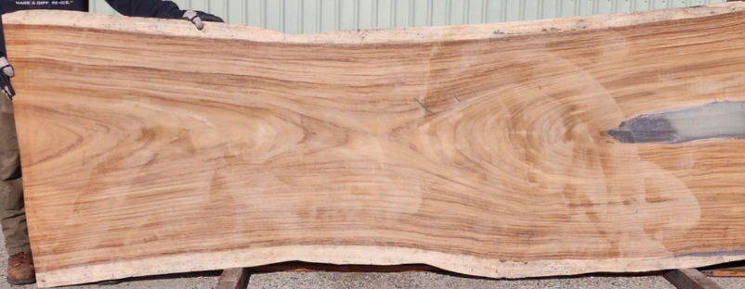
Inside Edge
Outside Edge
Curve is measured from gap inside edge to outside edge.
Examples provided here are for reference of typical color and grain patterns (including knots). The wood selected for your table will appear differently and have its own unique and desirable patterns and color variations.

Hickory: $-$$
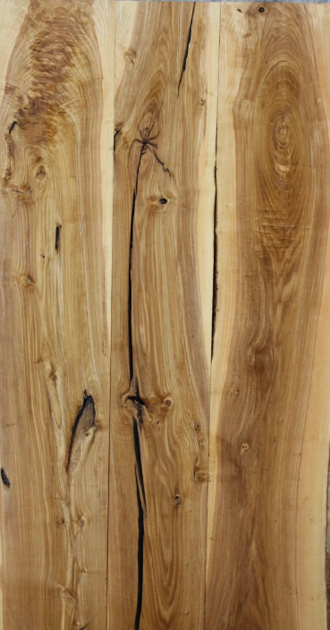
Hickory live edge lumber is characterized by its exceptional hardness, strength, and durability, along with a distinctive rustic appearance. Key features include a high Janka hardness rating of approximately 1820, a striking color contrast between the pale sapwood and reddish-brown heartwood, and a straight but can have a wavy grain with a coarse texture. This combination of physical strength and natural visual appeal makes it ideal for statement furniture, countertops, and high-traffic items.

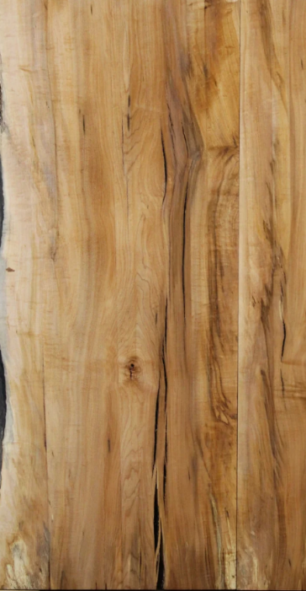
Hard Maple: $-$$
Hard maple live edge lumber is known for its pale color, fine and uniform texture, and exceptional strength and density. It typically features a creamy white to reddish-brown sapwood and heartwood, a smooth, even surface, and can exhibit beautiful figure like "curly," "fiddleback," or "birds-eye" patterns. The live edge showcases the natural, irregular outer edge of the tree, making each slab unique and highly valued for decorative projects like tables, countertops, and benches.

Ash: $-$$
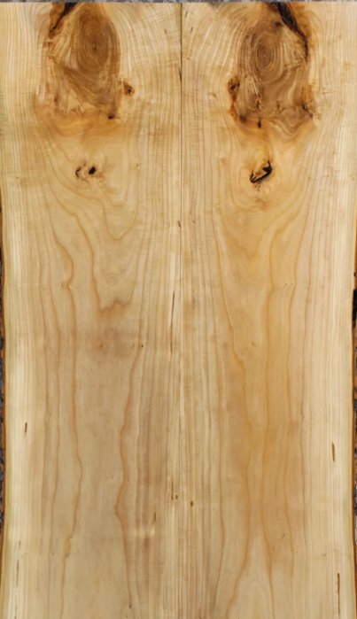
Ash wood live edge lumber is known for its light color, straight and pronounced grain, and excellent strength and shock resistance, making it a durable and popular choice for projects like tables and countertops. It has a medium to coarse texture.

White Oak: $$-$$$
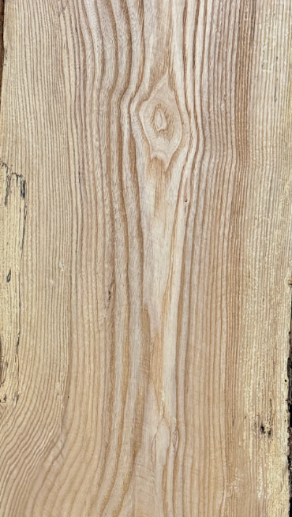
Live edge white oak lumber is known for its strength, durability, and water resistance, making it an excellent choice for durable furniture, flooring, and even boat building. Its characteristics include light to dark brown heartwood, light-colored sapwood, a mostly straight grain, and a medium to coarse texture. The wood is heavy and dense.

Black Walnut: $$-$$$
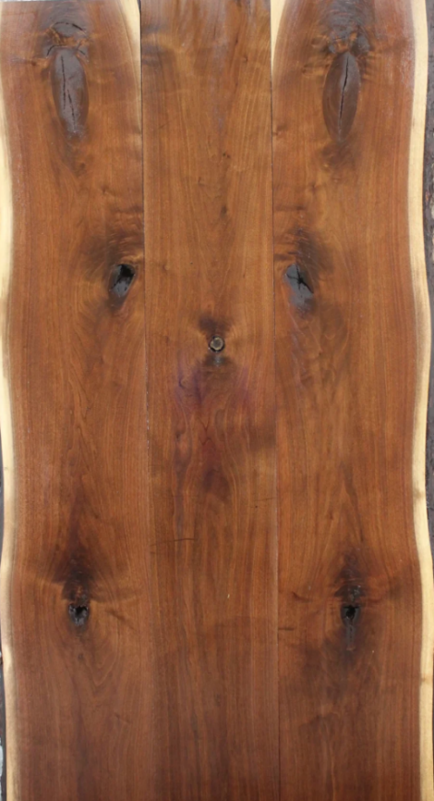
Black walnut live edge lumber is known for its rich, chocolate-brown heartwood, creamy-white sapwood, and often straight, but sometimes wavy or figured, grain. It is durable, stable, and is a popular choice for furniture like tables and counters due to its known strength and shock-absorbency.

Section 2: Design.
There are numerous design considerations; the basics are the slab (wood type, edge style, and quantity), the legs or trestles, size, joinery types (biscuit, bowtie, mortise-and-tenon, dowel, and dovetail), and sheen (matte, satin, semi-gloss, and gloss).

Multiple slabs: Some wood types will not grow large enough for a single slab to be used. Therefore, to produce near-seamless grain I select wood slabs from the same tree or slabs with similar grain patterns and then join them side-by-side to create the appearance of a singular slab (if possible). Another option is the “stitch” the slabs together using wood bowties or similar method (see Bowtie Inlay Options/Examples).

Examples:
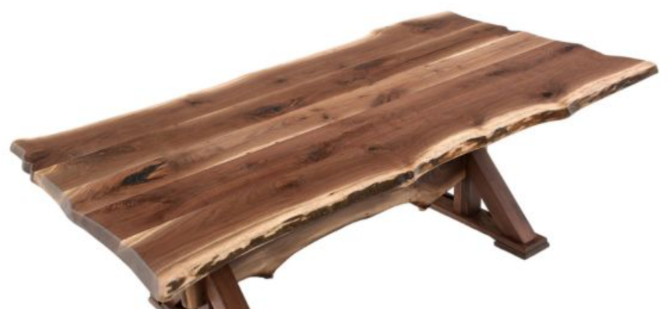

Example 1: This tabletop consists of 5 slabs jointed together.
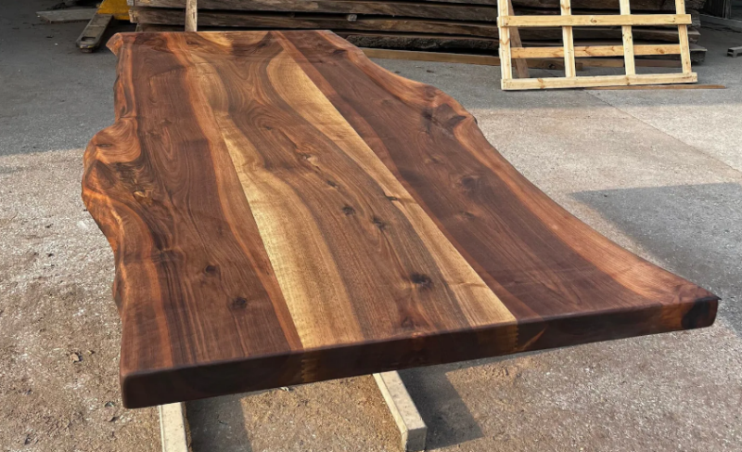
Example 2 (top): This tabletop consists of 3 slabs and uses the center as an accent to the similar outer slabs.
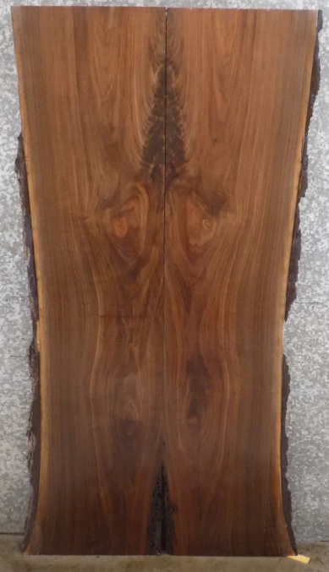
Example 3 (right): This tabletop consists of 2 slabs jointed together. Pieces are from the same tree.

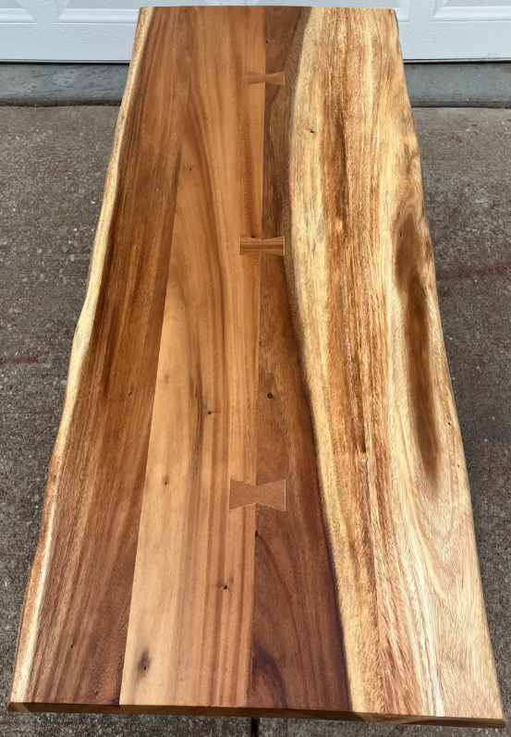
Example 4 (left): This tabletop consists of 2 slabs joined together by bowtie inlays.
Table Trestle and Leg Styles & Examples.

Style 1: This trestle features a single vertical beam, complemented by stretchers that reinforce both the base legs and the tabletop. A central stretcher links the trestles, enhancing the table's overall stability. The structural supports are assembled using mortise-and-tenon joinery.
Price: $$$
Stability: 9 of 10, very stable
Longevity: Very Good to Exceptional
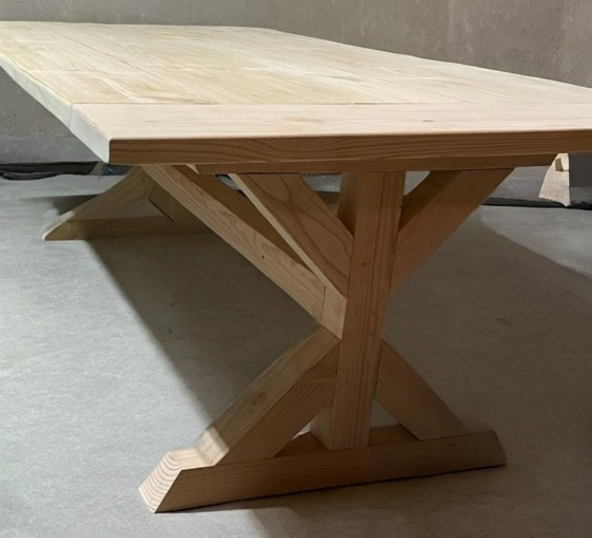
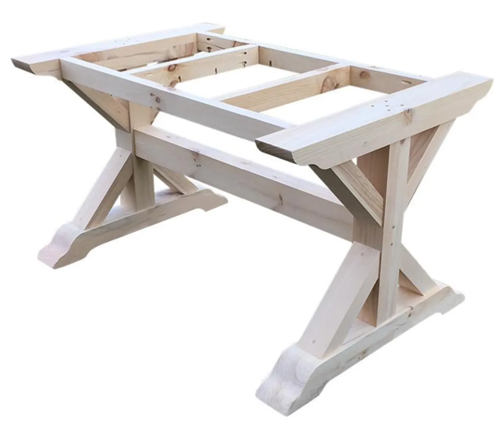

Style 2: The intersecting boards create 'X' trestles, which are joined to an additional stretcher secured to the center underside of the table base. The connections utilize lap joints reinforced with dowels.
Price: $$
Stability: 8 of 10, very stable
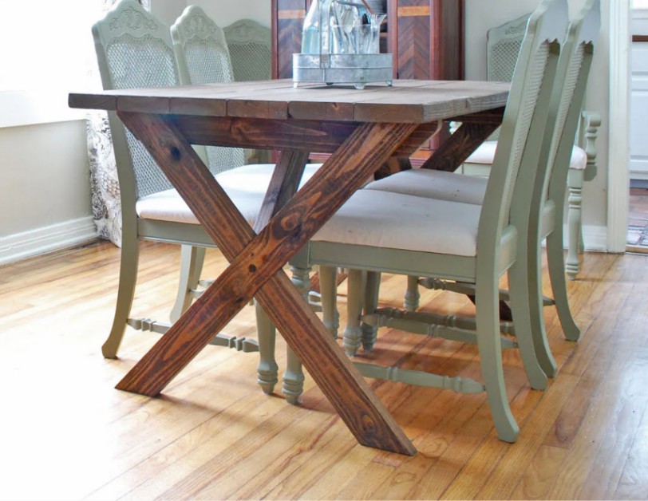
Longevity: Very Good

Style 3: The trestles are constructed in an X configuration using overlapping beams, which connect to the underside frame of the table through mortise and tenon joints. Each trestle is further reinforced by a supporting beam, and a steel pipe center stretcher which provides stability.
Price: $$
Stability: 8 of 10, very stable
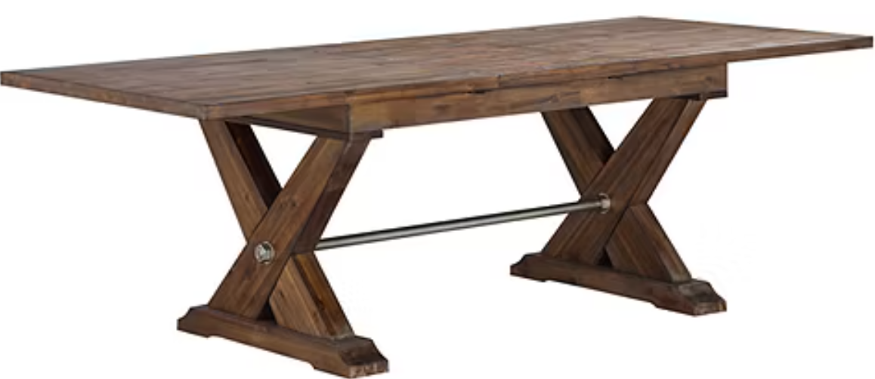
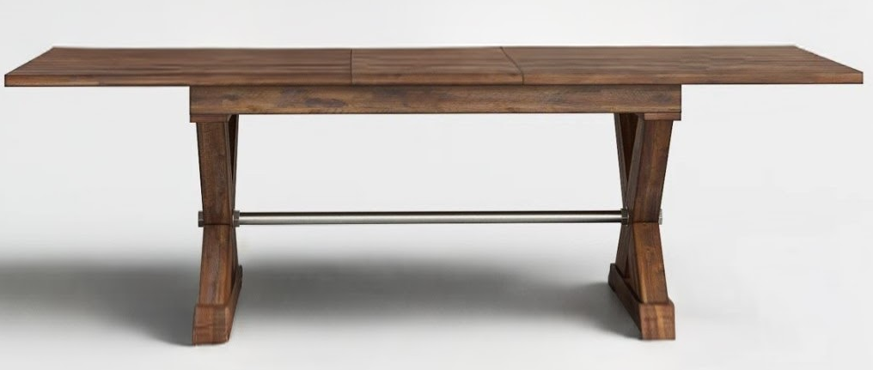
Longevity: Very Good to Exceptional

Style 4: The table features an elongated trestle designed in an ‘X’ configuration, reinforced with both upper and lower beams. A central stretcher is positioned near the base of the trestles for additional support, while angled stretchers extend from the center stretcher to the trestles and tabletop, enhancing overall stability.
Price: $$$
Stability: 8 of 10, very stable
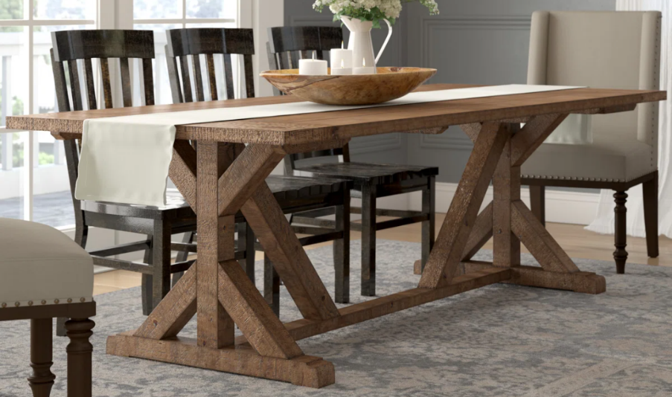
Longevity: Exceptional

Style 5: The table features beam-style legs, each pair joined by side stretchers, with a central stretcher linking the side elements. The upper ends of the legs are secured by a table skirt for added stability and cohesion.
Price: $$
Stability: 7 of 10, very stable
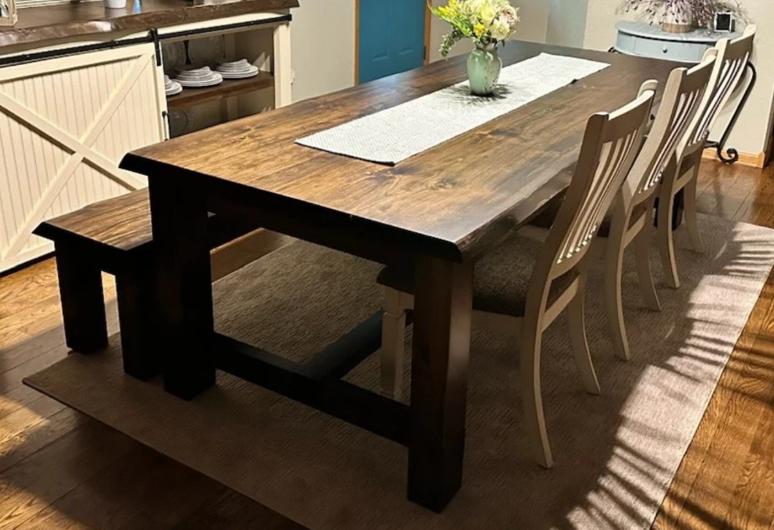
Longevity: Very Good

Style 6: The trellises are configured in an 'I' formation, with variable levels of design detailing, and are joined using a wedged mortise and tenon connection.
Price: $$
Stability: 8 of 10, very stable
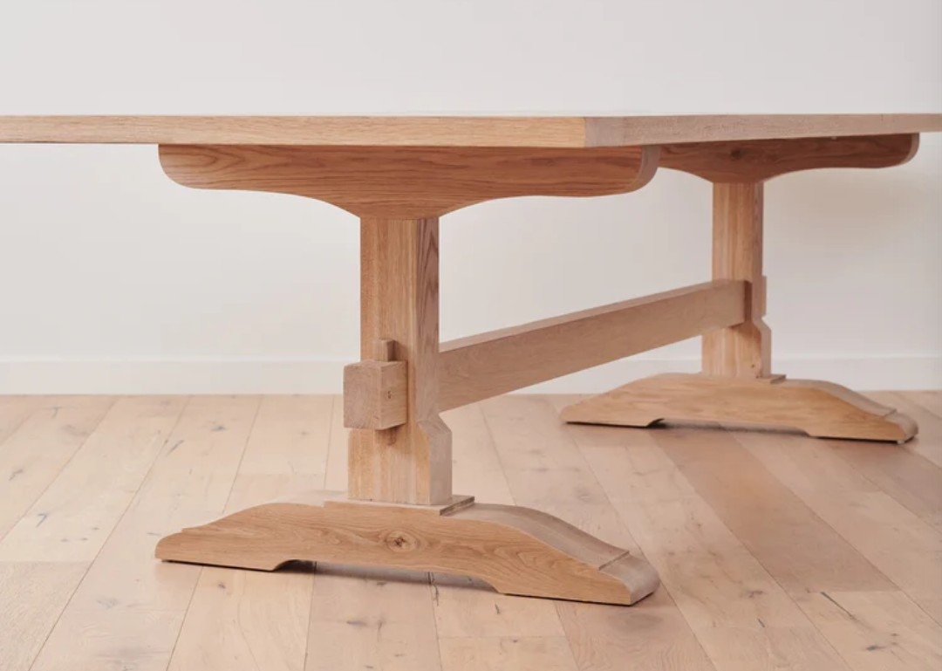
Longevity: Very Good

Style 7: The trellises are constructed in an 'A' configuration with a flat top and are joined by a central stretcher positioned near the base of the trestles. Angled stretchers extend from this central stretcher upwards to both the trestles and the tabletop. All connections utilize mortise and tenon joinery for structural integrity.
Price: $$$
Stability: 9 of 10, very stable
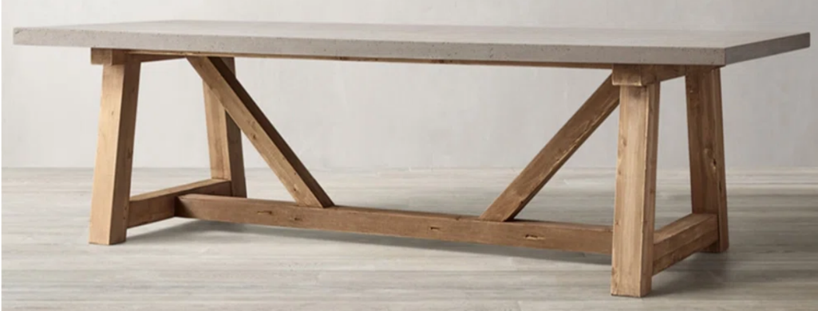
Longevity: Exceptional

Style 8: The trellises are constructed with base feet and a vertical beam supported by angled boards. A center stretcher positioned near the bottom of the trestles is reinforced by additional angled stretchers that extend from the center to the tabletop, providing enhanced structural stability. Skirting and horizontal supports are affixed to the tops of the trellises for added support. All connections utilize mortise and tenon joints as well as dowels.
Price: $$$$
Stability: 8 of 10, very stable
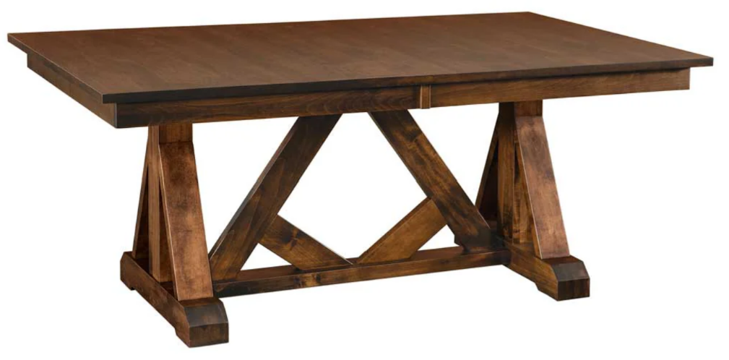
Longevity: Very good to Exceptional

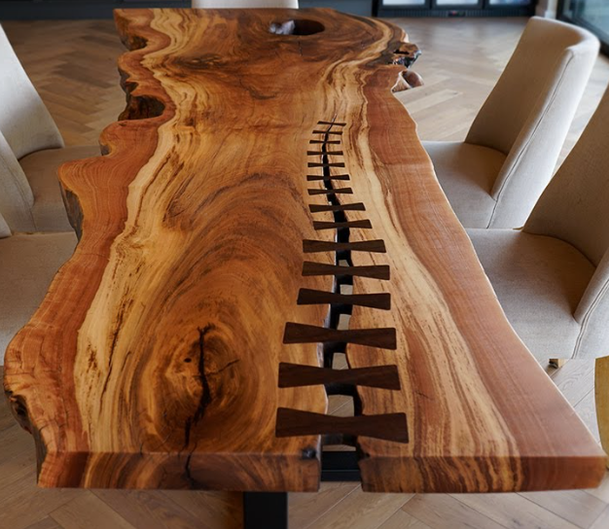
Inlays. Cracks may be visible in the tabletop options however they can be stabilized by specially crafted bowtie inlays. Most bowtie designs focus on aesthetics, and any style of bowtie will effectively address cracks. Inlays also add custom beauty to the piece by highlighting the existing wood by color matching or contrasting.

Bowtie Inlay Options
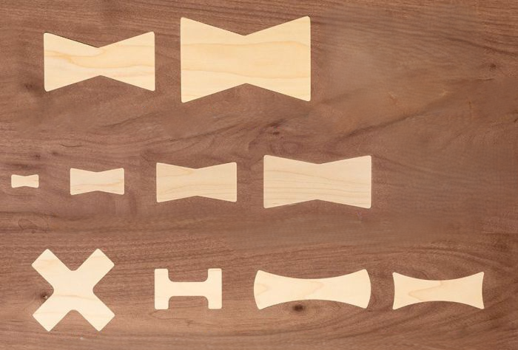
(A, B, C, D, & E):
B
A
E
D
C
`

Sheen. Matte, Satin, Semi-Gloss, and Gloss
For a more natural finish that enhances wood features:
Matte: For the most natural, subtle appearance, a matte finish provides little to no shine. It offers a soft, velvety look that best showcases the natural grain and beauty of the wood without reflections. This is an especially popular choice for those who want a raw, organic look for their live edge piece.
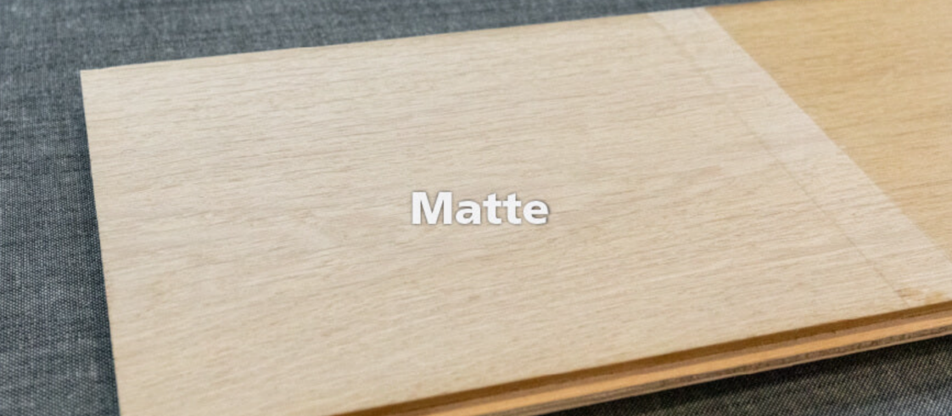

Satin: A popular choice for live edge projects, a satin finish offers a soft, silky luster that provides a nice balance between a low-key and a more reflective surface. It is often praised for its ability to hide minor surface scratches, making it an excellent option for dining tables and other frequently used furniture.
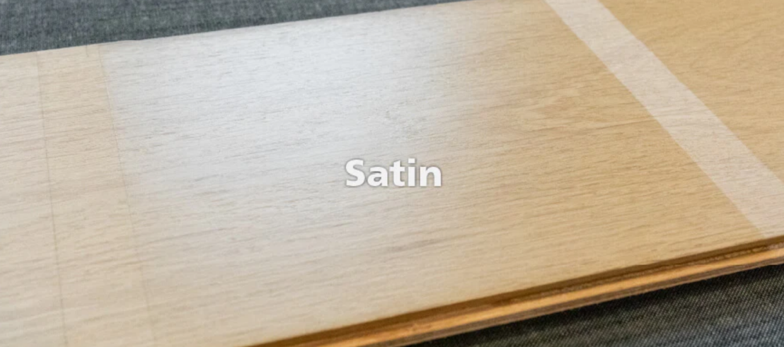

For a more reflective surface:
Semi-gloss: This sheen level offers a more noticeable reflection than satin, giving the wood a smoother, richer appearance. It strikes a nice compromise between the high shine of a gloss and the muted look of a satin finish, making it a good choice for those who want some added pop without a full mirror-like effect.
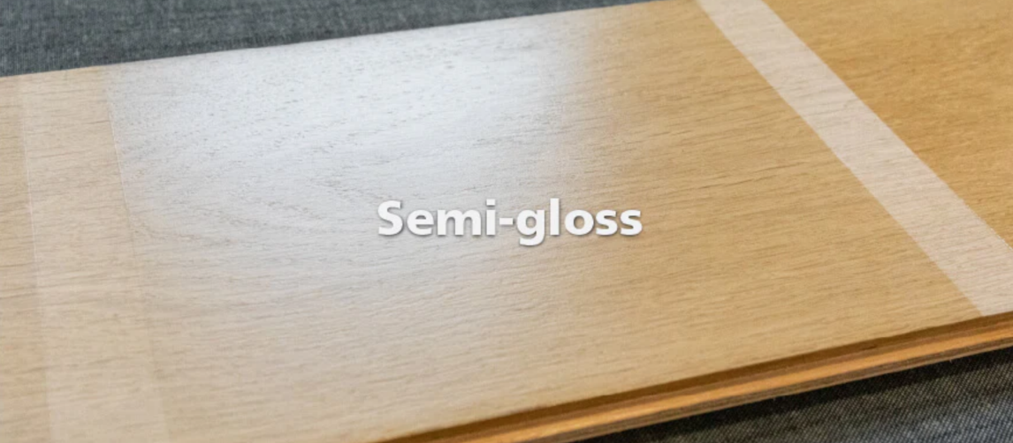

Gloss: For the highest level of reflection, a gloss finish provides a dramatic, mirror-like effect that can make the wood appear to have a "wet" look. While it makes a strong visual statement and adds depth, it also highlights any surface imperfections and requires more careful maintenance to keep clean.
