Scarborough Music Theatre
Annual General Meeting
Season 64: August 1, 2024 - July 31, 2025

Draft Minutes of Meeting held - August 19, 2025 at 7:00 pm
via Zoom and in person at 51 Estate Drive

Board of Directors Present: Olivia Jon (President), Dot Routledge (Vice President), Duane White, Mark Tingle (Treasurer), Sandy Robb (Secretary), Jan Harvey, Janey Carr, Tristyn King

Digital Moderator: Mike Scott

Members: Amanda Sinclair, Daniel Goldman, Eddy Isenberg, Jim Hyslop, Heather Hyslop, Justin P. Douglas, Kathleen Hyslop, Diana Pialis, Anne Currie O’Brien, Bill Simpson, David W. Smith, Erin Jones, Hannah Bild-Enkin, Judy Porter, Karen Direkze, Katherine Turner, Lynette Hines, Peter Lowas, Steven Jackson, Todd Davies, Vivian Lockton, Gary Prudence, Rob Lachance, Kerry Hobbs, Laura Wilde, Mark Parent Missing: Mike Scott

Guests: Miguel Malaco, Stephanie Niciforos

OPENING ITEMS

Meeting opened at 7:00pm (Olivia Jon)

Zoom Guidelines: Mike Scott, Moderator

Land acknowledgement: Dot Routledge

Review and Adopt the Agenda

MOTION: To adopt the Agenda of the 2024-2025 AGM
Moved by: Duane White Seconded by: Tristyn King Abstentions: 0 Opposed: 0
Motion: Carried

Review and approve the minutes of the 2023-2024 AGM

MOTION: Approve the minutes of the August 22, 2023 AGM August 20, 2024
Moved by: Janey Carr Second by: Duane White Abstentions: 2 Opposed: 0 Motion: Carried

Business arising from the minutes of the 2024 AGM
Direction to the Board: To have other people shadow the Treasurer to learn the position with an eye toward succession planning.

This action was already in motion during the 2023-2024 season before the direction had been given and continued during this current season.

Introduction of Board Members
Olivia Jon (President) Dot Routledge (Vice President), Mark Tingle (Treasurer), Sandy Robb (Secretary), Duane White, Jan Harvey, Janey Carr, Tristyn King, Tom Gallagher

2024 – 2025 ANNUAL REPORT (Report attached)

President’s Message (Olivia Jon)

It has been an honour to serve as President of SMT this past year. This full and busy season has been one of learning and joyful experiences. It is also a true blessing to see how well our shows have done this past season.
Our marketing and social media team and contributors (I wish I could name them all) continue to brilliantly promote shows and keep our company in the mainstream. You may have noticed some of the amazing trailers and video clips of our shows/singers in action, along with some great Instagram takeovers. We have had numerous people engage with us as a result.
Again, our SMTY Program Lead, Amanda Sinclair produced an outstanding youth production, Grease, with Amanda performing double duty directing The Sound of Music! The youth camps continue to be a success under the excellent guidance of Camps Facilitator Elizabeth Van Wyck. These ladies embrace the energy and the vibrancy of their young students and truly show what it means to be leaders in action.
Our unit manager continues to maintain the Estate and heartfelt thanks go to their concerted efforts to giving us a wonderful working space. We are diligently working towards adding and refurbishing the front room and installing air conditioning as our next steps! Thank you, Mark!
We are proud to have added extra performances to The Sound of Music, Grease and Rent as the audience demand was there. We also added a family friendly panto to the end of the season. Rapunzel was a first for SMT (being a summer show) but hope there will be more to come. These shows along with Sondheim on Sondheim and the Holiday Singalong Cabaret made for a truly successful season.
This year, your board of directors has been working hard and dedicated time to increasing social media presence, moving forward with community outreach, strengthening our relations with Scarborough Village Recreation Centre and the upkeep of our theatre. We raised over $73, 000 with our volunteers and participation with CGaming! Moreover, we continue to thrive as an organization that welcomes a diverse and wide scope of talent. Words cannot express my thanks to the 2024-2025 SMT Board of Directors and our board adjacent leaders for their incredible work. Bearing that in mind, please consider stepping up and helping. New members, creators and soon to be friends are always welcome!
Finally, a huge thank you to our members and volunteers for their continued support. I am excited to see everyone at the theatre for a season you don't want to miss Hello Dolly, She Loves Me and Legally Blonde (not forgetting our SMTY production of Anne of Green Gables). Of course, we also have our terrific annual Holiday Singalong and SMTY Sings Broadway cabarets. See you at the theatre!

Events and Audience Engagement

The Sound of Music (Kathleen McDowell and Rob Lachance, Producers)
The Sound of Music was the biggest production SMT has put on its stage in a long while. Twenty- eight actors, 13 musicians, 103 costumes, completely sold out before opening night, including an additional sing-along performance! If that wasn’t enough, it was an absolute joy for all involved!
The comments and positive reactions from our audiences thrilled our cast and crew as did the standing ovations that were offered for each performance. We were fortunate to cast not only extremely talented performers and musicians, but also a wonderfully kind group of people. It was a very positive and encouraging environment for our young von Trapp children. Our show introduced a lot of innovations that we are proud of.
We are very proud that we welcomed so many new performers into our company with 18 out of the 28 performers new to SMT. We brought a new sound designer/operator into the SMT family, and this was the first time that an SMT production had two co-music directors.
We introduced new technology in our set design with set projection mapping, giving us the possibility of establishing the location and mood of each scene without having to rely on moving heavy scenery on and off stage. Another added asset to our production was our new pneumatic caster system which made our set changes smooth, efficient and quiet.
Overall, we were thrilled with our production, and the theatre was filled with the sound of beautiful music!

Holiday Sing-Along Cabaret (Mark Tingle)

The annual Holiday Sing-Along Cabaret was a great show with the highest attendance in the 7 years history of the cabaret, selling over 471 tickets.
Several audience members told us that the Cabaret has become one of their holiday traditions. One said that they do their own version of the 12 days of Christmas too.
If you’ve never come to the cabaret, why not try it this coming year!

Sondheim on Sondheim (Sheri Kowalski)

Sondheim on Sondheim was a MASSIVE show to put on with over 41 numbers to learn. Dot, and Miguel did an incredible job in teaching the talented cast of 8 all of the songs. With illness surging through the cast and some support people, we ended up performing four different versions of the show and unfortunately had to cancel a performance. Each altered version was presented flawlessly. Due to a major snowstorm we had to cancel a second performance. Fortunately we were able to offer patrons an alternative performance in the final week of the run.

The set design was extremely creative and flawlessly executed. The end product was beautiful, and the audiences really enjoyed it and found they learned something about Sondheim, the man who changed the way musicals were created.

Rent (Sheri Kowalski/Kathleen McDowell)

What a show RENT was!
We were thrilled by the incredible response to auditions, with over 100 talented individuals showing up to share their gifts. From that pool, we built a powerhouse cast of 17 performers, including 7 new faces to SMT, creating a connection that shone through on stage.
Our Artistic Team brought a dynamic mix of experience and fresh energy, with several making their directorial or SMT debut.
RENT was no small feat to stage with its many moving parts (including a moving staircase). Thanks to the commitment, collaboration, and tireless work of our entire team audiences responded with enthusiasm, ticket sales soared, and we even added an extra performance.
We’re so proud of what we built together. To everyone involved: thank you for your passion, resilience, and artistry. The love from our audiences said it all—RENT truly resonated.

Rapunzel – A Family Friendly Pantomime (Olivia Jon and Tom Gallagher)

At the request of a donor, we were asked to present a summertime pantomime. Rapunzel was selected by Olivia Jon as she had performed in the show at Wychwood Theatre and was very familiar with the piece. Casting was done in April.
As this was the first time for a summertime show in a long while, we were unsure of attendance. We had selected an accelerated move in schedule with a Sunday move in and a Friday of the same week opening and incorporating several weekday matinees. The schedule was July 18, 19, 25 and 26 at 8pm and July 18, 19, 20, 25 and 26 at 2pm for a total of 9 shows.
By the end of the first weekend, we had over 1,400 tickets (including) given out, proving that summertime shows can sell, especially for kids
The kids really enjoyed the call-out feature of a pantomime and the cast stepped up and embraced the crazy audiences.
We have donations set aside for two more summer pantomimes.

Festival Performances and Community Outreach

Guildwood Day Parade - June 7

This year SMT had proud representatives from their summer Panto, Rapunzel, during the parade. Members distributed flyers and season brochures to families and networked with several vendors in the community.

Canada Day Parade - July 1

Many thanks to Theatre Scarborough's Community Outreach who represented Theatre Scarborough in the 2025 East York Canada Day Parade!
We made the news twice: CP24 and CTV!

Taste of Lawrence - July 5 and 6

SMT was invited by the Taste of the Lawrence festival to perform on the Family Stage. Nine performers (including 6 current, 2 youth members and 1 alumni) took to the stage to perform nine songs and talk about Theatre Scarborough. The weather was great, though hot, and the festival had a lot of traffic. The performers drew an enthusiastic response from the audience. This year, Olivia Jon, President, also served as a judge for the inaugural "Rising Stars" competition. Seven volunteers handed out brochures in the stage area during the performances.

Guild Alive with Culture - July 26 and 27

SMT continues to have a strong working relationship with Guild Festival Theatre and was again invited to perform in the Guild Alive with Culture festival this year on July 26. We were given a 30-minute slot on the mainstage at 11:30am (opening) and on the family stage from 3:00-3:30pm.
Theatre Scarborough also had our usual information booth at the festival which had volunteers from across the 3 handing out brochures and talking to hundreds of festival goers.

ACTCO Festival THEA Awards

- At the Lyric Theatre at the Meridian Arts Centre with brand new format
- 47 shows entered
- Over 450 attendees
- Thanks to Tori Waller, Tristyn King, Dot Routledge, Jo Tamaru and Ryan Sullivan for representing SMT as part of the show

SMT Nominations and Wins
- David Smith - Best Performance in a Leading Male Role for The Sound of Music - WIN
- Mack Flynn – Best Sound Design for Sondheim on Sondheim - Nominated
- Miguel Malaco & Charlie Davidson – Best Music Direction for The Sound of Music - Nominated
- Tori Waller - Best Newcomer/Youth Under 25 of a Musical for The Sound of Music - Nominated
- Aidan Sharpe, Charlie Davidson, David Cardinal, David Smith, Kerry Hobbs, Meg Underdown, Michelle Baynton and Tamara Stokoe – Best Ensemble for Sondheim on Sondheim – Nominated

The biggest thanks of all needs to go to the committee who put the entire event together: Anne Currie O’Brien (chair), John Currie, Lynda Waller, Katherine Turner and Dot Routledge. Kudos All!

SMTY Program, Events and Camps

Grease: Teen Version (Amanda Sinclair, Director)

SMTY’s production of GREASE - The High School Version, was a huge success with the cast and audiences alike with 40 youth on stage ranging from grade 6 - grade 12. Nine of our cast members graduated this year with one of them being with us from the beginning 9 years ago! We were very grateful to be on the set of The Sound of Music and benefit from the projection mapping designed for us for Rydell High! Grease, including an extra added performance was sold out before we even opened! We welcomed 16 new youth into our cast and other than those graduating, they would all like to return next year! We also added new members to our artistic team and crew. It was a great collaboration. The feedback from the audience was so positive and we are proud to provide a safe and enjoyable space for our youth!

SMTY Sings Broadway (Amanda Sinclair, Director)

There were nine SMTY members all of whom were in Grease (this was the first Cabaret for 6 of them). After 5 rehearsals the show ran one night in May on the Rent set. The audience loved the show and there was an immediate standing ovation!

SMT Youth Camps and Educational Programming (Elizabeth Van Wyck, Camp Administrator)

The 2024–2025 SMT Youth year was vibrant and inspiring, with more than 180 participants across all our programs! We continued to grow and diversify our offerings, keeping each program fresh and engaging thanks to the creative talents of more than a dozen guest artists and facilitators.
This year marked the 10th anniversary of our very first SMTY Summer Camp—and what a way to celebrate! We hosted four separate weeks of camp, our busiest summer yet. Each week was jam-packed with creativity, energy, and fun: from drama games, singing, scene work, and choreography to voice training, stage movement, and improv dance. A highlight of the summer was our very first SMT Camp field trip—taking the TTC to see SMT’s Rapunzel—a fantastic way to connect campers with our mainstage productions and celebrate the impact of live theatre.
The activity and excitement that comes with this continued growth of SMTY not only strengthens our youth programming, but it also comes with significant overall benefits to Scarborough Music Theatre, including welcoming new youth participants and their families into the SMT community, engaging a wide variety of new artistic staff, increasing SMT’s visibility in and around Scarborough, expanding the audience base for SMT’s shows and cabarets and increasing the diversity of SMT’s talent pool.
With thanks to a few anonymous donors, our camp programming was enhanced by having bursary money available for families that are challenged financially.
A huge thank-you to all our facilitators, co-facilitators, guest artists, volunteers, and SMT members who contributed their time and passion to make this year’s programming a success.

PA Day Camps

We hosted 67 campers at our six PA Day Camps this season, packed with drama games, choral singing, stage movement, dancing, improvisation, clowning, staging songs, fractured fairy tales, and tableaux work. Over the six camps we had a variety of facilitators, artists and volunteers.

SMTY March Break Camp - March 2025

Our March Break Camp, led by Elizabeth Van Wyck, brought in 12 campers.

SMTY Summer Day Camps

SMTY held four Summer Camps in 2025 with a total of 59 participants.

Camp #1 - July 14-18, 2025 (Lead Facilitator: Elizabeth Van Wyck)
Camp #2 - July 28-August 1, 2025 (Lead Facilitator: Sarah Stapleton)
Camp #3 - August 5-8, 2025 (Lead Facilitator: Sarah Stapleton)
Camp #4 - August 11-15, 2025 (Lead Facilitator: Sarah Stapleton)

SMTY Teen Intensive Week - August 18-22, 2024 (Lead Facilitator: Elizabeth Van Wyck)
SMTY’s Teen Intensive Week brought together a full cohort of 12 teens aged 14-18 for a week of workshops and coaching. This popular program is capped at 12 participants and was filled by May 15. For the second year in a row, we were excited to hold Teen Week in the Scarborough Village Theatre!

Let’s Dance! with Aliyah Husain
For the third successful year in a row, SMTY continued Aliyah Hussein’s Let’s Dance! drop-in classes for youth in April, May, and August. Aliyah organized, advertised and facilitated 5 youth classes, which brought more than 40 participants.

Department / Committee Reports

Props Department (Mark Tingle on behalf of Sue Smith)
We were all saddened by the passing of Andy Smith this past year. Sue Smith has returned to SMT as props mistress and continues to manage the props and organization of the props area. There have been several prop rentals to our sister groups and other groups as well.

Costumes (Mark Tingle on behalf of Diana Pialis)
Diana Pialis is managing the costume room and inventory. Diana beautifully designed costumes for all three mainstage shows this year.

Unit Managers/Workshop (Mark Tingle, Unit Manager)
Our renovated workshop had several rentals over the year which brought in some additional revenue, and all rentals worked around the regular schedule of building times for our main stage shows. Kerry Hobbs has taken ownership of the kitchen. Justin P. Douglas has undertaken renovation of the front lobby, hall and bathrooms.

Little Shop of Horror Puppet Rentals (Mark Tingle, Unit Manager)
The puppets had two outings this season to a High School in Kingston and to a Teen Theatre program in Aurora, where Mark Tingle was asked to operate Puppets 3 and 4. Puppet 4 has become damaged and difficult to manage. The Board approved a budget of $1,500 to it. The puppets are scheduled to go out again in October and in December, continuing to make rental revenue for us.

Front of House (Dot Routledge)
It has been a privilege and an honour to serve as Front of House Volunteer Coordinator this past season where over 100 amazing volunteers donated their time. A number of new volunteers were students who joined us to fulfill their volunteer hours for school.

Bylaw Committee (Olivia (Eun-Jung) Jon, Chair)
The Bylaw Committee reviewed the current SMT Bylaws to ensure that they were compliant with the Ontario Not-for-Profit Corporations Act, 2010 (ONCA) which is now in use. There were some revisions mostly in terminology. Two townhalls were held to allow interested members to give feedback.

Proposed Changes

Wording Changes Effective Throughout Document
Throughout the document there is a change of word “general” to “special” with regards to meetings with the exception of the use of the term Annual General Meeting.
- This change is made to align our terminology with that used in the Ontario Not-for-Profit Corporations Act, 2010 which governs our corporation.

Other Changes By Section
3.1 Board of Directors
The affairs of the Corporation shall be managed by a Board Directors including 4 Officers and no less than 7 Directors, each of whom at the time of the election and throughout the term of office shall be a voting Member of the Corporation. The election may be by a show of hands unless a ballot is requested by any member. In the case where the Annual General Meeting is held virtually, a digital poll may be conducted by the Nomination Chair.
- The words “no less than 7” are added. Changing the minimum number of Directors to 7 from 9 to allow for flexibility in the size of the board should less/more interest be shown.

3.1 Board of Directors
- Officers (President, Vice-President, Secretary, Treasurer) shall serve maximum 5 consecutive one-year terms on the Executive in the same role. If no Member seeks or accepts nomination for the role up to or at the election, the Officer may stand for election for another year.
- The term for the officers is expanded to 5 years from 3. This allows new officers to become comfortable and competent in the roles before working with a successor.
- Officers shall have staggered terms to enable continuity and consistency. Commencing on the approval of these By-laws by the Membership at an Annual General Meeting, the President and Vice President shall serve maximum three consecutive terms, and the Treasurer and Secretary shall serve maximum two consecutive terms to allow for staggering. After these initial maximum terms all positions will revert to three consecutive terms.
- The above verbiage will be removed. This is a hold over from the previous bylaws where the term limits were introduced. It is now extraneous.

6.4 Annual and Other Meetings of Members
Members may request a special meeting of the membership. The members of a corporation who hold at least 10 per cent of votes that may be cast at a meeting of the members sought to be held, or a lower percentage that is set out in the by-laws, may requisition the directors to call the meeting for the purposes stated in the requisition. The requisition, which may consist of several documents of similar form each signed by one or more members, must state the business to be transacted at the meeting and must be sent to each director and to the registered office of the corporation.
- The Board of Directors or the President shall have the power to call at any time a special meeting of the Corporation.
- The above verbiage will be added. This wording has been lifted directly from the Ontario Not-for-Profit Corporations Act, 2010 and added for information purposes so members are aware.

Motion to approve the updates to the Bylaws as presented
Moved by: Dot Routledge Seconded by: Janey Carr Motion: Carried

Hiring Committee (Mark Tingle, Chair)
The Hiring Committee for the 2025/2026 season included: Mark Tingle (Chair), Laura Wilde, Sandy Robb, Emily Brown and Steve Nadon included hiring for two of the three shows: Hello Dolly! and She Loves Me.
Legally Blonde was previously cancelled due to COVID and that team was promised first right of refusal.
Notices were sent internally through the SMT Newsletter and social media pages and also posted externally on the ACT-CO website and by our sister groups.
A Meet and Greet was held in November 2024 to allow potential candidates to ask questions and meet the panel and other fellow candidates. A deadline of January 7th, 2025, was set, and we received 25 applications in total for the season – individual and team – by that deadline.
The Committee interviewed on February 9, 11, and 12, 2025. The February 9th & 11th sessions were held at the Estate, however due to a winter storm, the February 12th session, was held via Zoom. Ultimately, the committee selected the following teams for the 2025-2026 season:

HELLO DOLLY! (November 2025)

Director | Jeremy Hurst
Music Director | Antony Discenza
Choreographer | David Smith
Stage Manager | Bita Baakhalagh
Producer | Ed Ho
Producer | Kay Wong
Jeremy Hurst, Bita Baakhalagh, Kay Wong are new to SMT, Antony Discenza has been in many orchestras. Welcome back to the production side Ed Ho. David Smith has moved from stage to production.

SHE LOVES ME (February 2026)

Director | Dot Routledge
Music Director | Miguel Malaco
Choreographer | Sabrina Hooper
Stage Manager | Amanda Cook
Producer | Sheri Kowalski
Producer | Shannon Cottrell
All are well known to SMT.

LEGALLY BLONDE (May 2026)

Director | Sergio Calderon
Music Director | Miguel Malaco
Choreographer | Baiba Senecal
Stage Manager | Amanda Cook
Producer | Kathleen McDowell
Producer | Rob LaChance
This is the original team from the production that was previously cancelled due to Covid with the exception of Miguel Malaco as Music Director replacement. Rob LaChance and Kathleen McDowell have been added to work on this show at their request.

Publicity and Marketing Committee (Justin P. Douglas, Marketing Lead)

For the first time in many seasons, we did not have a consistent Marketing Committee for the 2024/2025 season, but instead a series of individuals working on individual shows.
A major focus at the beginning of the season was reworking the SMT website to drive our SEO (search engine optimization) to drive more traffic to the site.
Effective marketing tools we carried forward from past seasons included:
- Creating show trailers for all of our mainstage shows
- Regularly programmed social media content to keep our followers engaged
- Promo videos running on the TV in the theatre lobby while our shows are in the venue
- Flyer distribution in the community
- Digital and tri-fold printed programmes for every show

Show Selection Committee for 2026/2027 Season (Katie Wise, Chair)
Committee members included Jill McMillan, Dot Routledge, Miguel Malaco, Sabrina Hooper, Amanda Sinclair, Cory Doran, Steve Lavoie, Renee Jones and Olivia Jon.
This committee was assembled by invitation on May 7th, and included past Directors, Musical Directors, Choreographers, Stage Managers, Actors, and Past and Present Board Members. The board mandate was shared with each committee member before the meeting. We discussed selecting three shows for the season with a back-up for each, similar in nature, in case there are conflicts. Overall, there were lively discussions and the group worked well together. We truly wanted to ensure there was something for everyone, and we believe this was achieved.
This season will mark the 65th anniversary of SMT and the Show Selection Committee proudly presents our season for 2026/2027.

Relationship with Theatre Scarborough
(Dot Routledge represented SMT at Theatre Scarborough this past season)
SMT has now been in existence for 63 years; however, we have only been performing at Scarborough Village Theatre (SVT) since 1982. When the City asked Scarborough Music Theatre, Scarborough Players (SP) and Scarborough Theatre Guild (STG) to program SVT back in 1980, they also asked to only deal with one organization – and thus Theatre Scarborough (TS) was born.
TS is its own registered charity - separate and unique from the three groups that perform there. Anyone is welcome to run for seven of the TS Board positions, however the other three positions are automatically filled by each of the Presidents of the member performing arts organizations (MPAO). As a member of SMT, SP, or STG – you are automatically a member of Theatre Scarborough and we need your mind, your time, and your hands to help run the theatre itself!
The Board of Theatre Scarborough is responsible for a number of critical activities to keep the theatre running. It is through the coordinated efforts of this Board and the volunteers who support these activities that we are able to effectively operate the theatre and keep that work “off of the MPAO’s plates”. What are those critical activities?
- Theatre Box Office – Running the shared ticketing system, Arts People.
- Theatre Refreshments – Stocking and selling refreshments to our patrons at each show.
- Theatre operations and maintenance – Maintaining, repairing, and replacing all the theatre equipment in our theatre.
- Seasonal Brochure – Coordinating the development and distribution of the annual Season Brochure on behalf of the MPAO.
- TS Website – Maintaining the TS website to support information, marketing, and online ticket sales … to allow the web-manager of each of the MPAO to keep their own information engaging and up to date.
- Community Outreach Manager – Liaise with the SVRC rep (our location partner); the City of Toronto (our landlord); and City, Provincial, and Federal area representatives, as well as lead TS participation in and engagement with local community groups and activities.
- Accessibility – Focussing on all things accessibility, from our website, our publications, our space, our support services. This is a new and developing area that needs creative minds to support it.
Consider joining the Board of Theatre Scarborough or sitting in on one of the monthly Board meetings to learn more. The Theatre Scarborough Annual General Meeting will be held on Wednesday, August 27, 2025, at 7:00pm via Zoom.

Membership (Jan Harvey, Membership Secretary)

Total Regular Memberships 2024-2025: 194

Life Members: 93 (no new life members for 2024/25)
New Members: 30
Return Members (Non-Life): 49
Honorary Members: 23

Total Associate Members: 50

New Associate Members: 18
Return Associate Members: 32
Graduates: 8

TOTAL MEMBERSHIPS FOR 2024/25: 244

If anyone who has been a member within the last 12 years wants to fill in the gaps, please send an email to membership@smt-theatre.com and we will let you know how many years you need to pay for.
Although anyone can choose to be a member of SMT, all persons cast in SMT productions are required to become members. Your membership runs from the day you pay your membership to the following July 31st. As well, individuals who pay their SMT-membership 12-years in a row become “SMT Life Members” – and never have to pay for membership again!

SUGGESTED 2025-2026 MEMBERSHIP FEES
This year we are suggesting a tiered membership rate as those who join later in the season do not get the same advantages and discounts as those who join earlier. We suggest the following rates:
Membership Start Period | Single / Paid Associate membership | Family membership | Regular Associate  (18 yrs & under) | Honorary / Life Members
August 1 to October 31, 2025 | $40 | $70 | $0 | $0
November 1, 2025 to February 28, 2026 | $30 | $60 | $0 | $0
March 1 to July 31, 2026 | $20 | $50 | $0 | $0

2025-2026 MEMBERSHIP BENEFITS
Member Benefits | Single, Family & Life | Associate | Associate (paid)
2 complimentary tickets (4 for Family membership) to be used for any SMT show during the current season | x | x | x
4 half-price tickets to opening night of any Theatre Scarborough mainstage show | x | x | x
Complimentary entry for the member to any SMT show where seats still exist 10 minutes prior to curtain | x | x | x
Can attend any adjudication public or private | x | x | x
Monthly newsletter and news blasts | x | x | x
Pre-notice and booking for auditions, workshops and camps | x | x | x
Can attend SMT Board of Directors meetings, Annual General meeting and any Special General meetings | x | x | x
Can vote at Annual General or Special General meetings | x
Complimentary agent tickets | x | x | x

Motion to approve the membership fees for the 2025 – 2026 year as presented
Moved by: Jan Harvey Seconded by: Mark Tingle Motion: Carried

Financial Report (Mark Tingle, Treasurer)

Finance Summary
We had a successful year; a majority of our shows turned a profit and even the first-time summertime pantomime managed to break even. Our main stage productions were mostly profitable — Sound of Music $13,418 profit, Sondheim on Sondheim lost $12,257 due to snowstorms, cast illness etc. and finally, Rent with $18,029 profit, totalling $19,190K in profit for our main stage shows. SMTY’s Grease was very successful with $10,214 in profit, the Holiday Cabaret and the SMTY Cabaret netted an additional $3,496 and the first-time summertime pantomime Rapunzel made a profit of $559, all which translate into a season profit of $33,458.

Budget 2025-2026
We have finalized the budget for the upcoming season. It was approved by the board in July. There are three large shows with full orchestra. With the increase of ticket prices this year and already surpassing our estimates for subscriptions (918 subscriptions sold) we anticipate another banner year. In the operational budget, $10K has been allocated for necessary capital purchases, as mandated and approved by the Board. We continue to adhere to the mandated savings plan for HASCAP Loan repayment.

Grants
This year we applied for several grants, but they have become much more competitive and difficult to secure. We have been researching using Grant Connect to identify other sources of grants and sponsorships.

Review Engagement/Accountant
Last year, we underwent our first review engagement with Fazzari & Partners with a fixed price contract set at $9,500 plus tax. We negotiated a new price this year. We are converting to QuickBooks Online as a better system to manage our finances.

Capital Purchases
This year, we made several equipment purchases. We were donated six rechargeable batteries from Sennheiser for the wireless mics. We plan to expand our rechargeable battery purchase to cover all our mics. We were renting lights from Long & McQuade for producing short trailers for promotional purposes. We have now purchased lights from Ontario Staging and a moving light board from David Buffham. These purchases save future rental fees.

Reserves/Investments - HASCAP
Our mutual funds, through a year of US uncertainty, have increased our portfolio value by $20K. Additionally, we strategically purchased several Guaranteed Investment Certificates (GICs) throughout the year to maintain liquidity and optimize our financial resources. We have strong reserves available ($274, 767 in mutual funds + $160,346 in our operating accounts).

CGaming - Rama East
For the past two years, we have been providing two volunteers for two shifts per month. Each volunteer contributes two or four hours per shift. So far this year, we have raised $74K which has been allocated towards our theatre and unit rent. Many thanks to Maxine Doucette, the program Charity Coordinator, and our volunteer team Sandy Robb, Jan Harvey, Olivia Jon, Janey Carr, Janet Flynn, Judy Gibson, Laura Wilde, Duane White, Ted Powers, Dot Routledge, Tom Gallagher, Anne Wood and Mark Tingle.

Final Thoughts
We are actively expanding our product offering each year. Increasing our sales for our current products, main stage, cabarets, the pantomime, increasing the number of youth camps throughout the year and possibly expanding to include a seniors show. For the past five years as your treasurer, we have introduced a new online system for tracking expenses, and an integrated reporting system. With the help of the Finance Committee, we will be introducing controls to reconcile all the accounts with a two-person process to make it easier to ensure the accounts remain balanced to the accounting system. I will remain on the board as a board signatory for the next year and continue to work with the new treasurer to ensure that the path is not lost.

Bank Accounts and Investments as of August 10, 2025
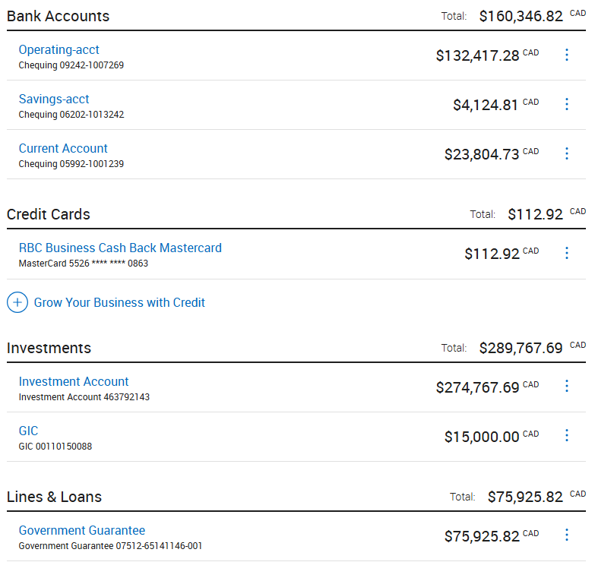2025 – 2026 Show Budget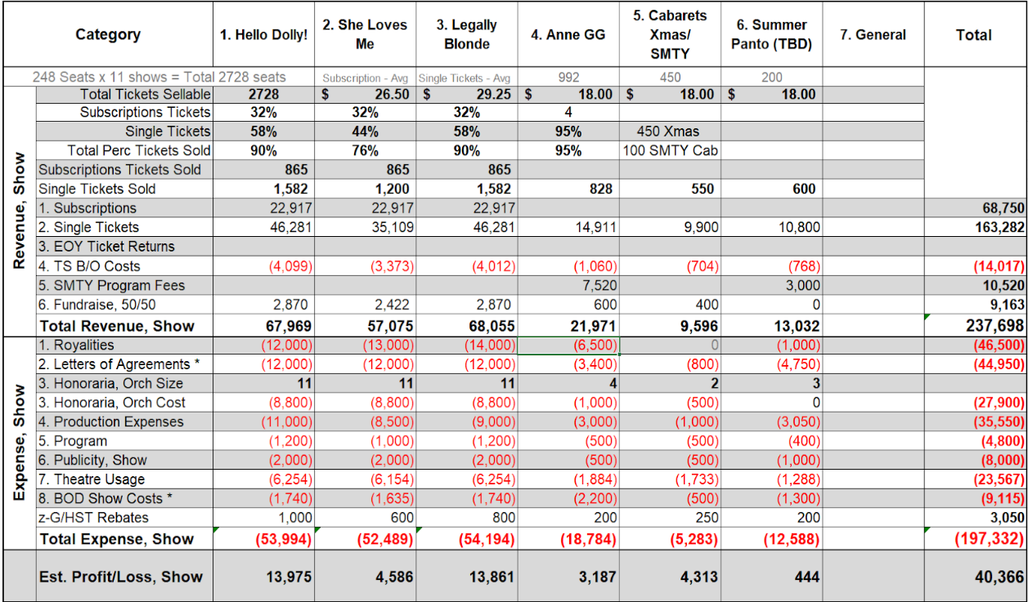

2025-2026 Budget - Other - Revenue/Expenses
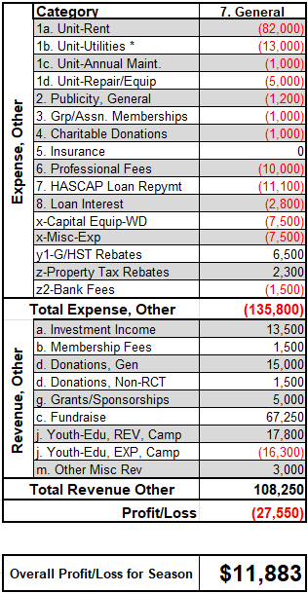

Financial Statements from the Review Engagement
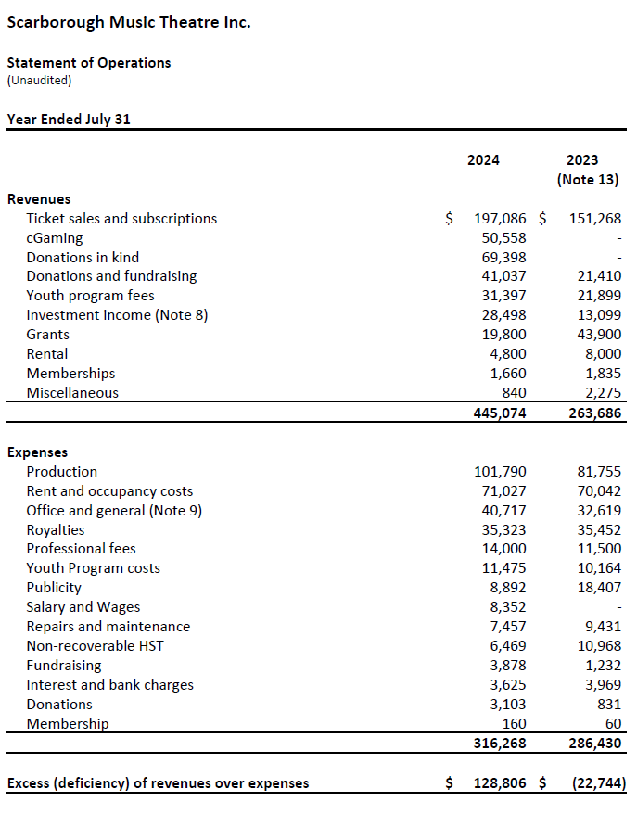
Review Engagement Report Season 2024 – 2025

Motion to accept the 2024 - 2024 Review Engagement Report and Financial Statement provided by Fazzari and Partners LLP
Moved by: Mark Tingle Seconded by: Sandy Robb Absentions: 1 Motion: Carried

Appoint Accounting Firm

Motion to appoint Fazzari and Partners LLP as the external accountants of SMT to hold office until the next Annual Meeting or until their successors are appointed and that the Board of Directors be authorized to fix their remuneration.
Moved by: Mark Tingle Seconded by: Dot Routledge Motion: Carried

Special Projects - Proposed Capital Projects for 2025-2026

Air Conditioning in Rehearsal Hall
- The heat in the unit during the summer months (June to September) is a constant issue.
- SMT would benefit from air conditioning in the rehearsal hall for the following reasons:
- It would alleviate safety concerns for SMT/SMTY auditions, pantomime rehearsals, SMTY summer camps, Let’s Dance classes and potential early rehearsals for fall show and/or the addition of a senior show.
- It would allow us to offer other evening programming such as workshops in the unit over the course of the summer.

Upgrade in Electrical Power
- We have had ongoing power issues at the unit for years.
- We have 40 amps from the current fuse box, and it is being pushed to its limit especially now that it is possible to work in the workshop and rehearsal concurrently.
- We need to upgrade our power to handle new AC units and concurrent usage of workshop equipment and pianos, fans, air purifiers, internet, laptops and other items in the rehearsal hall and green room.
Moving Lights
- Modern shows have more complex technical requirements that require more intense lighting..
- We purchased 4 used lights for $1,500 knowing that they were near the end of life. Two are now unusable.
- RENT had to rent two moving lights from McMann Events at a discounted rate for rentals of $2,500. It pushed the production budget over but given the type of show these lights were essential.
- Purchasing moving lights is expensive, but if we purchase a set they would pay for themselves in approximately two years, and we would own them instead of continuing to rent.
- We have tried several times for grant money to get upgraded lights but the types of grants we are typically eligible for do not lend themselves to this type of equipment especially when we do not own our space.

Actions of the Board

Motion to approve the actions of the 2024 – 2025 Board of Directors as presented
Moved by: Rob Lachance Seconded by: Emma Hyslop Abstentions: 8 Motion: Carried

Presentation of Annual Awards
Every year, SMT presents awards to members or volunteers who have made above and beyond contributions to SMT. Thank to all who took the time to submit a nomination on our new online award nomination form. Here are the winners.

ACT-CO President’s Award
This award is presented to those individuals who have contributed something special to the growth or spirit of their community’s theatre company.
Award presented to Dot Routledge

The Randy Leslie Award
This award is presented for a significant contribution in any area throughout the year.
Award presented to Jo Tamaru, Ryan Sullivan, Leo Chisholm, Tristyn King,
and the full cast of Sondheim and Sondheim: Aiden Sharpe, Charlie Davidson, David Cardinal, David W. Smith, Kerry Hobbs, Meg Underdown, Michelle Boynton, Tamara Stokoe

The Herschel Rosen Award
This award is normally given to individuals have made a significant contribution in governance or management and administration over the course of the year.
Award presented to Mark Tingle

The Ed Rancier Award
The winner should be someone who exemplifies the spirit of “Community” in Community Theatre
Award presented to Sandy Robb

Theatre Scarborough Award (to be presented at the Theatre Scarborough AGM)
Winner will be announced at the Theatre Scarborough AGM on August 28th at 7:00 pm

Member Feedback, Questions and Comments:
None received

Meeting control given to Jim Hislop, election chair.

Election of the Board of Directors for the term August 1, 2025 to July 31, 2026

Motion to elect Olivia Jon as President
Moved by: Amanda Sinclair Seconded by: Rob Lachance Abstentions: 1 Motion: Carried

Motion to elect Dot Routledge as Vice President
Moved by: Emma Hyslop Seconded by: Amanda Sinclair Abstentions: 1 Motion: Carried

Motion to elect Sandy Robb as Secretary
Moved by: Eddy Isenberg Seconded by: Kathleen Hyslop Abstentions: 1 Motion: Carried

Motion to elect Kathleen Hyslop as Treasurer
Moved by: Dot Routledge Seconded by: Amanda Sinclair Abstentions: 2 Motion: Carried

Motion to appoint eight Board Members as Directors for the 2025 – 2026 season as allowed in our bylaws – Duane White, Jan Harvey, Janey Carr, Justin P. Douglas, Tristyn King, Todd Davies, Daniel Goldman, Peter Lowas
Moved by: Mark Tingle Seconded by : Amanda Sinclair Abstentions: 8 Motion: Carried

Motion to close nominations
Moved by: Mark Tingle Seconded by: Amanda Sinclair Motion: Carried

Meeting control returned to Olivia Jon.

Closing activities: Olivia Jon

Thank you to:
- Mike Scott who acted as our moderator for tonight’s meeting.
- Jim Hyslop who acted as elections chair
- Jan Harvey who created the PowerPoint presentation for tonight’s meeting.
- All of tonight’s speakers.
- All of the volunteers who helped throughout the year.
- The outgoing 2024 -2025 Board of Directors for their hard work and dedication.
- For allowing me to participate as your President this year.

Next year’s AGM date: to be announced

Meeting Adjourned: 9:24 pm

