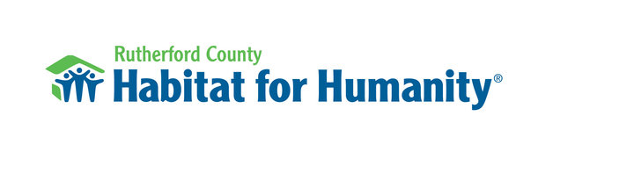

Family Services & Community Outreach
Full-Time | 40 hours/week
Pay: Based on experience
Rutherford County Habitat for Humanity is seeking a motivated professional with nonprofit experience to coordinate homeowner services and community outreach. This position supports families through the homeownership process and manages social media and other community outreach events. Training will be provided to become a Mortgage Loan Originator.
Key Responsibilities:
- Manage recruitment, application, and selection of Habitat partner families
- Support families throughout the homeownership process, including home dedications and sweat equity tracking
- Assist the Family Selection Committee and provide administrative support
- Maintain communication with current and prospective homeowners
- Help create promotional materials and newsletters.
- Assist with social media content that highlights Habitat families, volunteers and community impact.
- Support website updates and digital communications
Qualifications:
- Nonprofit experience required
- Proficiency with Microsoft Office
- Experience with social media, communications or digital content creation
- Strong organizational, communication, and interpersonal skills
- Mortgage loan experience preferred but not required
- Ability to manage multiple projects and maintain accurate records
- Must pass background checks
To Apply: Submit a resume to kfreeman@rutherfordhfh.org

