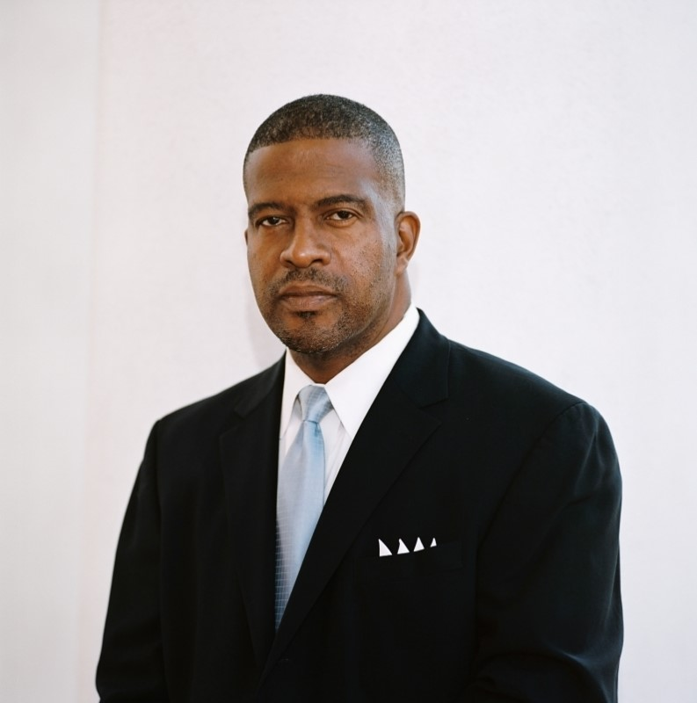
Dr. Gary L. Burgess, Sr.
A Biographical Snapshot

Dr. Gary L. Burgess, Sr. is a life-long resident of South Carolina and an award-winning veteran educator. He is a native of Inman, South Carolina. Burgess is the second child of the late Edward D. and Willean H. Burgess. He is married to the former Quintella M. Howard of Chicago, Illinois. They have three adult children: Lee, Alexandra, and Nathan; Darian a great-nephew reared in the home and one god-daughter, Joycelyn Hardy, MD. He is a graduate of Wofford College, Converse College, and the University of South Carolina at Columbia where he earned his doctorate. He has pastored the Universal Body of Christ Church located in Boiling Springs, SC for the past 42 years.
Burgess has experience as a classroom teacher, school administrator and as an elected school board member. He has an impressive action-oriented history regarding school reform as a reflective practitioner. Burgess personally experienced the effects of poverty growing up in a working-class home, witnessing how institutional perception of one’s social-economic background and ethnic heritage may negatively impact formal learning; thereby, creating and perpetuating institutionalized academic underperformance. He understands the difference between learning and “schooling.” Burgess knows learning is the most important outcome; therefore, he understands learning must not be constrained by the traditional school structure, the traditional school facility, the traditional school day, or the traditional school year. He believes invitational, and restorative learning environments must be created to transform how students learn the prescribed formal curriculum.
Burgess has influenced and overseen the transformation of suburban-middle-class schools, schools with rural-mill-village backgrounds, and urban schools. He has a strong commitment to make a positive difference in the lives of the students and in the communities, he serves- whether it is in the classroom, the administrative office, the board room, or the House of Faith.
Dr. Burgess was tapped by Wofford College, his Alma Mater, to assist with the 2015 celebration commemorating and honoring the history Wofford has shared with the African American community since the school’s founding- The 1854 Campaign. Burgess served on the Transition Assessment Team for South Carolina’s Superintendent of Education, the Honorable Mick Zais, in 2010. Currently, he serves on the Anderson County Board of Education as an elected public official. Burgess is C.E.O. and president of BRAG 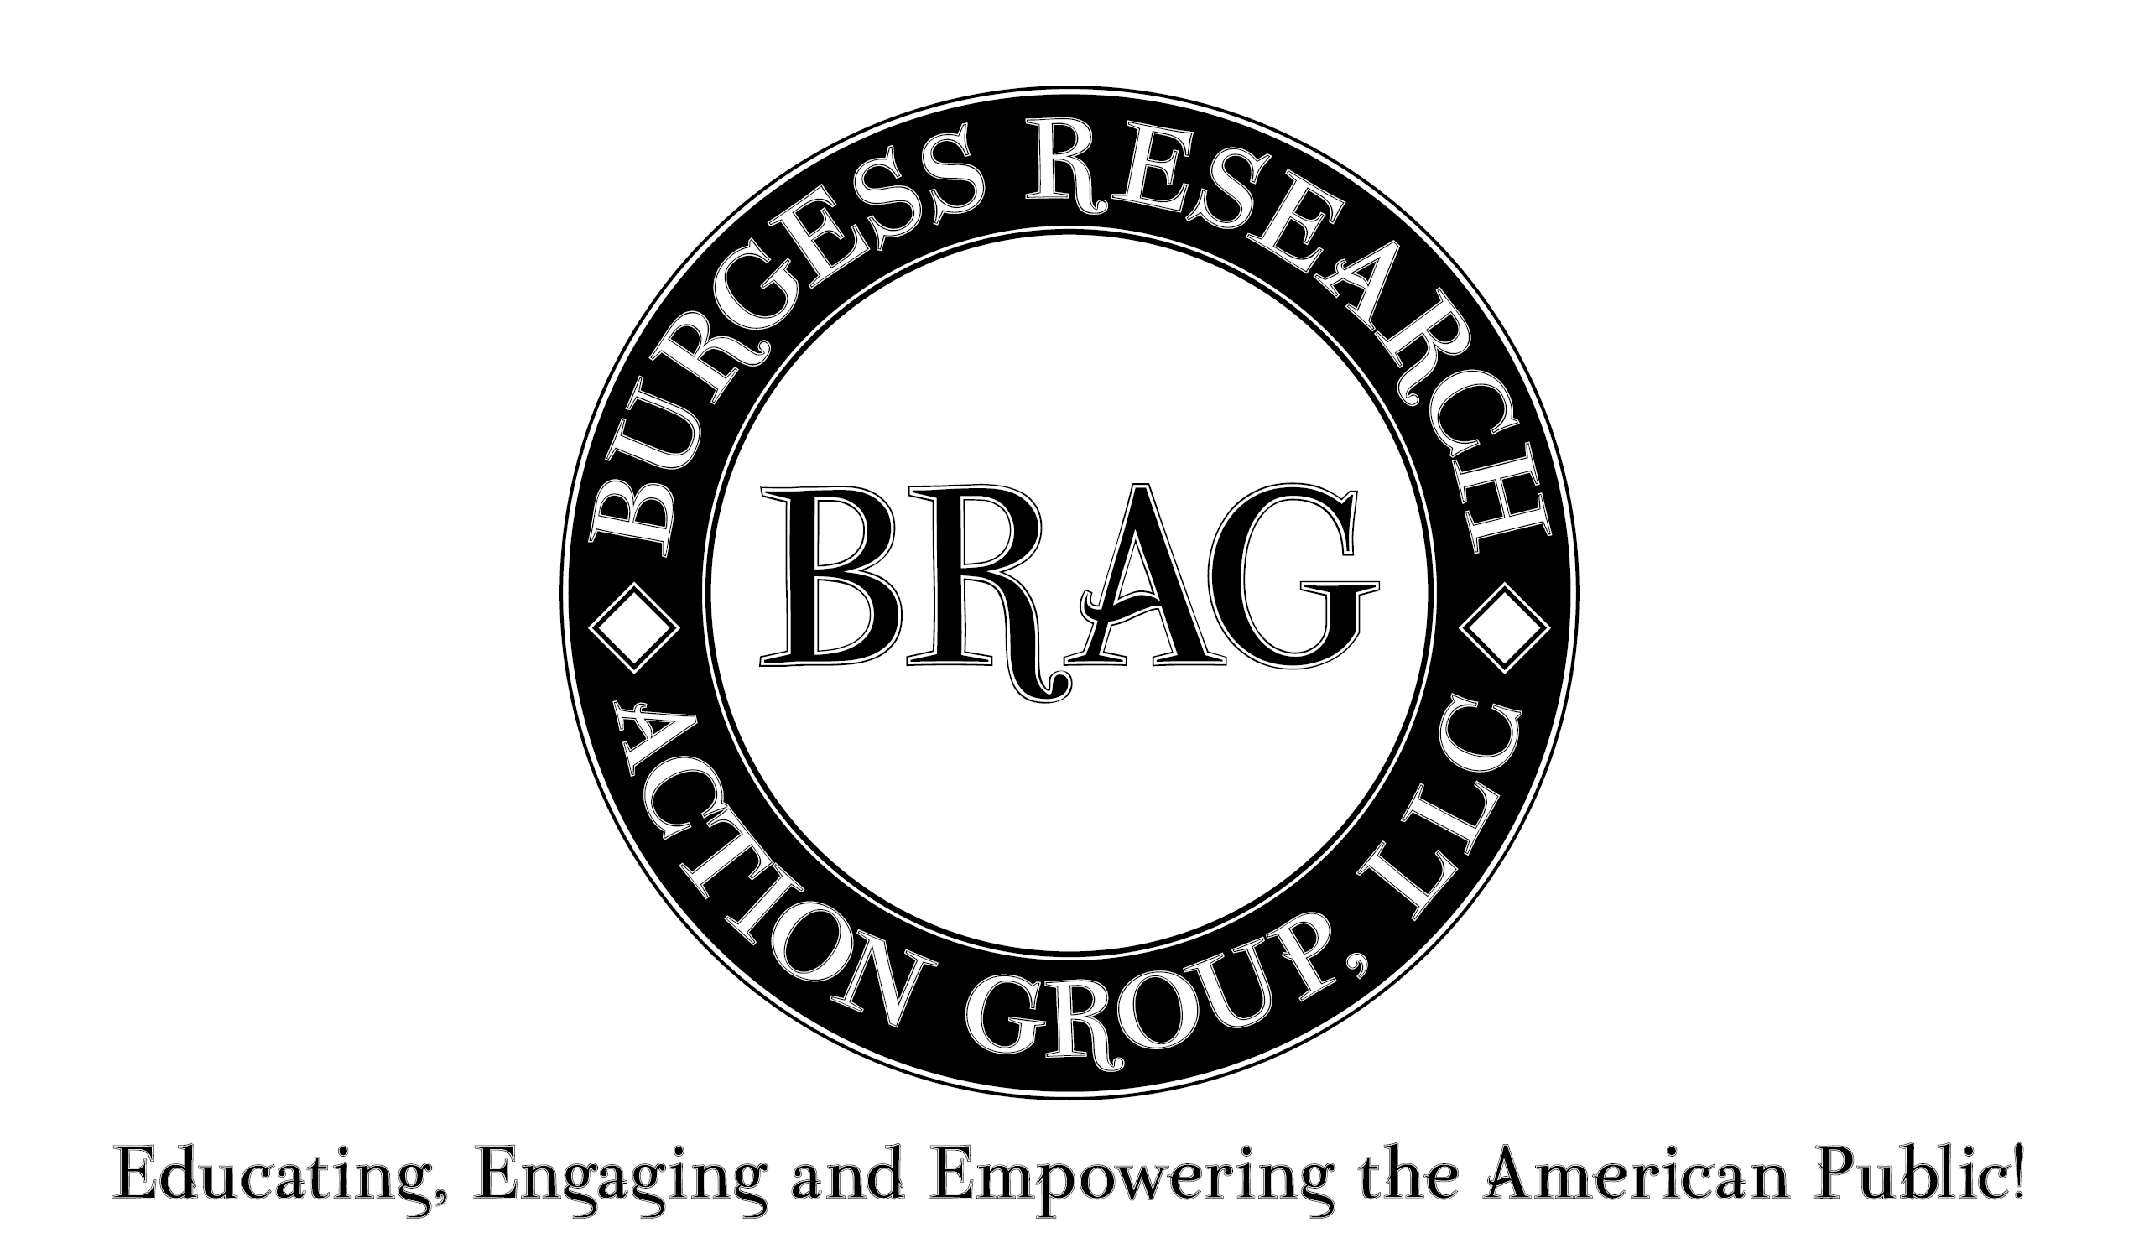- the Burgess Research Action Group. He serves as a consultant with American Educational Consultants of Beachwood, Ohio.
In 1988, Burgess coauthored an article published by the National Association of Secondary School Principals titled: “College Start: A Smooth Transition for Minority Students.” His dissertation, Navigating the Mainstream: The Perceptions of Working Class African American Males of Barriers to Academic Success in Their Local School Cultures’, addresses the challenges facing black male students as a group. His 2009 book with Star Books of Baltimore, Maryland, Distorted: Restoring the Intellectual Image of Students of American Slave Descent, speaks to correcting the negative psychological and social conditioning of black students. Burgess is often a guest columnist in various regional and statewide news publications because of his advocacy for the “underdog.”
Dr. Burgess most recently, January 2024 through October 2024, served as the director of the Charleston Advancement Academy Charter High School. He was the spokesperson and facilitator of the Florence County School District Four Board of Trustee during the 2021-2022 school. Dr. Burgess was Assistant Superintendent of Schools and Superintendent of Schools in Anderson County School District Four located in historic Pendleton, South Carolina, from 2002 to 2008. In 2005 he successfully campaigned for a 26.8-million-dollar bond referendum to build a new elementary school and renovate the existing schools in Anderson County School District Four. This referendum passed at a time of soaring gas prices, Hurricane Katrina, and when citizens across South Carolina were rejecting such referenda. He left the district in excellent financial shape with a significant cash reserve fund. Dr. Burgess has worked as an adjunct professor with Converse College in Spartanburg, SC and the Citadel in Charleston, SC.
He has been recognized by numerous local, state, regional, and national organizations as an educator. Burgess was honored as the Secondary Principal of the Year for the State of South Carolina in 1996 and was named a Milken National Educator in 1999-2000. In 1999, he was recognized by Visions magazine as one of the Top 25 African-America Influencers in South Carolina. Former South Carolina Governor Jim Hodges appointed him to South Carolina's Juvenile Parole Board and to the John De La Howe Board of Trustees.
Burgess served on the board of the National Blue Ribbon Schools of Excellence, Inc., and served as the corporation’s Chief Operating Officer. He was the principal researcher for the South Carolina Caucus of Black School Board Members. Burgess has been engaged as a national site visitor for the United States Department of Education Blue Ribbon Schools Program; in addition to serving as a site visitor for South Carolina’s Exemplary Writing Program and the Palmetto’s Finest Program. He is a pass chairman of the South Carolina Agricultural Education Committee.
Burgess is a former consulting editor with Clearing House: A journal of educational research, controversy, and practices, in addition to having served on the editorial board for Education Issues. Burgess is a contributor in the book Curriculum, Religion and Public Education: Conversations for an Enlarging Public Square, published by Teachers College Press. He was a guest columnist in P C Teach It, a national educational magazine. Burgess is highlighted in a HOPE (Harnessing Optimism and Potential through Education) Foundation’s video series entitled “Failure is not an Option.” He served on the board of the Wofford College National Alumni Association. Burgess was recognized by Wofford as the Outstanding Young Alumnus of the Year in 1997, the first African American to receive this distinction in the college’s history. In 2006, he was one of five Anderson County citizens to receive the coveted “Pointing the Way Award” given by the Anderson Independent-Mail newspaper. Burgess was recognized as a “Hometown Hero” in February 2013, in the Anderson School District Four area which he represents on the Anderson County Board of Education.
Dr. Burgess speaks on the local, state, regional, national, and international circuit. He addressed an interdenominational faith youth group on the Lewis Islands in Stornoway, Scotland in May 2000. In September 2000, he was one of two principals in the nation to address the National Blue-Ribbon Schools Ceremony held in Washington, D. C., sponsored by the United States Department of Education. The following year Burgess (the only principal in the nation) along with former First Lady Laura Bush, addressed the October 2001 National Blue-Ribbon Schools Conference held in the nation’s capital. That same year he presented at the National Educational Policy Fellowship in Miami, Florida.
Burgess has completed numerous seminars and conducted various workshops and school improvement forums. He worked with the National Dropout Prevention Center, housed at Clemson University, on a Program Assessment and Review Team to evaluate the Elmira City School District middle schools in New York in April 2002. Burgess addressed the National School Reform Conference held in Cleveland, Ohio in June 2002. He presented, December 2002 and 2003, at the National Education Reform Conference in Orlando, Florida at Disney World. In July 2003, he completed a Superintendent’s Leadership Seminar at Columbia University in New York City. In April 2008, Burgess conducted a forum, during a national institute in Reading, Massachusetts, addressing how educators might successfully engage students of poverty in the academic culture of their own schools. More recently he served as a principal organizer of the National Moving Forward Together Summit held in Columbia, South Carolina, in 2016 and 2017, designed to promote better relations between law enforcement and local communities. In 2019 he was invited to speak at the University of Cincinnati in Ohio.
Dr. Burgess has experience on the political stage of South Carolina as a statewide primary candidate for the office of South Carolina Superintendent of Education in both the Democratic and Republican parties. The citizens of Anderson County elected Burgess, in November 2010 and November 2014, with over 70% of the vote in both elections, to the Anderson County Board of Education. He was re-elected to the board in 2018 and 2022 without political opposition. This board has fiscal responsibility for the public-school system in Anderson, South Carolina. The Anderson County School Board recently elected him as vice chair of the board.

